UNITED STATES
SECURITIES AND EXCHANGE COMMISSION
Washington, D.C. 20549

Form 6-K

REPORT OF FOREIGN PRIVATE ISSUER PURSUANT TO RULE 13a-16 OR 15d-16 UNDER THE SECURITIES EXCHANGE ACT OF 1934

For the month of August 2026

Commission File Number: 001-37384

Lakefront Biotherapeutics
(Translation of registrant's name into English)

Schaliënhoevedreef 20T, 2800 Mechelen, Belgium
(Address of principal executive office)

Indicate by check mark whether the registrant files or will file annual reports under cover of Form 20-F or Form 40-F.
Form 20-F ☒ Form 40-F ☐

The information contained in this Report on Form 6-K, including Exhibits 99.1 and 99.2, except for the quotes of Mr. Henry Gosebruch and Mr. Aaron Cox included in Exhibit 99.1, is hereby incorporated by reference into the Company's Registration Statements on Form S-8 (File Nos. 333-204567, 333-208697, 333-211834, 333-215783, 333- 218160, 333-225263, 333-231765, 333-249416, 333-260500, 333-268756, 333-275886, 333-283361, and 333-292050).

First Half-Year 2026 Results

On August 10, 2026, the Registrant announced its unaudited first half-year results for 2026 in a press release and half year-report, copies of which are attached hereto as Exhibits 99.1 and 99.2, respectively, and are incorporated herein by reference.

Exhibit |  | Description
99.1 |  | Press Release dated August 10, 2026
99.2 |  | H1 Report 2026

SIGNATURES

Pursuant to the requirements of the Securities Exchange Act of 1934, the registrant has duly caused this report to be signed on its behalf by the undersigned, thereunto duly authorized.

 | Lakefront Biotherapeutics
 | (Registrant)
Date: August 12, 2026 | /s/ Ying Deng
 | Ying Deng
 | Authorized Officer

Exhibit 99.1

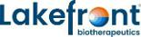

Lakefront Biotherapeutics Reports Half-Year 2026 Financial Results and Provides Business Update

Completed acquisition of Ouro Medicines with Gilead Sciences to advance
potential first and best-in-class T-cell engager

Forecast at least €1.6B of cash remaining after funding portfolio to first
gamgertamig approval

Maintain year-end 2026 cash and financial investments balance guidance of
~€2B, and now includes €50M share repurchase

Mechelen, Belgium; August 10, 2026, 22.01 CET; regulated information – Lakefront Biotherapeutics NV (Euronext & NASDAQ: LKFT) today announced its half-year 2026 financial results and provided a second quarter and post-period business update. These results are further detailed in the half-year 2026 financial report available on the financial reports section of the corporate website.

“In June, we closed our acquisition of Ouro Medicines with Gilead. By combining the strengths of our teams, we expect to accelerate and expand the already rapid development of our lead asset, gamgertamig. To that end, in 2027, we look forward to adding new proof-of-concept basket studies of gamgertamig in additional autoimmune indications. We are pleased with the progress in our ongoing trials in the U.S. and abroad and the emerging clinical data we have seen reflecting durability in the initial data set and consistent responses from the most recent cohorts. We are excited by the potential for gamgertamig to represent an important new immune reset treatment approach for patients across a large number of conditions. We are looking forward to sharing additional data on this potential first-in-class, best-in-class T-cell engager later this year,” said Henry Gosebruch, Chief Executive Officer of Lakefront.

Aaron Cox, Chief Financial Officer of Lakefront, added, “We are pleased to maintain our guidance for year-end 2026 cash and financial investments, which remains at approximately €2 billion, despite recently announcing a €50 million share repurchase expected to be completed by year end. Importantly, incremental to funding the portfolio to first approval, we forecast having at least €1.6 billion of dry powder remaining to fund additional strategic transactions and other capital allocation priorities.”

Second Quarter 2026 Business Update

CORPORATE

 | • | The Company’s name change to Lakefront Biotherapeutics was effective as of May 8, 2026, and the ticker on Euronext and NASDAQ (ADRs) was changed to LKFT.
 | • | The Company appointed Eric Hedrick, MD, as Chief Medical Officer. This expanded leadership role supports the Company’s strategic transformation following its acquisition of Ouro Medicines’ operational assets announced on June 4, 2026. Eric reports to Henry Gosebruch, CEO, and joined the Company’s Management Committee.
 | • | Lakefront announced the initiation of a €50 million share repurchase program on June 9, 2026. Repurchases under the program may be made no later than December 31, 2026. The program was entered into with Morgan Stanley & Co International PLC. The purchased shares are held as treasury shares. As of June 30, 241,904 shares were repurchased at an average price of €25.1261.
 | • | Paulo Fontoura resigned from the Board of Directors following Sanofi’s announcement of his appointment as Global Head of R&D at Sanofi on June 22, 2026.

IMMUNOLOGY PORTFOLIO

 | • | Lakefront and Gilead Sciences (Gilead) completed the acquisition of Ouro Medicines (Ouro). The companies will collaborate on the development of gamgertamig, a potential first-in-class and best-in-class T-cell engager in autoimmune diseases.
 | • | Gamgertamig has been granted both Fast Track and Orphan Drug Designation by the U.S. FDA for the treatment of autoimmune hemolytic anemia (AIHA) and immune thrombocytopenia (ITP) and is expected to enter registrational studies in 2027.
 | • | Ongoing Lakefront-sponsored clinical trials of gamgertamig in autoimmune diseases are actively enrolling, and expansion of the clinical trials program is anticipated in 2027.

 | o | Phase 1b study with gamgertamig in patients with autoimmune cytopenias (including ITP and AIHA) (NCT07083960), active in Australia and the United States.
 | o | Phase 1b study with gamgertamig in seropositive autoimmune diseases (including idiopathic inflammatory myositis, Sjögren’s disease, pemphigus vulgaris (PV), and pemphigus foliaceus (PF)) (NCT07229144) active in Australia, New Zealand, Czech Republic, and Japan.
 | o | Expect to initiate proof-of-concept basket studies assessing gamgertamig in additional autoimmune indications.

 | • | In addition, Keymed is conducting a number of company-sponsored studies in Greater China with gamgertamig in both malignant and autoimmune indications.
 | • | At the International Society on Thrombosis and Haemostasias (ISTH) 2026 Congress in Paris, Lakefront presented a poster on the effects of gamgertamig in a patient with active antiphospholipid antibody syndrome and concurrent autoimmune thrombocytopenia (click here to access the poster).
 | • | Additionally, Lakefront in-licensed a preclinical portfolio of three autoimmune and inflammatory disease programs originally from Ouro with an opt-in for Gilead for a 50/50 profit split post clinical proof-of-concept for $75 million per program.
 | • | GLPG3667 has completed GALARISSO and GALACELA studies1:

 | o | The Phase 2 GALARISSO study in dermatomyositis (DM) has completed the 24-week open-label extension with sustained efficacy and safety consistent with previously reported results.
 | o | The Phase 2 GALACELA study in systemic lupus erythematosus (SLE) has completed with continued favorable safety at 48 weeks; the trial did not meet the 32-week primary endpoint and comparable 48-week secondary endpoint.
 | o | As part of our ongoing efforts to maximize the value of the GLPG3667 program for both patients and the Company, Lakefront is evaluating all strategic options.

ONCOLOGY CAR-T CELL THERAPY UPDATE

 | • | The Company announced in January 2026 the start of the wind-down of its cell therapy activities. The wind-down remains on schedule and is expected to be substantially completed by the end of the third quarter of 2026.
 | • | To support long-term patient follow-up, the HESPERIA study continues to monitor safety of all patients treated in the discontinued parent studies; associated spending is expected to remain minimal.

1 Galapagos Announces Topline Results from Two Phase 3-Enabling Studies with Selective TYK2 Inhibitor GLPG3667 in Dermatomyositis and Systemic Lupus Erythematosus - Lakefront Biotherapeutics

Financial Guidance

 | • | Following the closing of the Ouro transaction and the related impact to cash, the Company expects its year end 2026 cash and financial investments balance to be in the range of €1.975 billion to €2.050 billion. This guidance includes the announced €50 million share buyback program, which was not considered in the previous guidance range.
 | • | Lakefront forecasts having at least €1.6 billion of its cash remaining for additional strategic transactions and other capital allocation priorities following funding the portfolio to first gamgertamig approval.
 | • | All figures assume an EUR/USD exchange rate of 1.175, consistent with year-end 2025 and prior guidance. As of June 30, 2026, the EUR/USD exchange rate was 1.1394.
 | • | These estimates are subject to change and depend on exchange rate fluctuations, and future business development activity.

Financial Performance
Key figures for the first half-year of 2026 (consolidated)
(€ millions, except basic & diluted earnings/loss (-) per share)

 |  | Six months ended June 30,
 |  | 2026 |  |  |  | 2025 |  |  |  | % Change
Supply revenues |  |  | 14.1 |  |  |  | 18.5 |  |  |  | -24 | %
Collaboration revenues |  |  | 4.5 |  |  |  | 121.8 |  |  |  | -96 | %
Total net revenues |  |  | 18.6 |  |  |  | 140.3 |  |  |  | -87 | %
Cost of sales |  |  | (13.9 | ) |  |  | (18.4 | ) |  |  | -24 | %
R&D expenses |  |  | (56.5 | ) |  |  | (278.0 | ) |  |  | -80 | %
G&Ai and S&Mii expenses |  |  | (58.0 | ) |  |  | (74.5 | ) |  |  | -22 | %
Other operating income |  |  | 2.6 |  |  |  | 14.9 |  |  |  | -83 | %
Operating loss |  |  | (107.2 | ) |  |  | (215.7 | ) |  |  | -54 | %
Fair value adjustments and net exchange differences |  |  | 97.1 |  |  |  | (66.2 | )
Net other financial result |  |  | 26.1 |  |  |  | 21.2
Income taxes |  |  | (0.2 | ) |  |  | 1.7
Net profit/loss (-) from continuing operations |  |  | 15.8 |  |  |  | (259.0 | )
Net profit/loss (-) from discontinued operations, net of tax |  |  | 0.8 |  |  |  | (0.1 | )
Net profit/loss (-) of the period |  |  | 16.6 |  |  |  | (259.1 | )
Basic and diluted earnings/loss (-) per share (€) |  |  | 0.25 |  |  |  | (3.93 | )
Financial investments, cash and cash equivalents |  |  | 2,239.5 |  |  |  | 3,091.5

Details of the financial results for the first half-year of 2026

Total operating loss from continuing operations for the first six months of 2026 amounted to €107.2 million, compared to an operating loss of €215.7 million for the first six months of 2025. The operating loss in 2025 was negatively impacted by the executed strategic reorganization announced in January 2025, for €131.6 million. This was mainly reflected in severance costs of €47.5 million, costs for early termination of collaborations of €45.7 million and impairment on fixed assets related to small molecules activities of €12.0 million, professional services costs of €16.6 million, €8.0 million accelerated non-cash cost recognition for subscription right plans and €1.8 million other expenses.

 | • | Total net revenues amounted to €18.6 million for the first six months of 2026, compared to €140.3 million for the first six months of 2025. For the first six months of 2025, the revenue recognition related to the exclusive access rights granted to Gilead for Lakefront’s drug discovery platform amounted to €115.1 million. The deferred income balance related to the drug discovery platform was fully released in revenue at the end of 2025. We have recognized royalty income from Gilead for Jyseleca® for €4.5 million in the first six months of 2026 (compared to €5.6 million in the same period last year).
 | • | Cost of sales amounted to €13.9 million for the first six months of 2026, compared to €18.4 million for the first six months of 2025, and related to the supply of Jyseleca® to Alfasigma under the transition agreement. The related revenues are reported in total net revenues.
 | • | R&D expenses amounted to €56.5 million for the first six months of 2026, compared to €278.0 million for the first six months of 2025. In the first six months of 2025, the Company recorded increased personnel expenses (mainly related to severance costs), an impairment on fixed assets (related to small molecules programs) and a provision for early termination of collaboration agreements. Also, due to the wind-down of the cell therapy activities, the spending in the cell therapy programs decreased in the first six months of 2026 as compared to the first six months of 2025.
 | • | G&A and S&M expenses amounted to €58.0 million for the first six months of 2026, compared to €74.5 million for the first six months of 2025. This decrease was mainly due to lower personnel costs (primarily severance costs).
 | • | Other operating income amounted to €2.6 million for the first six months of 2026, compared to €14.9 million for the first six months of 2025, mainly driven by lower R&D incentives income.

Net financial income amounted to €123.2 million for the first six months of 2026, compared to net financial loss of €45.0 million for the first six months of 2025.

 | • | Fair value adjustments and net currency exchange results amounted to a positive amount of €97.1 million for the first six months of 2026, compared to a negative amount of €66.2 million for the first six months of 2025, and were primarily attributable to €52.4 million of positive changes in fair value of financial investments and €38.8 million of unrealized currency exchange gains on Lakefront’s cash and cash equivalents and financial investments at amortized cost in U.S. dollars.

 | • | Net other financial income amounted to €26.1 million for the first six months of 2026, compared to net other financial income of €21.2 million for the first six months of 2025. Net interest income amounted to €24.9 million for the first six months of 2026, compared to €21.5 million of net interest income for the first six months of 2025. Fair value gains and interest income derived from cash, cash equivalents and financial investments excluding any currency exchange results amounted to €48.6 million for the first six months of 2026 (compared to €49.7 million for the same period last year).

The Company reported a net profit from continuing operations of €15.8 million for the first six months of 2026, compared to a net loss from its continuing operations of €259.0 million for the first six months of 2025.

Net profit from discontinued operations related to Jyseleca® amounted to €0.8 million for the first six months of 2026, compared to net loss amounting to €0.1 million for the first six months of 2025.

Lakefront reported a net profit of €16.6 million for the first six months of 2026, compared to a net loss of €259.1 million for the first six months of 2025.

Cash position

Financial investments and cash and cash equivalents totaled €2,239.5 million on June 30, 2026, as compared to €2,998.0 million on December 31, 2025. The cash and cash equivalents and financial investments included $1,962.2 million held in U.S. dollars ($2,159.0 million on December 31, 2025) which could generate foreign exchange gains or losses in the financial results in accordance with the fluctuation of the EUR/U.S. dollar exchange rate as the Lakefront’s functional currency is EUR (translated at a rate of 1.1394 €/$ at June 30, 2026).

Total net decrease in cash and cash equivalents and financial investments amounted to €758.5 million during the first six months of 2026, compared to a net decrease of €226.3 million during the first six months of 2025. This net decrease was composed of (i) €63.6 million of operational cash burniii, which includes cash in of €78.4 million related to the return on financial investments, (ii) €38.5 million of positive exchange rate differences, changes in fair value of current financial investments, variation in accrued interest income, (iii) €1.1 million acquisition of equity investments, (iv) €4.1 million of net cash in related to the sale of subsidiaries, (v) €2.9 million purchase of own shares and (vi) €733.5 million cash out related to the purchase of Ouro Medicines.

About Lakefront® Biotherapeutics

Lakefront Biotherapeutics (formerly known as Galapagos) is a biotechnology company dedicated to building a differentiated pipeline of medicines for patients with serious diseases in areas of high unmet need. The Company has established a clinical-stage portfolio in immunology and inflammation, anchored by gamgertamig, a potential first-in-class and best-in-class BCMAxCD3 T-cell engager for autoimmune diseases. Backed by deep deal-making expertise, operational flexibility, and a strong capital position, Lakefront identifies, acquires, and advances high-quality assets with clear potential to deliver meaningful patient impact and long-term shareholder value. For more information, visit https://www.lakefrontbio.com or follow us on LinkedIn or X.

For further information, contact Lakefront Biotherapeutics:

Investor Relations
Sherri Spear
+1 412 522 6418
sherri.spear@lakefrontbio.com

Forward-looking statements

This press release contains forward-looking statements, all of which involve certain risks and uncertainties. These statements are often, but are not always, made through the use of words or phrases such as “believe,” “anticipate,” “expect,” “intend,” “plan,” “seek,” “upcoming,” “future,” “estimate,” “may,” “will,” “could,” “would,” “potential,” “forward,” “goal,” “next,” “continue,” “should,” “encouraging,” “aim,” “progress,” “remain,” “explore,” “further” as well as similar expressions.

These statements include, but are not limited to, statements regarding our business development strategy, including the collaboration agreement between Gilead Sciences (Gilead) and us and the expected benefits of such collaboration, including the expected benefits from our collaboration with respect to Ouro Medicines (Ouro or Ouro Medicines); statements regarding our corporate transformation, including the changes to our board of directors and management; statements regarding our business and financial condition, including our cash position, the rate and timing of our cash burn, and the proposed uses and allocations of our capital resources; statements regarding the wind down of our cell therapy activities, including regarding the timing and completion thereof; statements regarding the potential attributes and benefits of gamgertamig and our other current and future product candidates, our ability to advance such product candidates into, and successfully complete, clinical trials, and our commercialization efforts for such product candidates and our future approved products, if any. We caution the reader that forward-looking statements are based on our management’s current expectations and beliefs and are not guarantees of future performance. Forward-looking statements may involve known and unknown risks, uncertainties and other factors which might cause actual events, financial condition and liquidity, performance or achievements, or the industry in which we operate, to be materially different from any historic or future results, financial conditions, performance or achievements expressed or implied by such forward-looking statements. In addition, even if our results, performance, financial condition and liquidity, and the development of the industry in which it operates are consistent with such forward-looking statements, they may not be predictive of results or developments in future periods.

Such risks include, but are not limited to, the risk that we are not able to realize the benefits of our collaboration with Gilead, including with respect to Ouro; the risk that our financial estimates may be incorrect (including because one or more of its assumptions underlying our revenue or expense expectations may not be realized); the risk that we will not be able to execute on our currently contemplated business plan or strategy and/or will revise our business plan or strategy; risks related to our ability to successfully identify, pursue and consummate new transformational business development transactions, including our ability to identify product candidates that will have commercial success and/or be profitable; the risk that the commercial potential of gamgertamig or our other current and product candidates proves to be inaccurate; the impact of this press release on our business relationships, employee retention and hiring, and stock price; the inherent risks and uncertainties associated with competitive developments, clinical trials, recruitment of patients, product development activities and regulatory approval requirements; risks related to our reliance on collaborations with third parties (including, but not limited to, our collaboration partner Gilead); risks associated with our ability to advance product candidates into, and successfully complete, clinical trials, including the inherent uncertainties associated with competitive developments, clinical trial and product development activities, and regulatory approval requirements (including the possibility of unfavorable new clinical data and further analyses of existing clinical data, the risks related to clinical failure at any stage of clinical development); and the risk that our estimates regarding the commercial potential of our product candidates (if approved) or expectations regarding the costs and revenues associated with the commercialization rights may be inaccurate.

A further list and description of these risks, uncertainties and other risks can be found in our filings and reports with the Securities and Exchange Commission (SEC), including in our most recent annual report on Form 20-F filed with the SEC and our subsequent filings and reports filed with the SEC. Given these risks and uncertainties, the reader is advised not to place any undue reliance on such forward-looking statements. In addition, even if the result of our operations, financial condition and liquidity, or the industry in which we operate, are consistent with such forward-looking statements, they may not be predictive of results, performance or achievements in future periods. These forward-looking statements speak only as of the date of publication of this press release. We expressly disclaim any obligation to update any such forward-looking statements in this press release to reflect any change in our expectations or any change in events, conditions or circumstances, unless specifically required by law or regulation.

Lakefront Biotherapeutics NV was formerly known as Galapagos NV. Throughout this press release, we refer to the company as “Lakefront Biotherapeutics,” “LKFT,” “Lakefront” or “Lakefront Bio.”

 | I | General and administrative
 | II | Sales and marketing
 | III | The operational cash burn (or operational cash flow if this liquidity measure is positive) is equal to the increase or decrease in the cash and cash equivalents (excluding the effect of exchange rate differences on cash and cash equivalents), minus:
 | • | the net proceeds, if any, from share capital and share premium increases included in the net cash flows generated from/used in (-) financing activities
 | • | the net proceeds or cash used, if any, related to the acquisitions or disposals of businesses; the acquisition of financial assets held at fair value through other comprehensive income; the movement in restricted cash and movement in financial investments, if any, the cash advances and loans given to third parties, if any, included in the net cash flows generated from/used in (-) investing activities
 | • | the cash used for other liabilities related to the acquisition or disposal of businesses, if any, included in the net cash flows generated from/used in (-) operating activities.
 | • | The cash used for the purchase of own shares.

This alternative liquidity measure is in the view of the Company an important metric for a biotech company in the development stage. The operational cash burn for the six months ended June 30, 2026, amounted to €63.6 million and can be reconciled to the cash flow statement by considering the increase in cash and cash equivalents of €41.6 million, adjusted by (i) the net sale of financial investments amounting to €838.6 million, (ii) the cash-in related to the sale of subsidiaries of €4.1 million, (iii) the acquisition of equity investments of €1.1 million, (iv) the purchase of own shares of €2.9 million, and (v) the cash out from acquisition of Ouro Medicines of €733.5 million.

Exhibit 99.2
 | 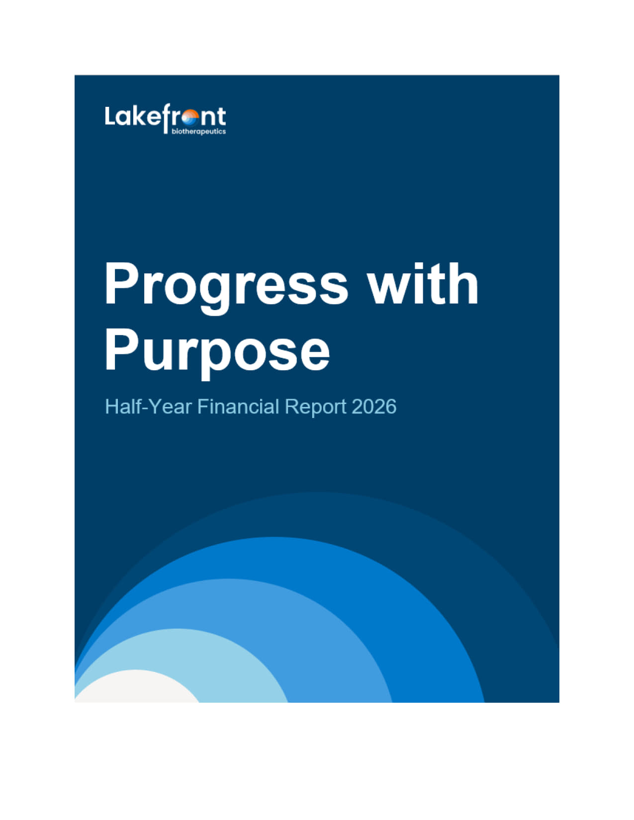 | Half-Year Financial Report 2026
 | 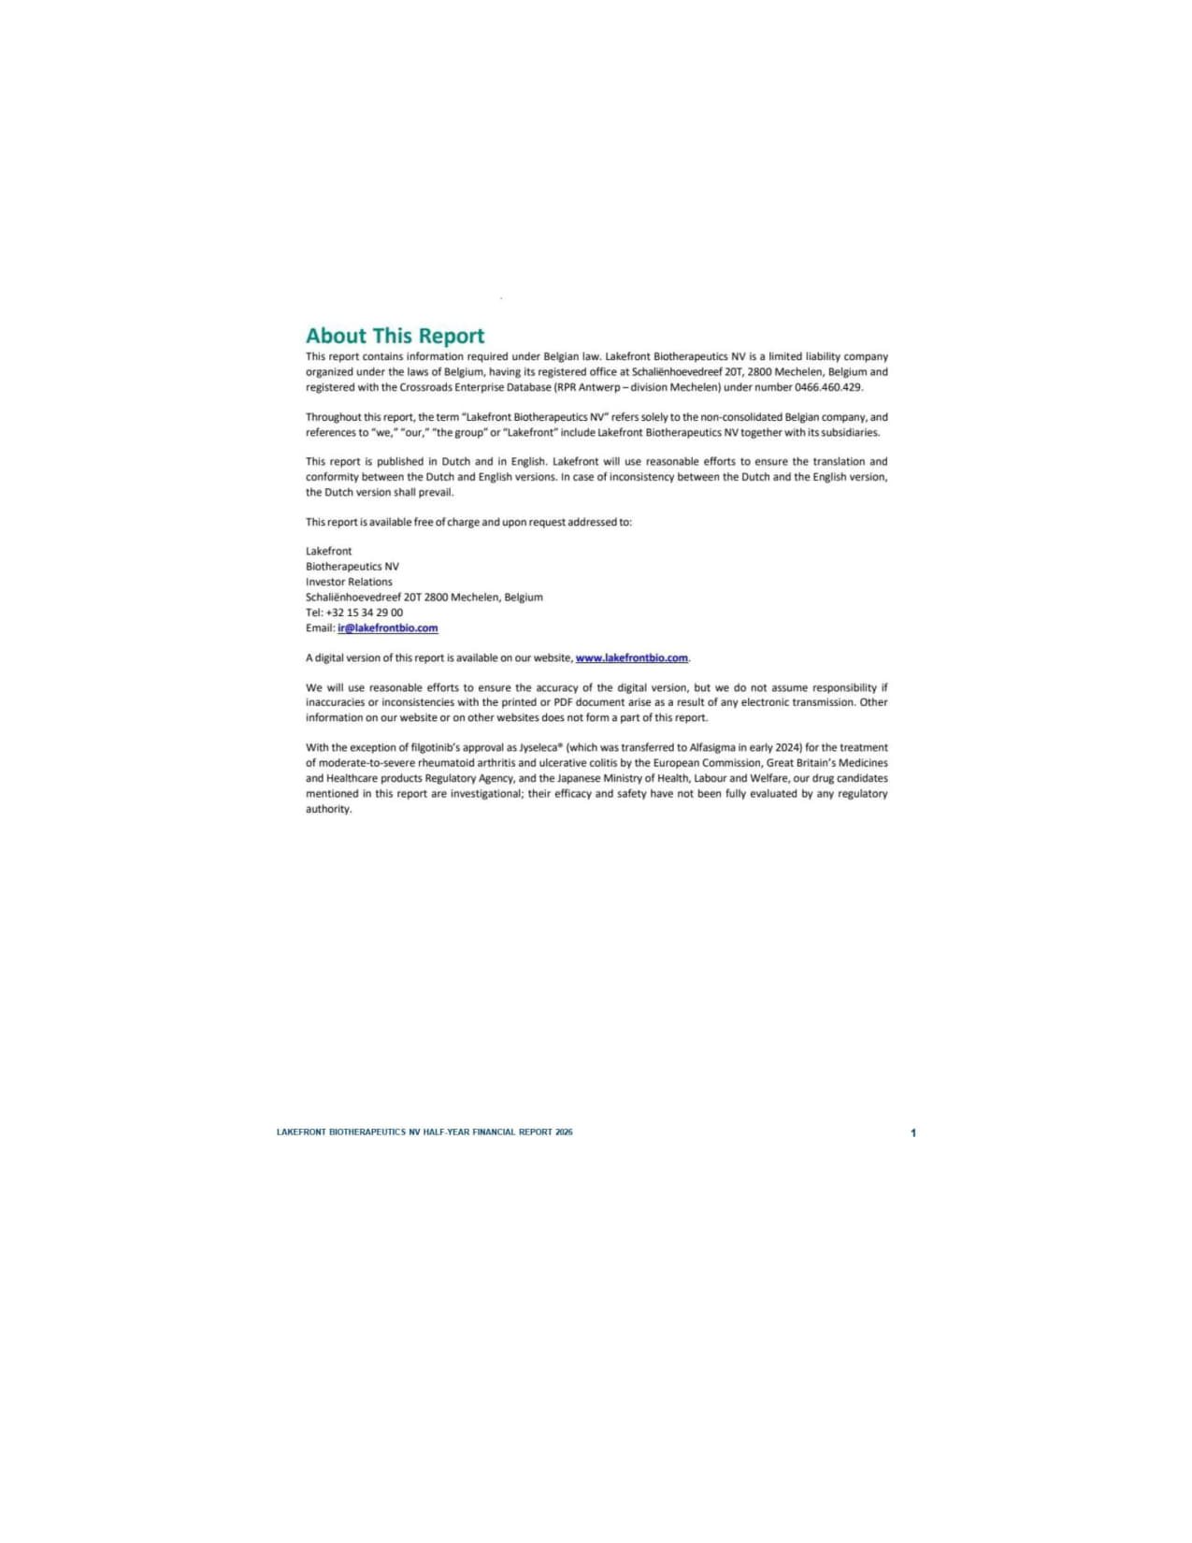 | OTHER INFORMATION 1 Galapagos NV Half-Year Financial Report 2026 ACTIVE/208711980.4 About This Report This report contains information required under Belgian law. Lakefront Biotherapeutics NV is a limited liability company organized under the laws of Belgium, having its registered office at Schaliënhoevedreef 20T, 2800 Mechelen, Belgium and registered with the Crossroads Enterprise Database (RPR Antwerp – division Mechelen) under number 0466.460.429. Throughout this report, the term “Lakefront Biotherapeutics NV” refers solely to the non-consolidated Belgian company, and references to “we,” “our,” “the group” or “Lakefront” include Lakefront Biotherapeutics NV together with itssubsidiaries. This report is published in Dutch and in English. Lakefront will use reasonable efforts to ensure the translation and conformity between the Dutch and English versions. In case of inconsistency between the Dutch and the English version, the Dutch version shall prevail. Thisreport is available free of charge and upon request addressed to: Lakefront Biotherapeutics NV Investor Relations Schaliënhoevedreef 20T 2800 Mechelen, Belgium Tel: +32 15 34 29 00 Email: ir@lakefrontbio.com A digital version of this report is available on our website, www.lakefrontbio.com. We will use reasonable efforts to ensure the accuracy of the digital version, but we do not assume responsibility if inaccuracies or inconsistencies with the printed or PDF document arise as a result of any electronic transmission. Other information on our website or on other websites does not form a part of this report. With the exception of filgotinib’s approval as Jyseleca® (which was transferred to Alfasigma in early 2024) for the treatment of moderate-to-severe rheumatoid arthritis and ulcerative colitis by the European Commission, Great Britain’s Medicines and Healthcare products Regulatory Agency, and the Japanese Ministry of Health, Labour and Welfare, our drug candidates mentioned in this report are investigational; their efficacy and safety have not been fully evaluated by any regulatory authority.
 | 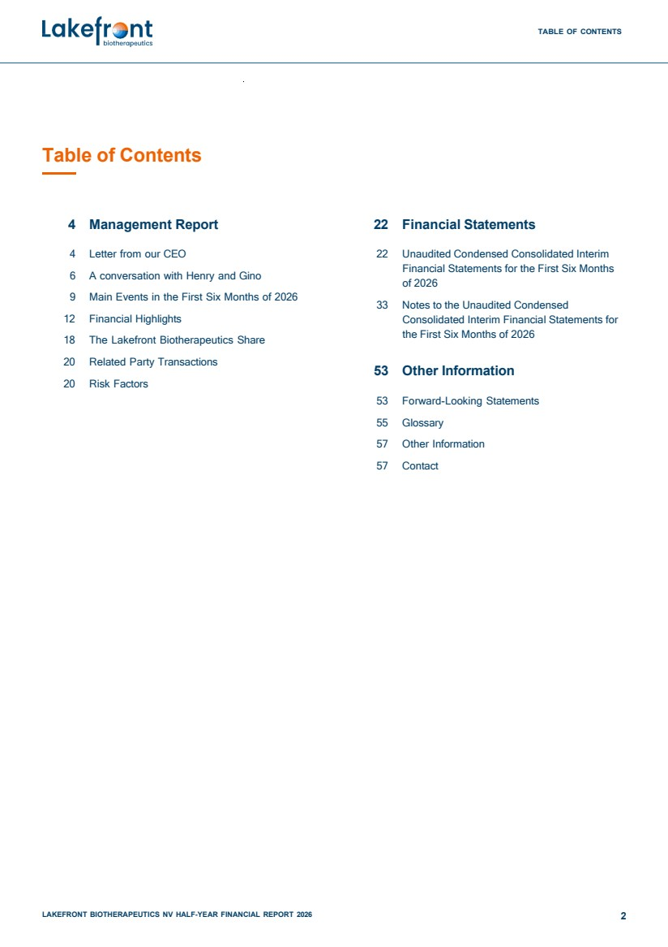 | Table of Contents TABLE OF CONTENTS 4 Management Report 22 Financial Statements 4 Letter from our CEO 6 A conversation with Henry and Gino 9 Main Events in the First Six Months of 2026 12 Financial Highlights 18 The Lakefront Biotherapeutics Share 20 Related Party Transactions 20 Risk Factors 22 Unaudited Condensed Consolidated Interim Financial Statements for the First Six Months of 2026 33 Notes to the Unaudited Condensed Consolidated Interim Financial Statements for the First Six Months of 2026 53 Other Information 53 Forward-Looking Statements 55 Glossary 57 Other Information 57 Contact LAKEFRONT BIOTHERAPEUTICS NV HALF-YEAR FINANCIAL REPORT 2026 2
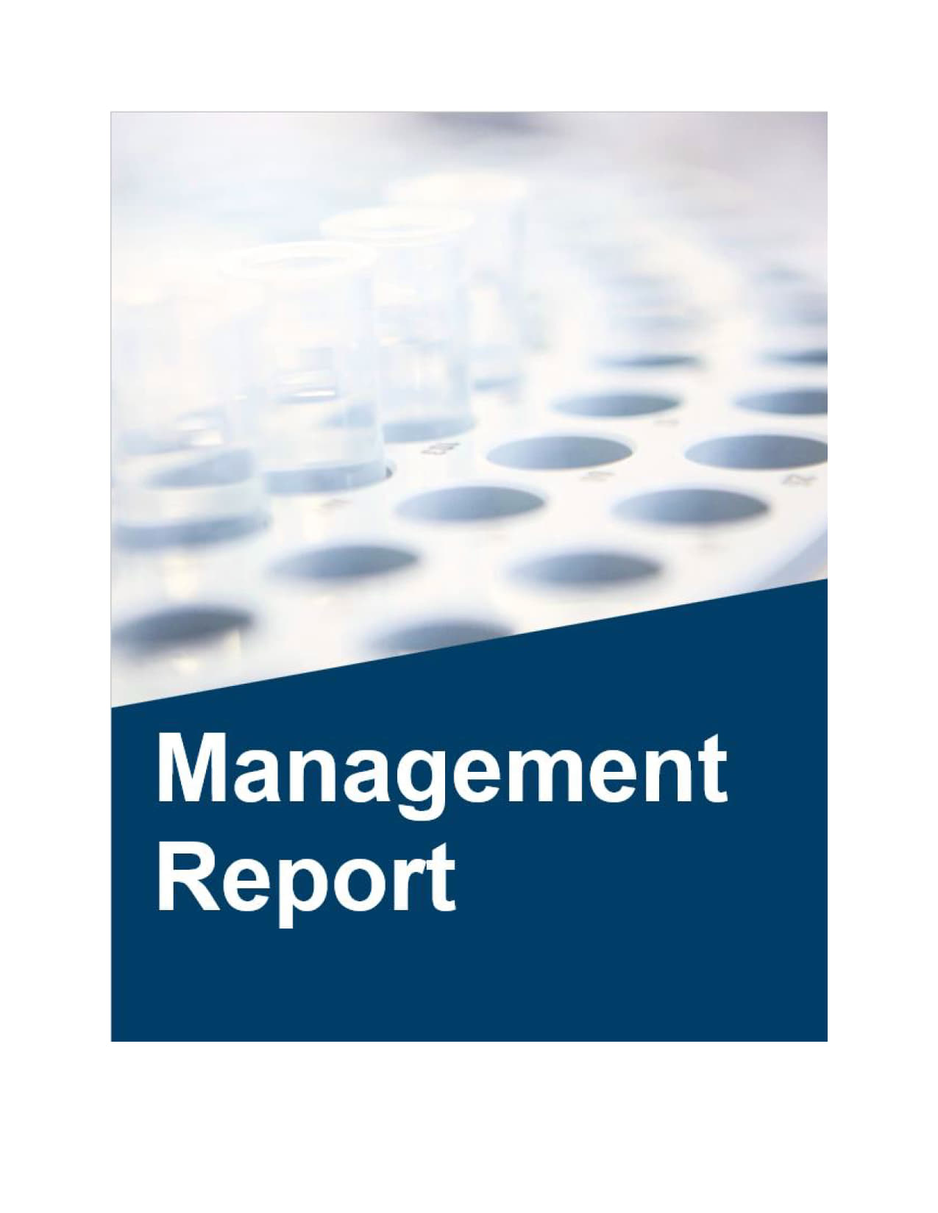
 | 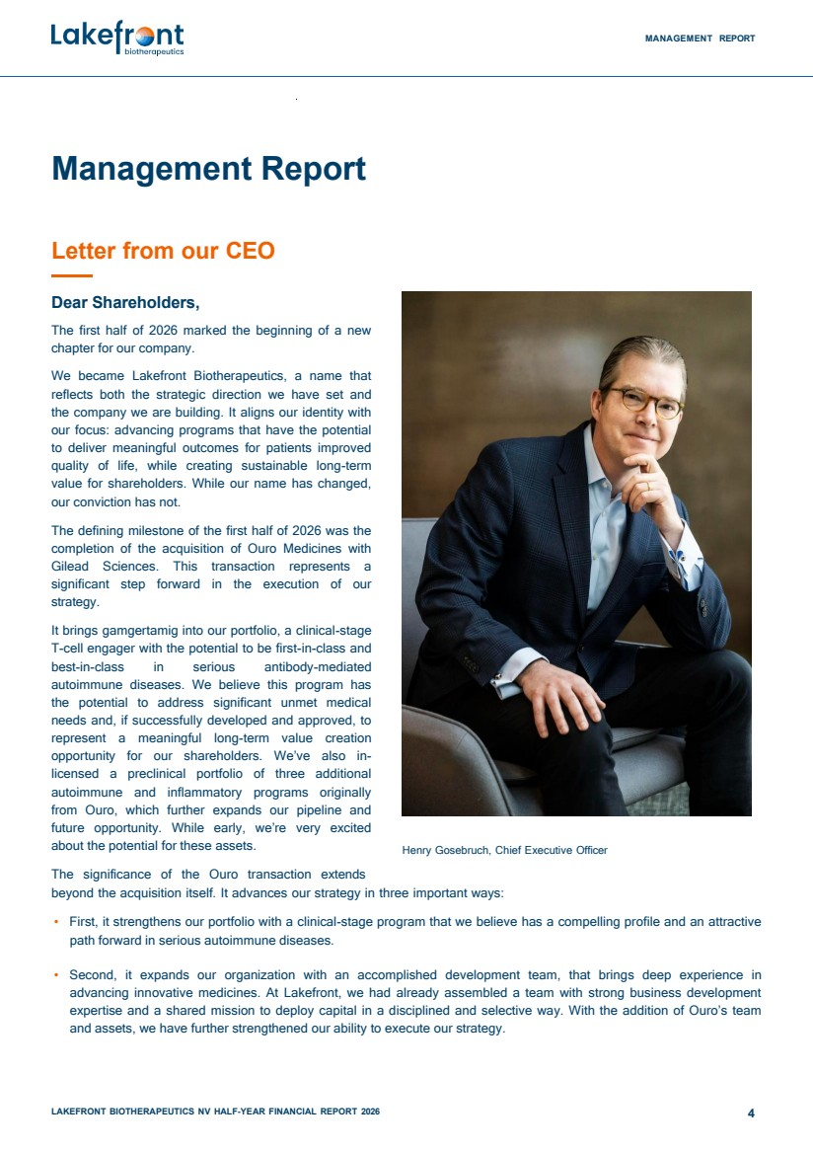 | MANAGEMENT REPORT LAKEFRONT BIOTHERAPEUTICS NV HALF-YEAR FINANCIAL REPORT 2026 4 Management Report Letter from our CEO Dear Shareholders, The first half of 2026 marked the beginning of a new chapter for our company. We became Lakefront Biotherapeutics, a name that reflects both the strategic direction we have set and the company we are building. It aligns our identity with our focus: advancing programs that have the potential to deliver meaningful outcomes for patients improved quality of life, while creating sustainable long-term value for shareholders. While our name has changed, our conviction has not. The defining milestone of the first half of 2026 was the completion of the acquisition of Ouro Medicines with Gilead Sciences. This transaction represents a significant step forward in the execution of our strategy. It brings gamgertamig into our portfolio, a clinical-stage T-cell engager with the potential to be first-in-class and best-in-class in serious antibody-mediated autoimmune diseases. We believe this program has the potential to address significant unmet medical needs and, if successfully developed and approved, to represent a meaningful long-term value creation opportunity for our shareholders. We’ve also in-licensed a preclinical portfolio of three additional autoimmune and inflammatory programs originally from Ouro, which further expands our pipeline and future opportunity. While early, we’re very excited about the potential for these assets. The significance of the Ouro transaction extends Henry Gosebruch, Chief Executive Officer beyond the acquisition itself. It advances our strategy in three important ways: • First, it strengthens our portfolio with a clinical-stage program that we believe has a compelling profile and an attractive path forward in serious autoimmune diseases. • Second, it expands our organization with an accomplished development team, that brings deep experience in advancing innovative medicines. At Lakefront, we had already assembled a team with strong business development expertise and a shared mission to deploy capital in a disciplined and selective way. With the addition of Ouro’s team and assets, we have further strengthened our ability to execute our strategy.
 | 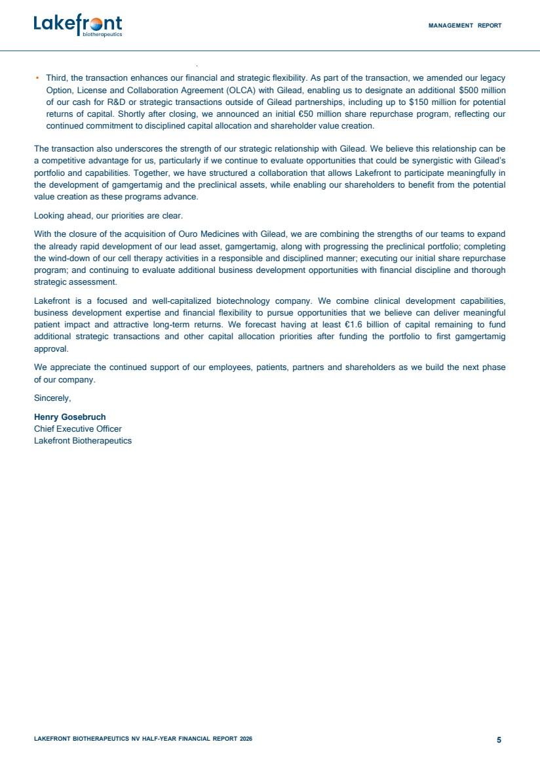 | MANAGEMENT REPORT LAKEFRONT BIOTHERAPEUTICS NV HALF-YEAR FINANCIAL REPORT 2026 5 • Third, the transaction enhances our financial and strategic flexibility. As part of the transaction, we amended our legacy Option, License and Collaboration Agreement (OLCA) with Gilead, enabling us to designate an additional $500 million of our cash for R&D or strategic transactions outside of Gilead partnerships, including up to $150 million for potential returns of capital. Shortly after closing, we announced an initial €50 million share repurchase program, reflecting our continued commitment to disciplined capital allocation and shareholder value creation. The transaction also underscores the strength of our strategic relationship with Gilead. We believe this relationship can be a competitive advantage for us, particularly if we continue to evaluate opportunities that could be synergistic with Gilead’s portfolio and capabilities. Together, we have structured a collaboration that allows Lakefront to participate meaningfully in the development of gamgertamig and the preclinical assets, while enabling our shareholders to benefit from the potential value creation as these programs advance. Looking ahead, our priorities are clear. With the closure of the acquisition of Ouro Medicines with Gilead, we are combining the strengths of our teams to expand the already rapid development of our lead asset, gamgertamig, along with progressing the preclinical portfolio; completing the wind-down of our cell therapy activities in a responsible and disciplined manner; executing our initial share repurchase program; and continuing to evaluate additional business development opportunities with financial discipline and thorough strategic assessment. Lakefront is a focused and well-capitalized biotechnology company. We combine clinical development capabilities, business development expertise and financial flexibility to pursue opportunities that we believe can deliver meaningful patient impact and attractive long-term returns. We forecast having at least €1.6 billion of capital remaining to fund additional strategic transactions and other capital allocation priorities after funding the portfolio to first gamgertamig approval. We appreciate the continued support of our employees, patients, partners and shareholders as we build the next phase of our company. Sincerely, Henry Gosebruch Chief Executive Officer Lakefront Biotherapeutics
 | 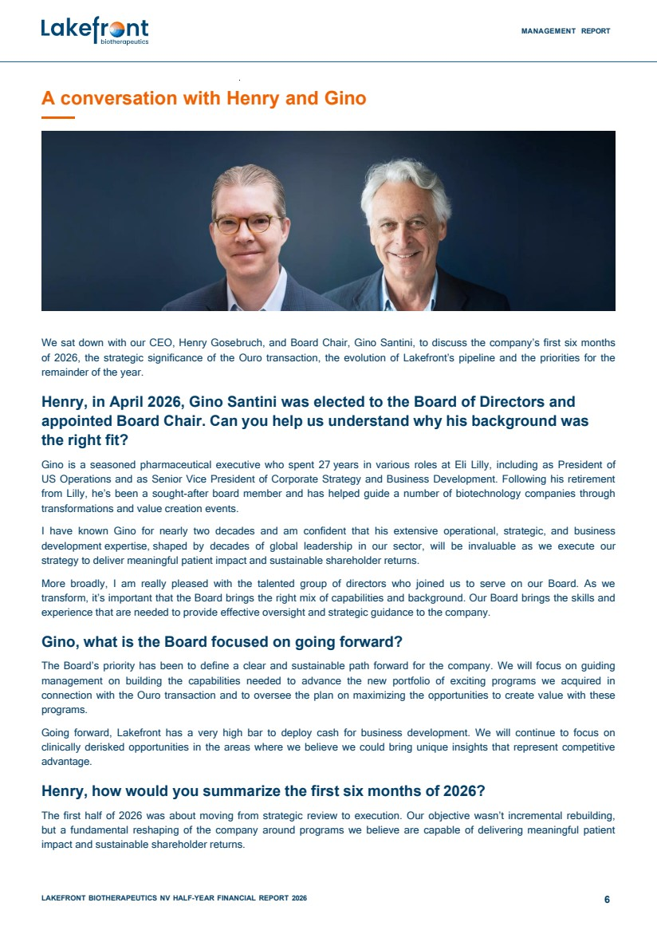 | MANAGEMENT REPORT LAKEFRONT BIOTHERAPEUTICS NV HALF-YEAR FINANCIAL REPORT 2026 6 A conversation with Henry and Gino We sat down with our CEO, Henry Gosebruch, and Board Chair, Gino Santini, to discuss the company’s first six months of 2026, the strategic significance of the Ouro transaction, the evolution of Lakefront’s pipeline and the priorities for the remainder of the year. Henry, in April 2026, Gino Santini was elected to the Board of Directors and appointed Board Chair. Can you help us understand why his background was the right fit? Gino is a seasoned pharmaceutical executive who spent 27 years in various roles at Eli Lilly, including as President of US Operations and as Senior Vice President of Corporate Strategy and Business Development. Following his retirement from Lilly, he’s been a sought-after board member and has helped guide a number of biotechnology companies through transformations and value creation events. I have known Gino for nearly two decades and am confident that his extensive operational, strategic, and business development expertise, shaped by decades of global leadership in our sector, will be invaluable as we execute our strategy to deliver meaningful patient impact and sustainable shareholder returns. More broadly, I am really pleased with the talented group of directors who joined us to serve on our Board. As we transform, it’s important that the Board brings the right mix of capabilities and background. Our Board brings the skills and experience that are needed to provide effective oversight and strategic guidance to the company. Gino, what is the Board focused on going forward? The Board’s priority has been to define a clear and sustainable path forward for the company. We will focus on guiding management on building the capabilities needed to advance the new portfolio of exciting programs we acquired in connection with the Ouro transaction and to oversee the plan on maximizing the opportunities to create value with these programs. Going forward, Lakefront has a very high bar to deploy cash for business development. We will continue to focus on clinically derisked opportunities in the areas where we believe we could bring unique insights that represent competitive advantage. Henry, how would you summarize the first six months of 2026? The first half of 2026 was about moving from strategic review to execution. Our objective wasn’t incremental rebuilding, but a fundamental reshaping of the company around programs we believe are capable of delivering meaningful patient impact and sustainable shareholder returns.
 | 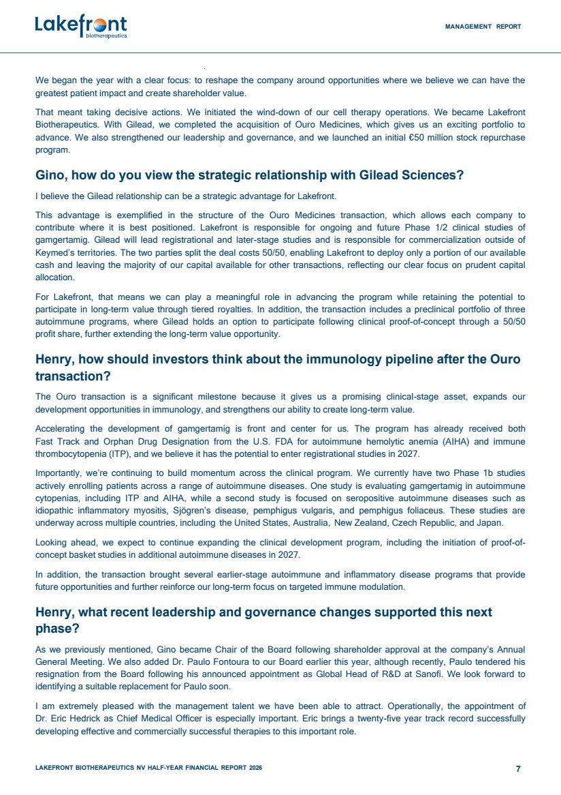 | MANAGEMENT REPORT LAKEFRONT BIOTHERAPEUTICS NV HALF-YEAR FINANCIAL REPORT 2026 7 We began the year with a clear focus: to reshape the company around opportunities where we believe we can have the greatest patient impact and create shareholder value. That meant taking decisive actions. We initiated the wind-down of our cell therapy operations. We became Lakefront Biotherapeutics. With Gilead, we completed the acquisition of Ouro Medicines, which gives us an exciting portfolio to advance. We also strengthened our leadership and governance, and we launched an initial €50 million stock repurchase program. Gino, how do you view the strategic relationship with Gilead Sciences? I believe the Gilead relationship can be a strategic advantage for Lakefront. This advantage is exemplified in the structure of the Ouro Medicines transaction, which allows each company to contribute where it is best positioned. Lakefront is responsible for ongoing and future Phase 1/2 clinical studies of gamgertamig. Gilead will lead registrational and later-stage studies and is responsible for commercialization outside of Keymed’s territories. The two parties split the deal costs 50/50, enabling Lakefront to deploy only a portion of our available cash and leaving the majority of our capital available for other transactions, reflecting our clear focus on prudent capital allocation. For Lakefront, that means we can play a meaningful role in advancing the program while retaining the potential to participate in long-term value through tiered royalties. In addition, the transaction includes a preclinical portfolio of three autoimmune programs, where Gilead holds an option to participate following clinical proof-of-concept through a 50/50 profit share, further extending the long-term value opportunity. Henry, how should investors think about the immunology pipeline after the Ouro transaction? The Ouro transaction is a significant milestone because it gives us a promising clinical-stage asset, expands our development opportunities in immunology, and strengthens our ability to create long-term value. Accelerating the development of gamgertamig is front and center for us. The program has already received both Fast Track and Orphan Drug Designation from the U.S. FDA for autoimmune hemolytic anemia (AIHA) and immune thrombocytopenia (ITP), and we believe it has the potential to enter registrational studies in 2027. Importantly, we’re continuing to build momentum across the clinical program. We currently have two Phase 1b studies actively enrolling patients across a range of autoimmune diseases. One study is evaluating gamgertamig in autoimmune cytopenias, including ITP and AIHA, while a second study is focused on seropositive autoimmune diseases such as idiopathic inflammatory myositis, Sjögren’s disease, pemphigus vulgaris, and pemphigus foliaceus. These studies are underway across multiple countries, including the United States, Australia, New Zealand, Czech Republic, and Japan. Looking ahead, we expect to continue expanding the clinical development program, including the initiation of proof-of-concept basket studies in additional autoimmune diseases in 2027. In addition, the transaction brought several earlier-stage autoimmune and inflammatory disease programs that provide future opportunities and further reinforce our long-term focus on targeted immune modulation. Henry, what recent leadership and governance changes supported this next phase? As we previously mentioned, Gino became Chair of the Board following shareholder approval at the company’s Annual General Meeting. We also added Dr. Paulo Fontoura to our Board earlier this year, although recently, Paulo tendered his resignation from the Board following his announced appointment as Global Head of R&D at Sanofi. We look forward to identifying a suitable replacement for Paulo soon. I am extremely pleased with the management talent we have been able to attract. Operationally, the appointment of Dr. Eric Hedrick as Chief Medical Officer is especially important. Eric brings a twenty-five year track record successfully developing effective and commercially successful therapies to this important role.
 | 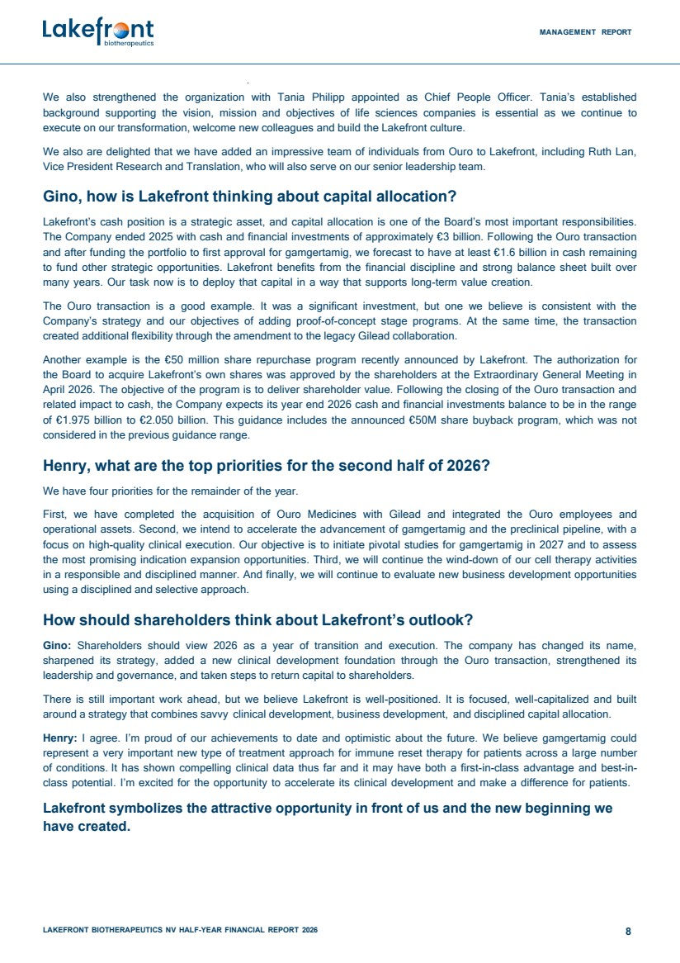 | MANAGEMENT REPORT LAKEFRONT BIOTHERAPEUTICS NV HALF-YEAR FINANCIAL REPORT 2026 8 We also strengthened the organization with Tania Philipp appointed as Chief People Officer. Tania’s established background supporting the vision, mission and objectives of life sciences companies is essential as we continue to execute on our transformation, welcome new colleagues and build the Lakefront culture. We also are delighted that we have added an impressive team of individuals from Ouro to Lakefront, including Ruth Lan, Vice President Research and Translation, who will also serve on our senior leadership team. Gino, how is Lakefront thinking about capital allocation? Lakefront’s cash position is a strategic asset, and capital allocation is one of the Board’s most important responsibilities. The Company ended 2025 with cash and financial investments of approximately €3 billion. Following the Ouro transaction and after funding the portfolio to first approval for gamgertamig, we forecast to have at least €1.6 billion in cash remaining to fund other strategic opportunities. Lakefront benefits from the financial discipline and strong balance sheet built over many years. Our task now is to deploy that capital in a way that supports long-term value creation. The Ouro transaction is a good example. It was a significant investment, but one we believe is consistent with the Company’s strategy and our objectives of adding proof-of-concept stage programs. At the same time, the transaction created additional flexibility through the amendment to the legacy Gilead collaboration. Another example is the €50 million share repurchase program recently announced by Lakefront. The authorization for the Board to acquire Lakefront’s own shares was approved by the shareholders at the Extraordinary General Meeting in April 2026. The objective of the program is to deliver shareholder value. Following the closing of the Ouro transaction and related impact to cash, the Company expects its year end 2026 cash and financial investments balance to be in the range of €1.975 billion to €2.050 billion. This guidance includes the announced €50M share buyback program, which was not considered in the previous guidance range. Henry, what are the top priorities for the second half of 2026? We have four priorities for the remainder of the year. First, we have completed the acquisition of Ouro Medicines with Gilead and integrated the Ouro employees and operational assets. Second, we intend to accelerate the advancement of gamgertamig and the preclinical pipeline, with a focus on high-quality clinical execution. Our objective is to initiate pivotal studies for gamgertamig in 2027 and to assess the most promising indication expansion opportunities. Third, we will continue the wind-down of our cell therapy activities in a responsible and disciplined manner. And finally, we will continue to evaluate new business development opportunities using a disciplined and selective approach. How should shareholders think about Lakefront’s outlook? Gino: Shareholders should view 2026 as a year of transition and execution. The company has changed its name, sharpened its strategy, added a new clinical development foundation through the Ouro transaction, strengthened its leadership and governance, and taken steps to return capital to shareholders. There is still important work ahead, but we believe Lakefront is well-positioned. It is focused, well-capitalized and built around a strategy that combines savvy clinical development, business development, and disciplined capital allocation. Henry: I agree. I’m proud of our achievements to date and optimistic about the future. We believe gamgertamig could represent a very important new type of treatment approach for immune reset therapy for patients across a large number of conditions. It has shown compelling clinical data thus far and it may have both a first-in-class advantage and best-in-class potential. I’m excited for the opportunity to accelerate its clinical development and make a difference for patients. Lakefront symbolizes the attractive opportunity in front of us and the new beginning we have created.
 | 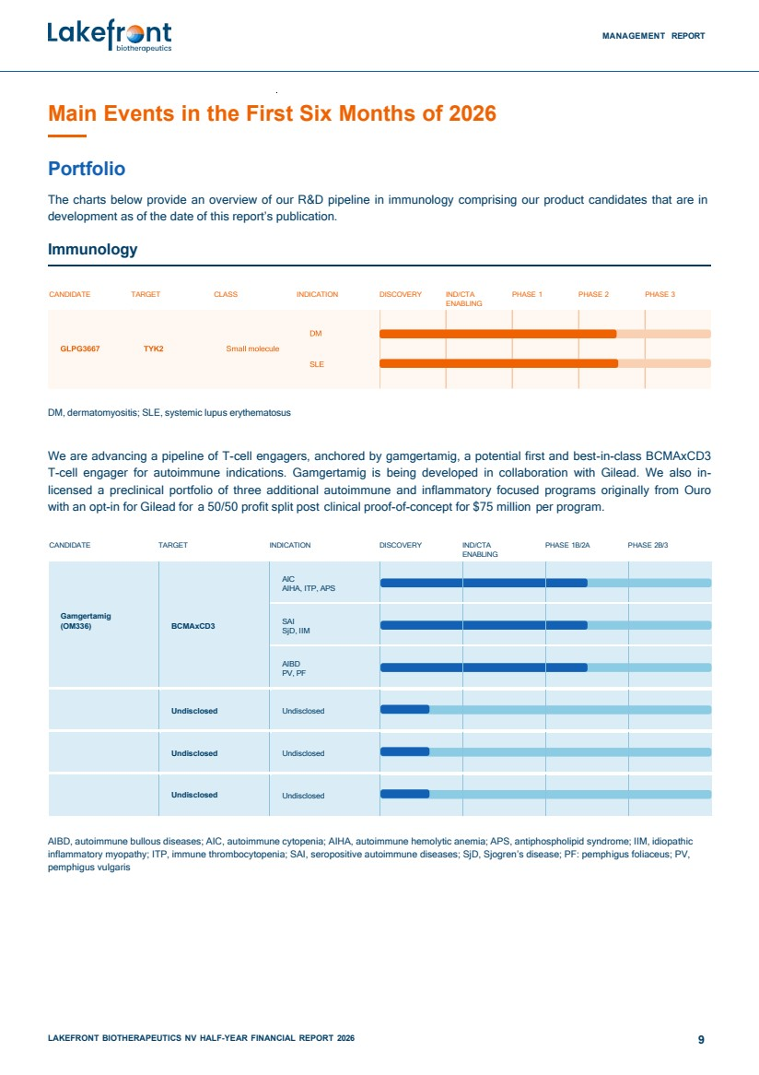 | MANAGEMENT REPORT LAKEFRONT BIOTHERAPEUTICS NV HALF-YEAR FINANCIAL REPORT 2026 9 Main Events in the First Six Months of 2026 Portfolio The charts below provide an overview of our R&D pipeline in immunology comprising our product candidates that are in development as of the date of this report’s publication. Immunology CANDIDATE TARGET CLASS INDICATION DISCOVERY IND/CTA ENABLING PHASE 1 PHASE 2 PHASE 3 DM, dermatomyositis; SLE, systemic lupus erythematosus We are advancing a pipeline of T-cell engagers, anchored by gamgertamig, a potential first and best-in-class BCMAxCD3 T-cell engager for autoimmune indications. Gamgertamig is being developed in collaboration with Gilead. We also in-licensed a preclinical portfolio of three additional autoimmune and inflammatory focused programs originally from Ouro with an opt-in for Gilead for a 50/50 profit split post clinical proof-of-concept for $75 million per program. CANDIDATE TARGET INDICATION DISCOVERY IND/CTA ENABLING PHASE 1B/2A PHASE 2B/3 Gamgertamig (OM336) BCMAxCD3 AIC AIHA, ITP, APS SAI SjD, IIM AIBD PV, PF Undisclosed Undisclosed Undisclosed Undisclosed Undisclosed Undisclosed AIBD, autoimmune bullous diseases; AIC, autoimmune cytopenia; AIHA, autoimmune hemolytic anemia; APS, antiphospholipid syndrome; IIM, idiopathic inflammatory myopathy; ITP, immune thrombocytopenia; SAI, seropositive autoimmune diseases; SjD, Sjogren’s disease; PF: pemphigus foliaceus; PV, pemphigus vulgaris
 | 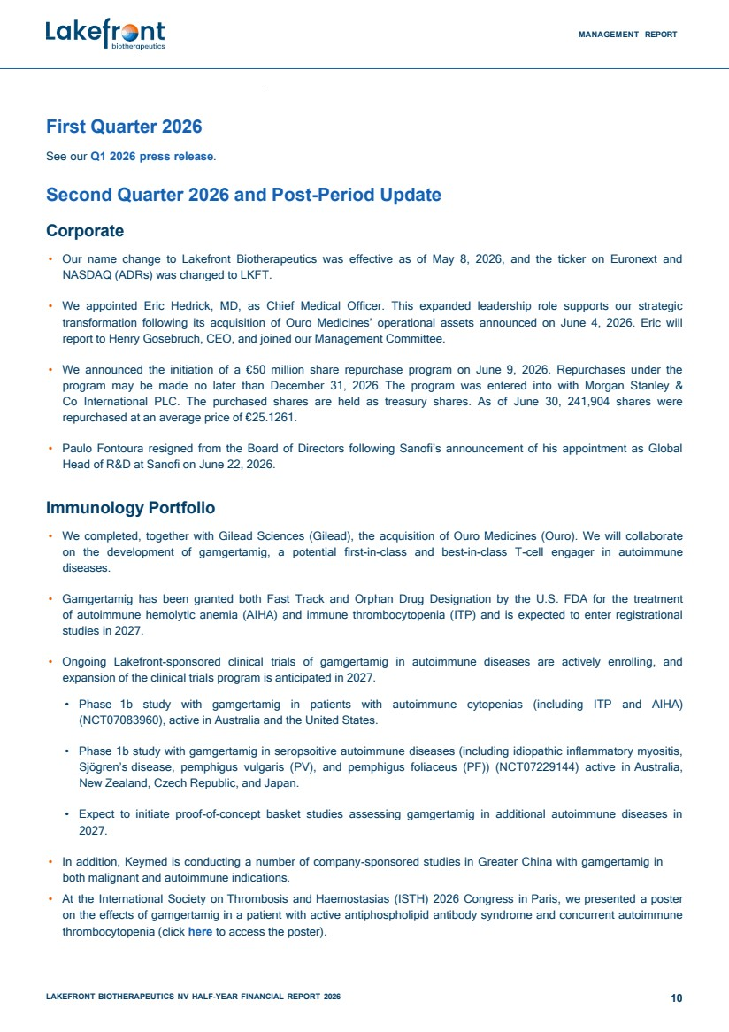 | MANAGEMENT REPORT LAKEFRONT BIOTHERAPEUTICS NV HALF-YEAR FINANCIAL REPORT 2026 10 First Quarter 2026 See our Q1 2026 press release. Second Quarter 2026 and Post-Period Update Corporate • Our name change to Lakefront Biotherapeutics was effective as of May 8, 2026, and the ticker on Euronext and NASDAQ (ADRs) was changed to LKFT. • We appointed Eric Hedrick, MD, as Chief Medical Officer. This expanded leadership role supports our strategic transformation following its acquisition of Ouro Medicines’ operational assets announced on June 4, 2026. Eric will report to Henry Gosebruch, CEO, and joined our Management Committee. • We announced the initiation of a €50 million share repurchase program on June 9, 2026. Repurchases under the program may be made no later than December 31, 2026. The program was entered into with Morgan Stanley & Co International PLC. The purchased shares are held as treasury shares. As of June 30, 241,904 shares were repurchased at an average price of €25.1261. • Paulo Fontoura resigned from the Board of Directors following Sanofi’s announcement of his appointment as Global Head of R&D at Sanofi on June 22, 2026. Immunology Portfolio • We completed, together with Gilead Sciences (Gilead), the acquisition of Ouro Medicines (Ouro). We will collaborate on the development of gamgertamig, a potential first-in-class and best-in-class T-cell engager in autoimmune diseases. • Gamgertamig has been granted both Fast Track and Orphan Drug Designation by the U.S. FDA for the treatment of autoimmune hemolytic anemia (AIHA) and immune thrombocytopenia (ITP) and is expected to enter registrational studies in 2027. • Ongoing Lakefront-sponsored clinical trials of gamgertamig in autoimmune diseases are actively enrolling, and expansion of the clinical trials program is anticipated in 2027. • Phase 1b study with gamgertamig in patients with autoimmune cytopenias (including ITP and AIHA) (NCT07083960), active in Australia and the United States. • Phase 1b study with gamgertamig in seropsoitive autoimmune diseases (including idiopathic inflammatory myositis, Sjögren’s disease, pemphigus vulgaris (PV), and pemphigus foliaceus (PF)) (NCT07229144) active in Australia, New Zealand, Czech Republic, and Japan. • Expect to initiate proof-of-concept basket studies assessing gamgertamig in additional autoimmune diseases in 2027. • In addition, Keymed is conducting a number of company-sponsored studies in Greater China with gamgertamig in both malignant and autoimmune indications. • At the International Society on Thrombosis and Haemostasias (ISTH) 2026 Congress in Paris, we presented a poster on the effects of gamgertamig in a patient with active antiphospholipid antibody syndrome and concurrent autoimmune thrombocytopenia (click here to access the poster).
 | 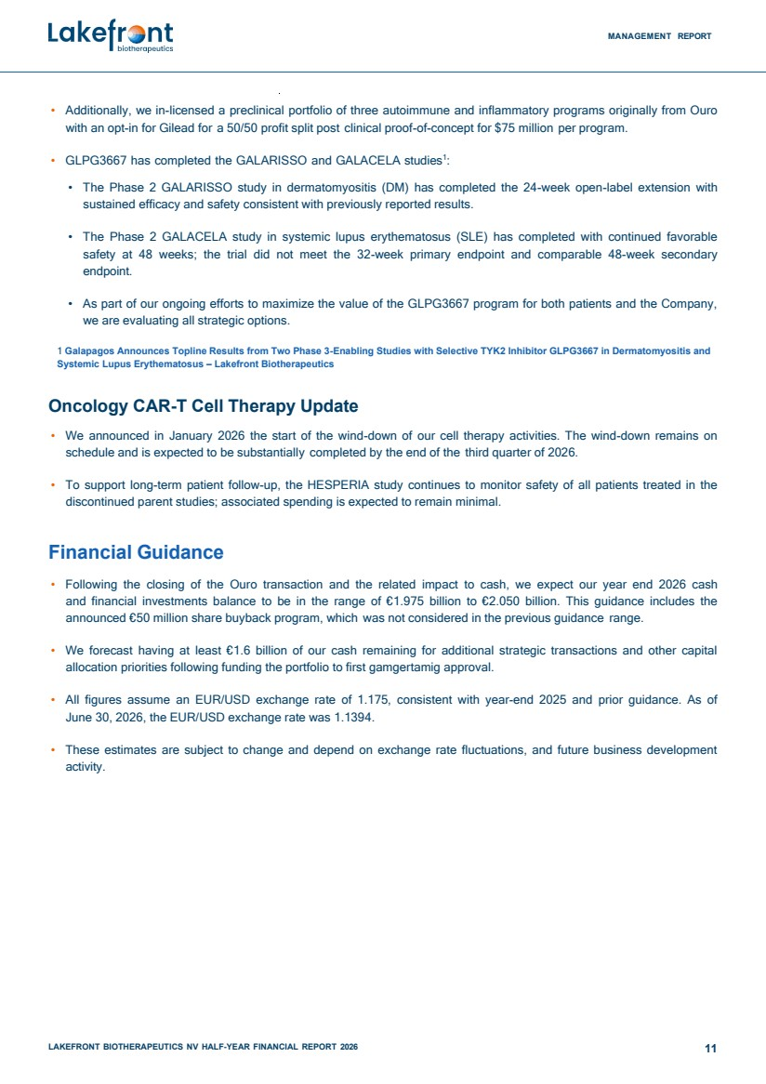 | MANAGEMENT REPORT LAKEFRONT BIOTHERAPEUTICS NV HALF-YEAR FINANCIAL REPORT 2026 11 • Additionally, we in-licensed a preclinical portfolio of three autoimmune and inflammatory programs originally from Ouro with an opt-in for Gilead for a 50/50 profit split post clinical proof-of-concept for $75 million per program. • GLPG3667 has completed the GALARISSO and GALACELA studies1 : • The Phase 2 GALARISSO study in dermatomyositis (DM) has completed the 24-week open-label extension with sustained efficacy and safety consistent with previously reported results. • The Phase 2 GALACELA study in systemic lupus erythematosus (SLE) has completed with continued favorable safety at 48 weeks; the trial did not meet the 32-week primary endpoint and comparable 48-week secondary endpoint. • As part of our ongoing efforts to maximize the value of the GLPG3667 program for both patients and the Company, we are evaluating all strategic options. 1 Galapagos Announces Topline Results from Two Phase 3-Enabling Studies with Selective TYK2 Inhibitor GLPG3667 in Dermatomyositis and Systemic Lupus Erythematosus – Lakefront Biotherapeutics Oncology CAR-T Cell Therapy Update • We announced in January 2026 the start of the wind-down of our cell therapy activities. The wind-down remains on schedule and is expected to be substantially completed by the end of the third quarter of 2026. • To support long-term patient follow-up, the HESPERIA study continues to monitor safety of all patients treated in the discontinued parent studies; associated spending is expected to remain minimal. Financial Guidance • Following the closing of the Ouro transaction and the related impact to cash, we expect our year end 2026 cash and financial investments balance to be in the range of €1.975 billion to €2.050 billion. This guidance includes the announced €50 million share buyback program, which was not considered in the previous guidance range. • We forecast having at least €1.6 billion of our cash remaining for additional strategic transactions and other capital allocation priorities following funding the portfolio to first gamgertamig approval. • All figures assume an EUR/USD exchange rate of 1.175, consistent with year-end 2025 and prior guidance. As of June 30, 2026, the EUR/USD exchange rate was 1.1394. • These estimates are subject to change and depend on exchange rate fluctuations, and future business development activity.
 | 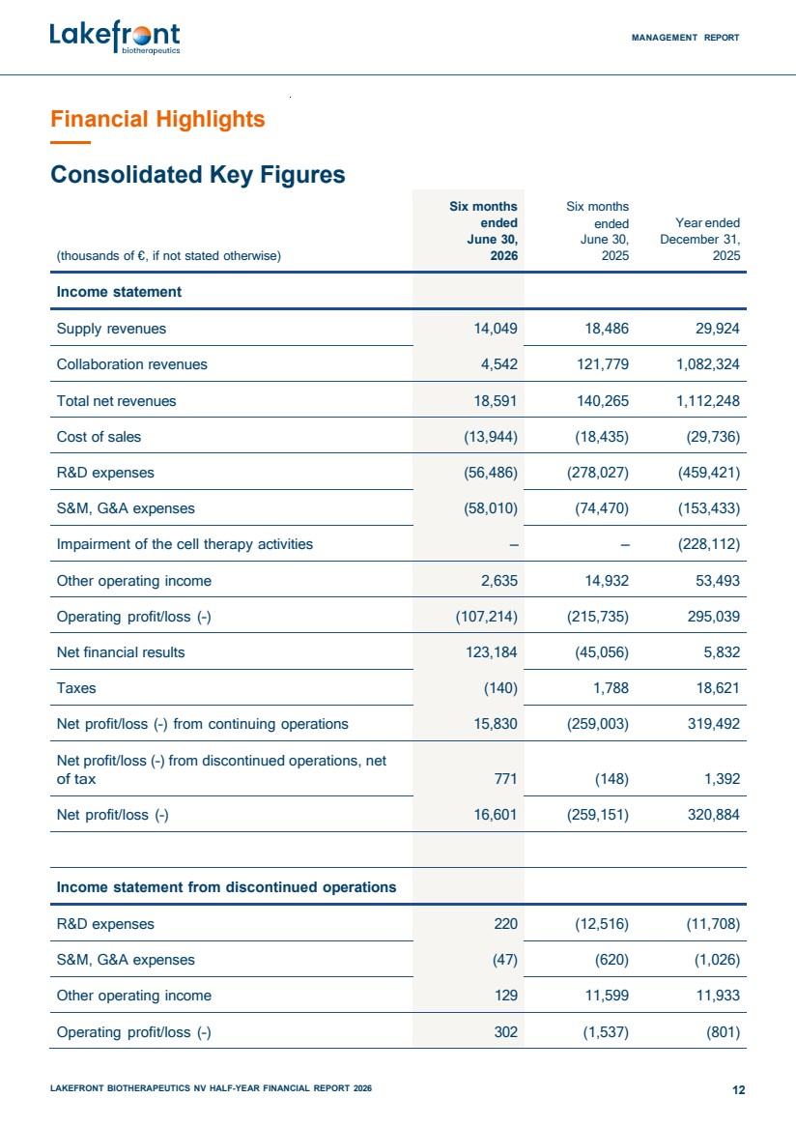 | MANAGEMENT REPORT LAKEFRONT BIOTHERAPEUTICS NV HALF-YEAR FINANCIAL REPORT 2026 12 Financial Highlights Consolidated Key Figures (thousands of €, if not stated otherwise) Six months ended June 30, 2026 Six months ended June 30, 2025 Year ended December 31, 2025 Income statement Supply revenues 14,049 18,486 29,924 Collaboration revenues 4,542 121,779 1,082,324 Total net revenues 18,591 140,265 1,112,248 Cost of sales (13,944) (18,435) (29,736) R&D expenses (56,486) (278,027) (459,421) S&M, G&A expenses (58,010) (74,470) (153,433) Impairment of the cell therapy activities – – (228,112) Other operating income 2,635 14,932 53,493 Operating profit/loss (–) (107,214) (215,735) 295,039 Net financial results 123,184 (45,056) 5,832 Taxes (140) 1,788 18,621 Net profit/loss (–) from continuing operations 15,830 (259,003) 319,492 Net profit/loss (–) from discontinued operations, net of tax 771 (148) 1,392 Net profit/loss (–) 16,601 (259,151) 320,884 Income statement from discontinued operations R&D expenses 220 (12,516) (11,708) S&M, G&A expenses (47) (620) (1,026) Other operating income 129 11,599 11,933 Operating profit/loss (–) 302 (1,537) (801)
 | 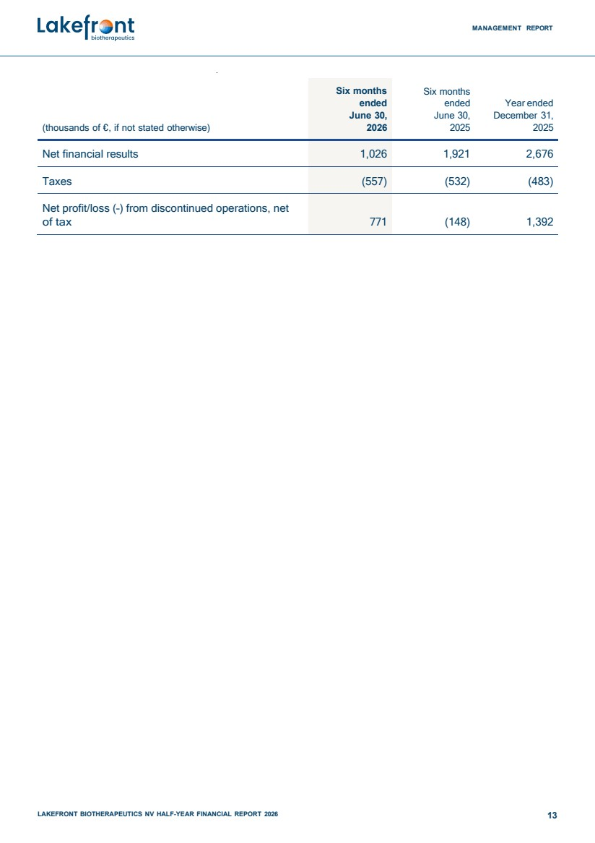 | MANAGEMENT REPORT LAKEFRONT BIOTHERAPEUTICS NV HALF-YEAR FINANCIAL REPORT 2026 13 (thousands of €, if not stated otherwise) Six months ended June 30, 2026 Six months ended June 30, 2025 Year ended December 31, 2025 Net financial results 1,026 1,921 2,676 Taxes (557) (532) (483) Net profit/loss (–) from discontinued operations, net of tax 771 (148) 1,392
 | 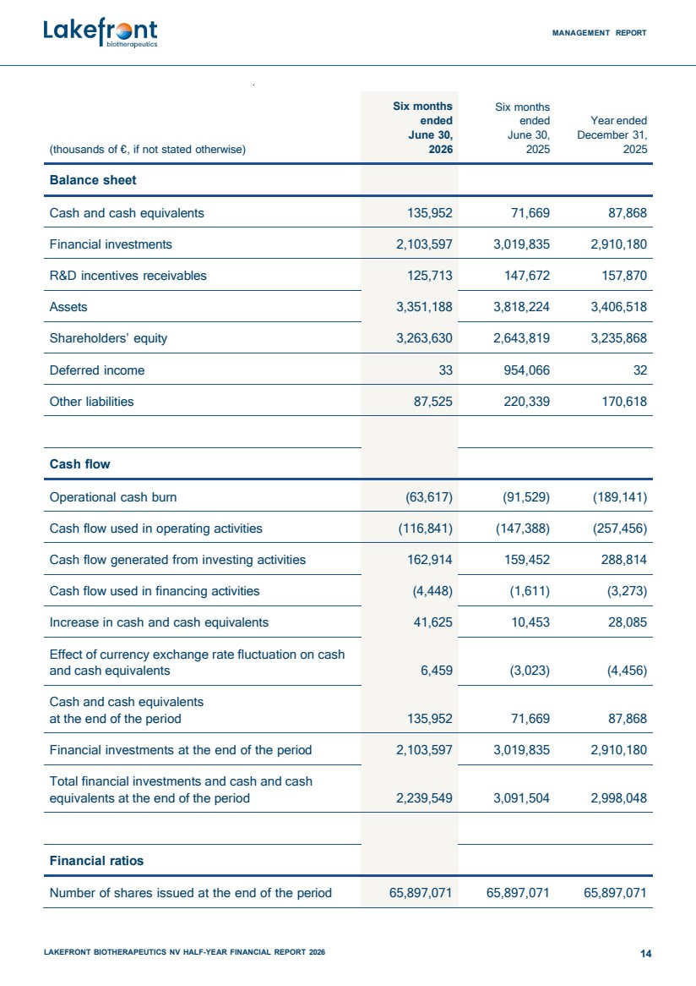 | MANAGEMENT REPORT LAKEFRONT BIOTHERAPEUTICS NV HALF-YEAR FINANCIAL REPORT 2026 14 (thousands of €, if not stated otherwise) Six months ended June 30, 2026 Six months ended June 30, 2025 Year ended December 31, 2025 Balance sheet Cash and cash equivalents 135,952 71,669 87,868 Financial investments 2,103,597 3,019,835 2,910,180 R&D incentives receivables 125,713 147,672 157,870 Assets 3,351,188 3,818,224 3,406,518 Shareholders’ equity 3,263,630 2,643,819 3,235,868 Deferred income 33 954,066 32 Other liabilities 87,525 220,339 170,618 Cash flow Operational cash burn (63,617) (91,529) (189,141) Cash flow used in operating activities (116,841) (147,388) (257,456) Cash flow generated from investing activities 162,914 159,452 288,814 Cash flow used in financing activities (4,448) (1,611) (3,273) Increase in cash and cash equivalents 41,625 10,453 28,085 Effect of currency exchange rate fluctuation on cash and cash equivalents 6,459 (3,023) (4,456) Cash and cash equivalents at the end of the period 135,952 71,669 87,868 Financial investments at the end of the period 2,103,597 3,019,835 2,910,180 Total financial investments and cash and cash equivalents at the end of the period 2,239,549 3,091,504 2,998,048 Financial ratios Number of shares issued at the end of the period 65,897,071 65,897,071 65,897,071
 | 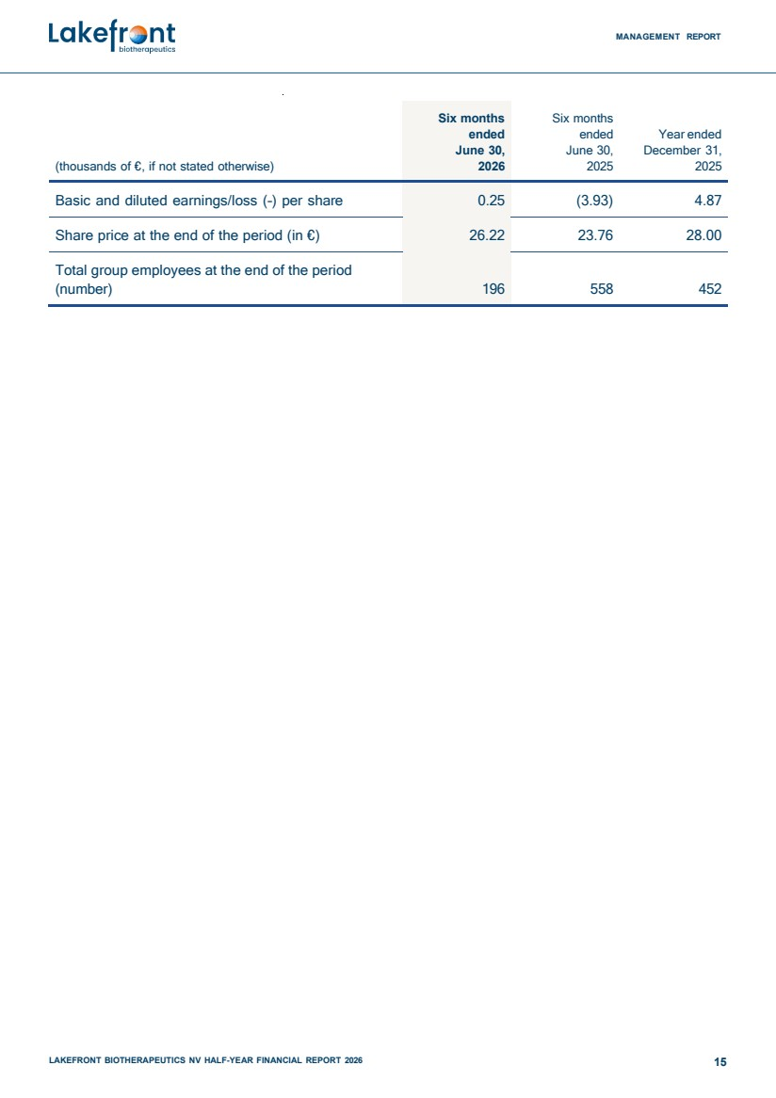 | MANAGEMENT REPORT LAKEFRONT BIOTHERAPEUTICS NV HALF-YEAR FINANCIAL REPORT 2026 15 (thousands of €, if not stated otherwise) Six months ended June 30, 2026 Six months ended June 30, 2025 Year ended December 31, 2025 Basic and diluted earnings/loss (–) per share 0.25 (3.93) 4.87 Share price at the end of the period (in €) 26.22 23.76 28.00 Total group employees at the end of the period (number) 196 558 452
 | 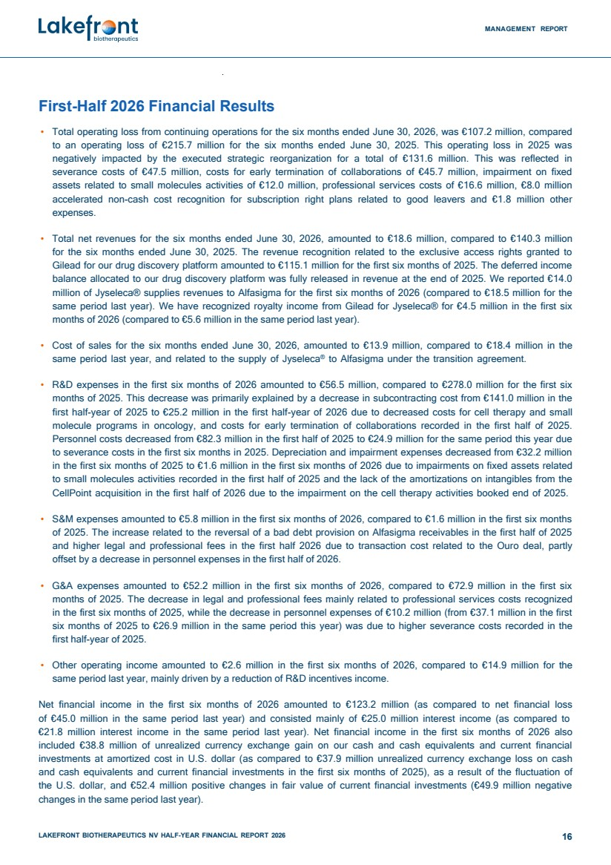 | MANAGEMENT REPORT LAKEFRONT BIOTHERAPEUTICS NV HALF-YEAR FINANCIAL REPORT 2026 16 First-Half 2026 Financial Results • Total operating loss from continuing operations for the six months ended June 30, 2026, was €107.2 million, compared to an operating loss of €215.7 million for the six months ended June 30, 2025. This operating loss in 2025 was negatively impacted by the executed strategic reorganization for a total of €131.6 million. This was reflected in severance costs of €47.5 million, costs for early termination of collaborations of €45.7 million, impairment on fixed assets related to small molecules activities of €12.0 million, professional services costs of €16.6 million, €8.0 million accelerated non-cash cost recognition for subscription right plans related to good leavers and €1.8 million other expenses. • Total net revenues for the six months ended June 30, 2026, amounted to €18.6 million, compared to €140.3 million for the six months ended June 30, 2025. The revenue recognition related to the exclusive access rights granted to Gilead for our drug discovery platform amounted to €115.1 million for the first six months of 2025. The deferred income balance allocated to our drug discovery platform was fully released in revenue at the end of 2025. We reported €14.0 million of Jyseleca® supplies revenues to Alfasigma for the first six months of 2026 (compared to €18.5 million for the same period last year). We have recognized royalty income from Gilead for Jyseleca® for €4.5 million in the first six months of 2026 (compared to €5.6 million in the same period last year). • Cost of sales for the six months ended June 30, 2026, amounted to €13.9 million, compared to €18.4 million in the same period last year, and related to the supply of Jyseleca® to Alfasigma under the transition agreement. • R&D expenses in the first six months of 2026 amounted to €56.5 million, compared to €278.0 million for the first six months of 2025. This decrease was primarily explained by a decrease in subcontracting cost from €141.0 million in the first half-year of 2025 to €25.2 million in the first half-year of 2026 due to decreased costs for cell therapy and small molecule programs in oncology, and costs for early termination of collaborations recorded in the first half of 2025. Personnel costs decreased from €82.3 million in the first half of 2025 to €24.9 million for the same period this year due to severance costs in the first six months in 2025. Depreciation and impairment expenses decreased from €32.2 million in the first six months of 2025 to €1.6 million in the first six months of 2026 due to impairments on fixed assets related to small molecules activities recorded in the first half of 2025 and the lack of the amortizations on intangibles from the CellPoint acquisition in the first half of 2026 due to the impairment on the cell therapy activities booked end of 2025. • S&M expenses amounted to €5.8 million in the first six months of 2026, compared to €1.6 million in the first six months of 2025. The increase related to the reversal of a bad debt provision on Alfasigma receivables in the first half of 2025 and higher legal and professional fees in the first half 2026 due to transaction cost related to the Ouro deal, partly offset by a decrease in personnel expenses in the first half of 2026. • G&A expenses amounted to €52.2 million in the first six months of 2026, compared to €72.9 million in the first six months of 2025. The decrease in legal and professional fees mainly related to professional services costs recognized in the first six months of 2025, while the decrease in personnel expenses of €10.2 million (from €37.1 million in the first six months of 2025 to €26.9 million in the same period this year) was due to higher severance costs recorded in the first half-year of 2025. • Other operating income amounted to €2.6 million in the first six months of 2026, compared to €14.9 million for the same period last year, mainly driven by a reduction of R&D incentives income. Net financial income in the first six months of 2026 amounted to €123.2 million (as compared to net financial loss of €45.0 million in the same period last year) and consisted mainly of €25.0 million interest income (as compared to €21.8 million interest income in the same period last year). Net financial income in the first six months of 2026 also included €38.8 million of unrealized currency exchange gain on our cash and cash equivalents and current financial investments at amortized cost in U.S. dollar (as compared to €37.9 million unrealized currency exchange loss on cash and cash equivalents and current financial investments in the first six months of 2025), as a result of the fluctuation of the U.S. dollar, and €52.4 million positive changes in fair value of current financial investments (€49.9 million negative changes in the same period last year).
 | 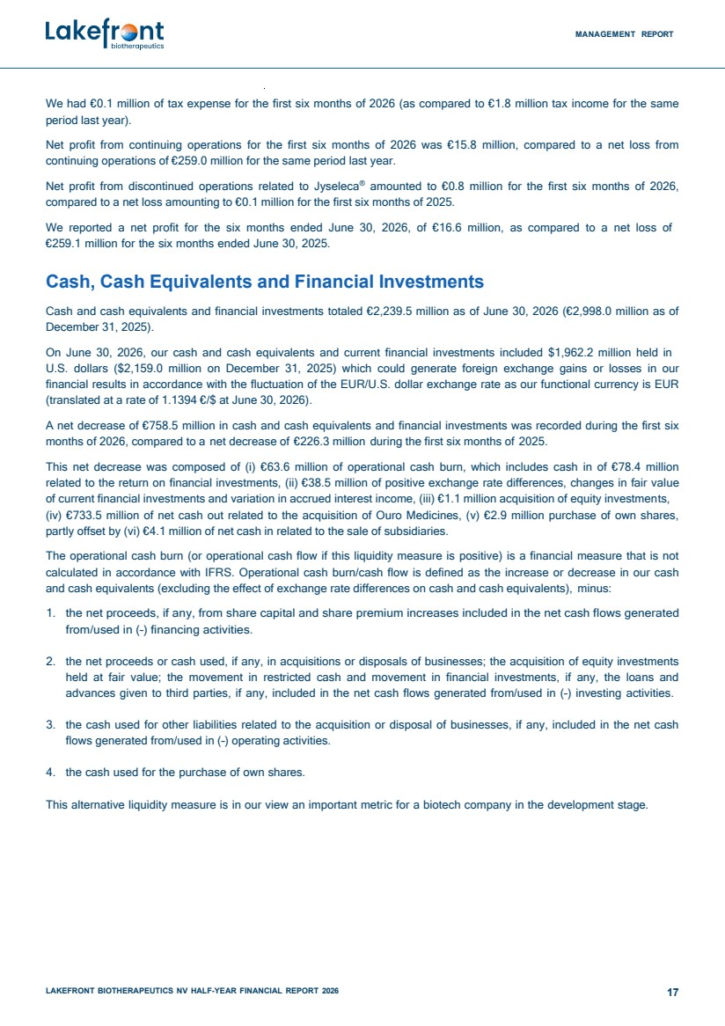 | MANAGEMENT REPORT LAKEFRONT BIOTHERAPEUTICS NV HALF-YEAR FINANCIAL REPORT 2026 17 We had €0.1 million of tax expense for the first six months of 2026 (as compared to €1.8 million tax income for the same period last year). Net profit from continuing operations for the first six months of 2026 was €15.8 million, compared to a net loss from continuing operations of €259.0 million for the same period last year. Net profit from discontinued operations related to Jyseleca® amounted to €0.8 million for the first six months of 2026, compared to a net loss amounting to €0.1 million for the first six months of 2025. We reported a net profit for the six months ended June 30, 2026, of €16.6 million, as compared to a net loss of €259.1 million for the six months ended June 30, 2025. Cash, Cash Equivalents and Financial Investments Cash and cash equivalents and financial investments totaled €2,239.5 million as of June 30, 2026 (€2,998.0 million as of December 31, 2025). On June 30, 2026, our cash and cash equivalents and current financial investments included $1,962.2 million held in U.S. dollars ($2,159.0 million on December 31, 2025) which could generate foreign exchange gains or losses in our financial results in accordance with the fluctuation of the EUR/U.S. dollar exchange rate as our functional currency is EUR (translated at a rate of 1.1394 €/$ at June 30, 2026). A net decrease of €758.5 million in cash and cash equivalents and financial investments was recorded during the first six months of 2026, compared to a net decrease of €226.3 million during the first six months of 2025. This net decrease was composed of (i) €63.6 million of operational cash burn, which includes cash in of €78.4 million related to the return on financial investments, (ii) €38.5 million of positive exchange rate differences, changes in fair value of current financial investments and variation in accrued interest income, (iii) €1.1 million acquisition of equity investments, (iv) €733.5 million of net cash out related to the acquisition of Ouro Medicines, (v) €2.9 million purchase of own shares, partly offset by (vi) €4.1 million of net cash in related to the sale of subsidiaries. The operational cash burn (or operational cash flow if this liquidity measure is positive) is a financial measure that is not calculated in accordance with IFRS. Operational cash burn/cash flow is defined as the increase or decrease in our cash and cash equivalents (excluding the effect of exchange rate differences on cash and cash equivalents), minus: 1. the net proceeds, if any, from share capital and share premium increases included in the net cash flows generated from/used in (–) financing activities. 2. the net proceeds or cash used, if any, in acquisitions or disposals of businesses; the acquisition of equity investments held at fair value; the movement in restricted cash and movement in financial investments, if any, the loans and advances given to third parties, if any, included in the net cash flows generated from/used in (–) investing activities. 3. the cash used for other liabilities related to the acquisition or disposal of businesses, if any, included in the net cash flows generated from/used in (–) operating activities. 4. the cash used for the purchase of own shares. This alternative liquidity measure is in our view an important metric for a biotech company in the development stage.
 | 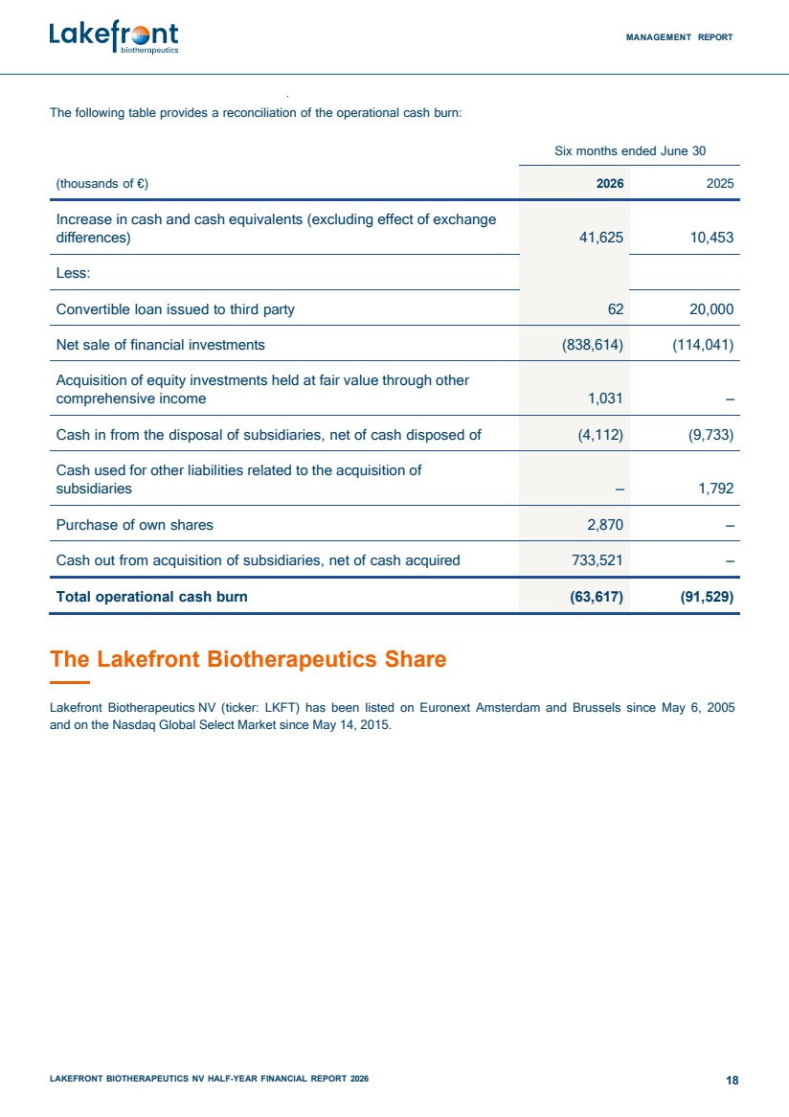 | MANAGEMENT REPORT LAKEFRONT BIOTHERAPEUTICS NV HALF-YEAR FINANCIAL REPORT 2026 18 The following table provides a reconciliation of the operational cash burn: Six months ended June 30 (thousands of €) 2026 2025 Increase in cash and cash equivalents (excluding effect of exchange differences) 41,625 10,453 Less: Convertible loan issued to third party 62 20,000 Net sale of financial investments (838,614) (114,041) Acquisition of equity investments held at fair value through other comprehensive income 1,031 – Cash in from the disposal of subsidiaries, net of cash disposed of (4,112) (9,733) Cash used for other liabilities related to the acquisition of subsidiaries – 1,792 Purchase of own shares 2,870 – Cash out from acquisition of subsidiaries, net of cash acquired 733,521 – Total operational cash burn (63,617) (91,529) The Lakefront Biotherapeutics Share Lakefront Biotherapeutics NV (ticker: LKFT) has been listed on Euronext Amsterdam and Brussels since May 6, 2005 and on the Nasdaq Global Select Market since May 14, 2015.
 | 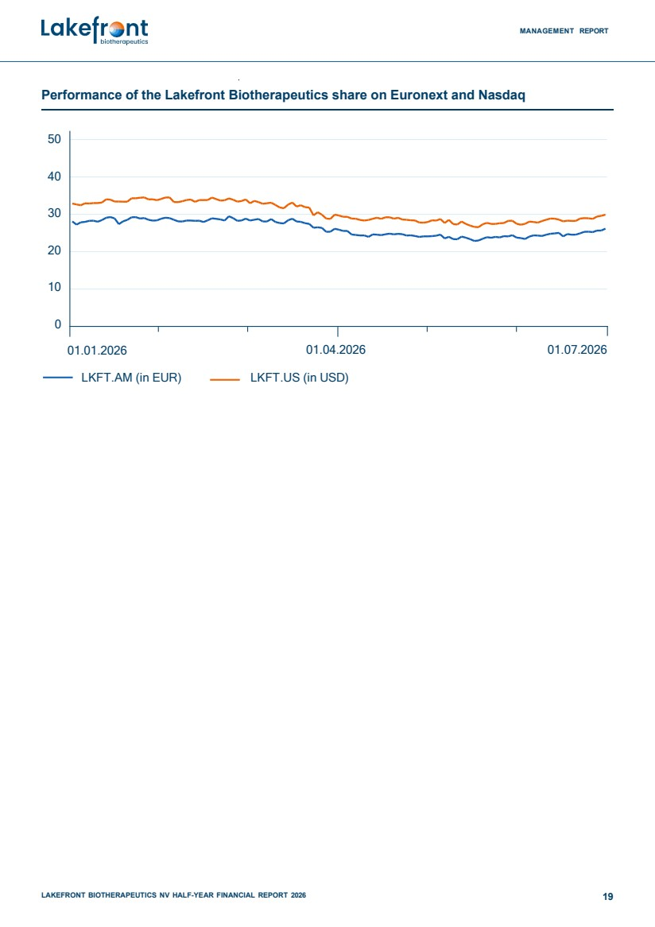 | MANAGEMENT REPORT LAKEFRONT BIOTHERAPEUTICS NV HALF-YEAR FINANCIAL REPORT 2026 19 Performance of the Lakefront Biotherapeutics share on Euronext and Nasdaq 50 40 30 20 10 0 01.01.2026 01.04.2026 01.07.2026 LKFT.AM (in EUR) LKFT.US (in USD)
 | 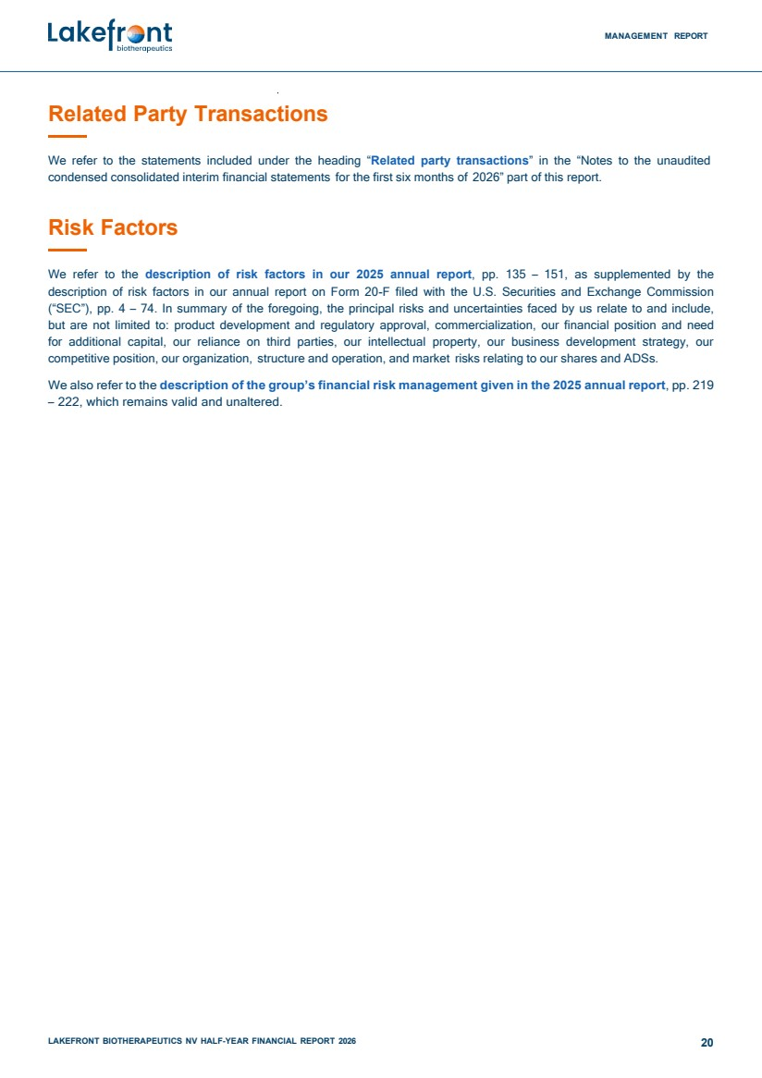 | MANAGEMENT REPORT LAKEFRONT BIOTHERAPEUTICS NV HALF-YEAR FINANCIAL REPORT 2026 20 Related Party Transactions We refer to the statements included under the heading “Related party transactions” in the “Notes to the unaudited condensed consolidated interim financial statements for the first six months of 2026” part of this report. Risk Factors We refer to the description of risk factors in our 2025 annual report, pp. 135 – 151, as supplemented by the description of risk factors in our annual report on Form 20-F filed with the U.S. Securities and Exchange Commission (“SEC”), pp. 4 – 74. In summary of the foregoing, the principal risks and uncertainties faced by us relate to and include, but are not limited to: product development and regulatory approval, commercialization, our financial position and need for additional capital, our reliance on third parties, our intellectual property, our business development strategy, our competitive position, our organization, structure and operation, and market risks relating to our shares and ADSs. We also refer to the description of the group’s financial risk management given in the 2025 annual report, pp. 219 – 222, which remains valid and unaltered.

 | 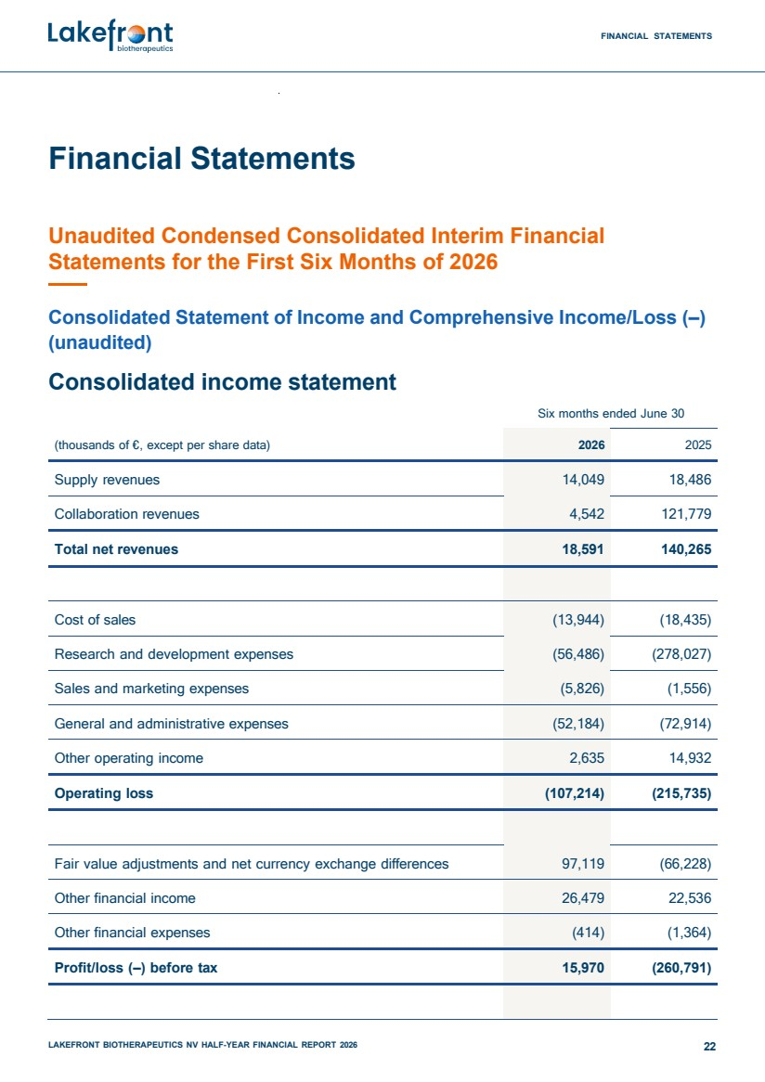 | FINANCIAL STATEMENTS LAKEFRONT BIOTHERAPEUTICS NV HALF-YEAR FINANCIAL REPORT 2026 22 Financial Statements Unaudited Condensed Consolidated Interim Financial Statements for the First Six Months of 2026 Consolidated Statement of Income and Comprehensive Income/Loss (–) (unaudited) Consolidated income statement Six months ended June 30 (thousands of €, except per share data) 2026 2025 Supply revenues 14,049 18,486 Collaboration revenues 4,542 121,779 Total net revenues 18,591 140,265 Cost of sales (13,944) (18,435) Research and development expenses (56,486) (278,027) Sales and marketing expenses (5,826) (1,556) General and administrative expenses (52,184) (72,914) Other operating income 2,635 14,932 Operating loss (107,214) (215,735) Fair value adjustments and net currency exchange differences 97,119 (66,228) Other financial income 26,479 22,536 Other financial expenses (414) (1,364) Profit/loss (–) before tax 15,970 (260,791)
 | 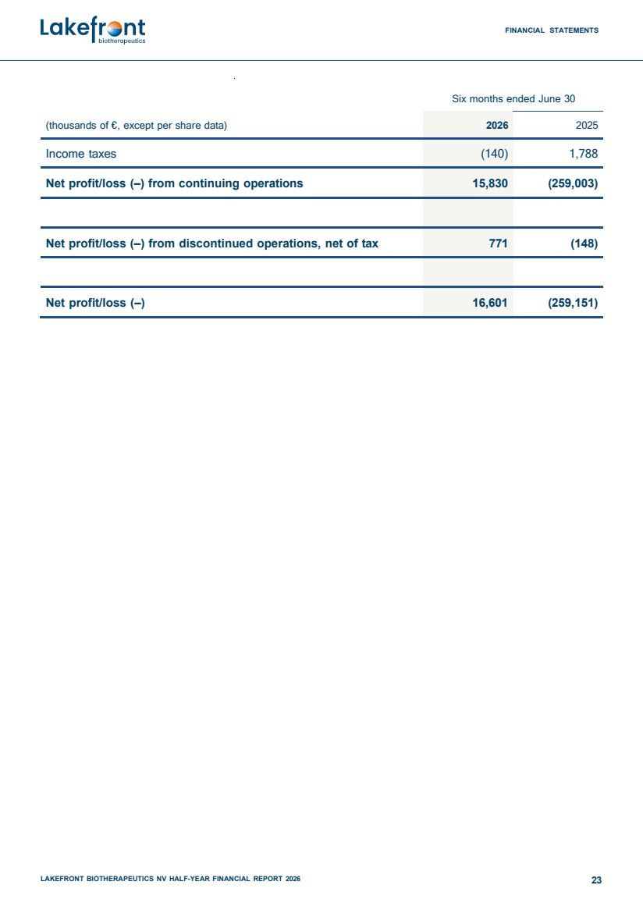 | FINANCIAL STATEMENTS LAKEFRONT BIOTHERAPEUTICS NV HALF-YEAR FINANCIAL REPORT 2026 23 Six months ended June 30 (thousands of €, except per share data) 2026 2025 Income taxes (140) 1,788 Net profit/loss (–) from continuing operations 15,830 (259,003) Net profit/loss (–) from discontinued operations, net of tax 771 (148) Net profit/loss (–) 16,601 (259,151)
 | 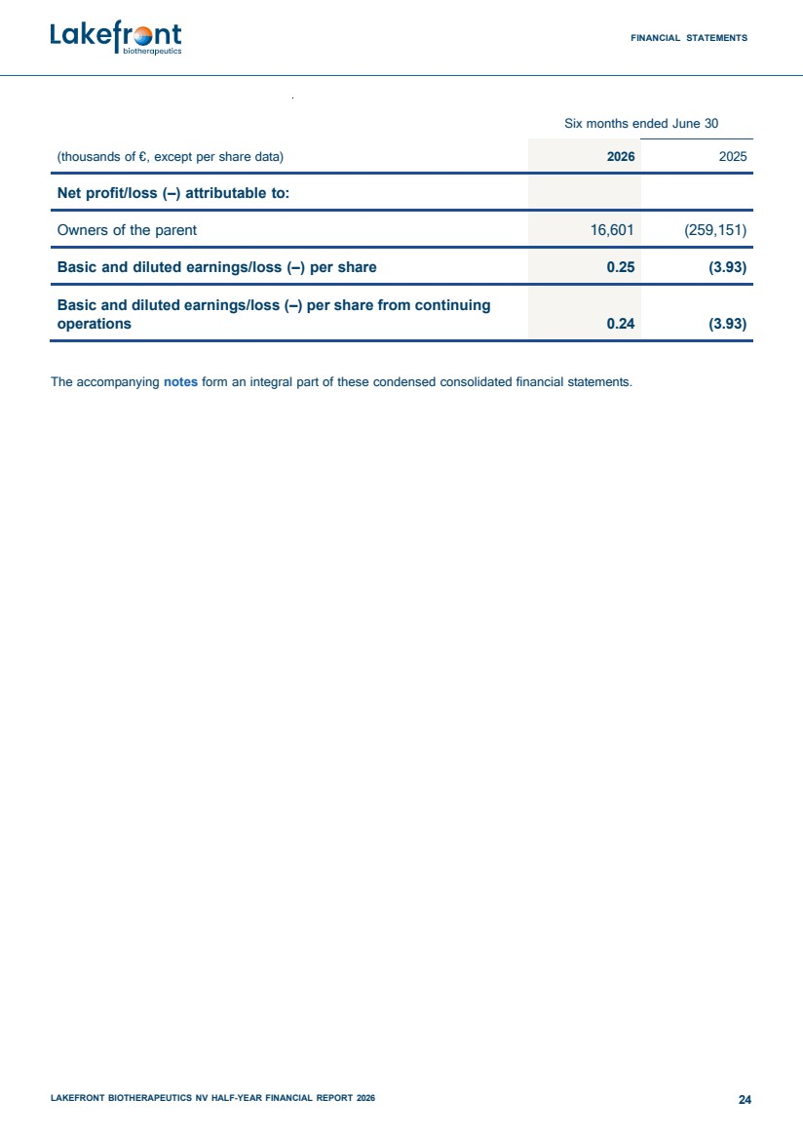 | FINANCIAL STATEMENTS LAKEFRONT BIOTHERAPEUTICS NV HALF-YEAR FINANCIAL REPORT 2026 24 Six months ended June 30 (thousands of €, except per share data) 2026 2025 Net profit/loss (–) attributable to: Owners of the parent 16,601 (259,151) Basic and diluted earnings/loss (–) per share 0.25 (3.93) Basic and diluted earnings/loss (–) per share from continuing operations 0.24 (3.93) The accompanying notes form an integral part of these condensed consolidated financial statements.
 | 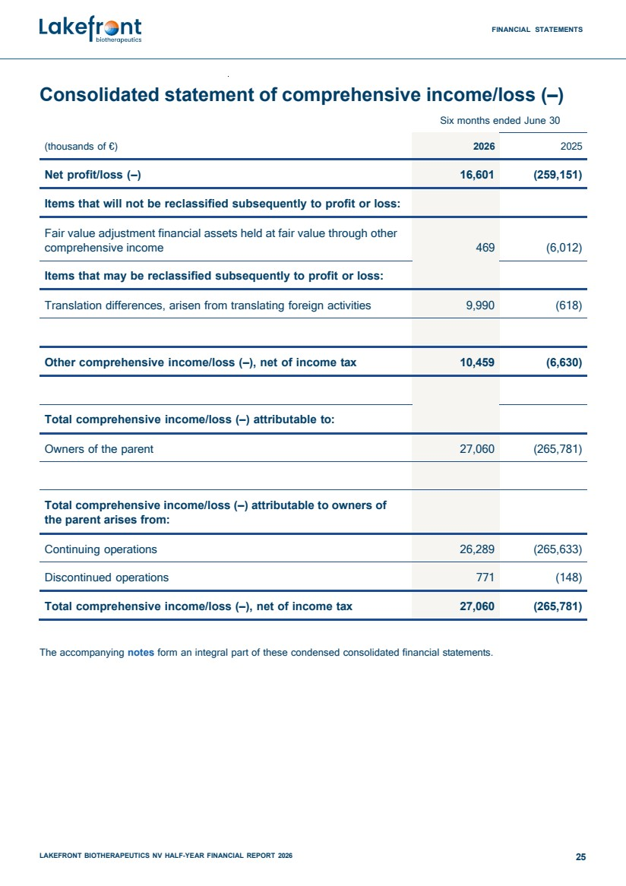 | FINANCIAL STATEMENTS LAKEFRONT BIOTHERAPEUTICS NV HALF-YEAR FINANCIAL REPORT 2026 25 Consolidated statement of comprehensive income/loss (–) Six months ended June 30 (thousands of €) 2026 2025 Net profit/loss (–) 16,601 (259,151) Items that will not be reclassified subsequently to profit or loss: Fair value adjustment financial assets held at fair value through other comprehensive income 469 (6,012) Items that may be reclassified subsequently to profit or loss: Translation differences, arisen from translating foreign activities 9,990 (618) Other comprehensive income/loss (–), net of income tax 10,459 (6,630) Total comprehensive income/loss (–) attributable to: Owners of the parent 27,060 (265,781) Total comprehensive income/loss (–) attributable to owners of the parent arises from: Continuing operations 26,289 (265,633) Discontinued operations 771 (148) Total comprehensive income/loss (–), net of income tax 27,060 (265,781) The accompanying notes form an integral part of these condensed consolidated financial statements.
 | 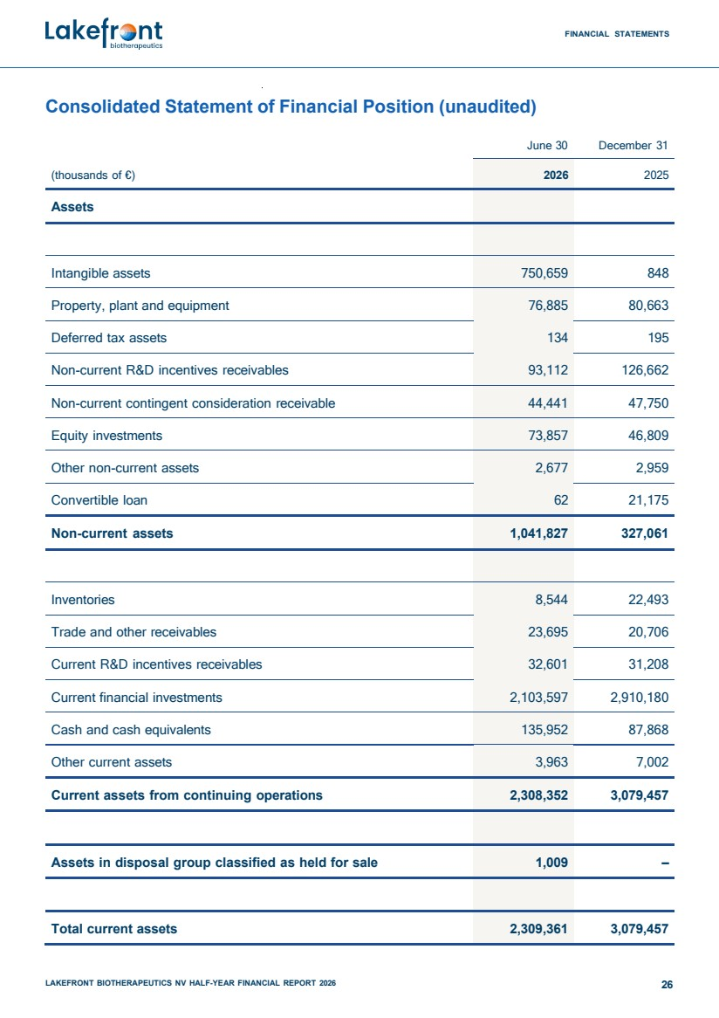 | FINANCIAL STATEMENTS LAKEFRONT BIOTHERAPEUTICS NV HALF-YEAR FINANCIAL REPORT 2026 26 Consolidated Statement of Financial Position (unaudited) June 30 December 31 (thousands of €) 2026 2025 Assets Intangible assets 750,659 848 Property, plant and equipment 76,885 80,663 Deferred tax assets 134 195 Non-current R&D incentives receivables 93,112 126,662 Non-current contingent consideration receivable 44,441 47,750 Equity investments 73,857 46,809 Other non-current assets 2,677 2,959 Convertible loan 62 21,175 Non-current assets 1,041,827 327,061 Inventories 8,544 22,493 Trade and other receivables 23,695 20,706 Current R&D incentives receivables 32,601 31,208 Current financial investments 2,103,597 2,910,180 Cash and cash equivalents 135,952 87,868 Other current assets 3,963 7,002 Current assets from continuing operations 2,308,352 3,079,457 Assets in disposal group classified as held for sale 1,009 – Total current assets 2,309,361 3,079,457
 | 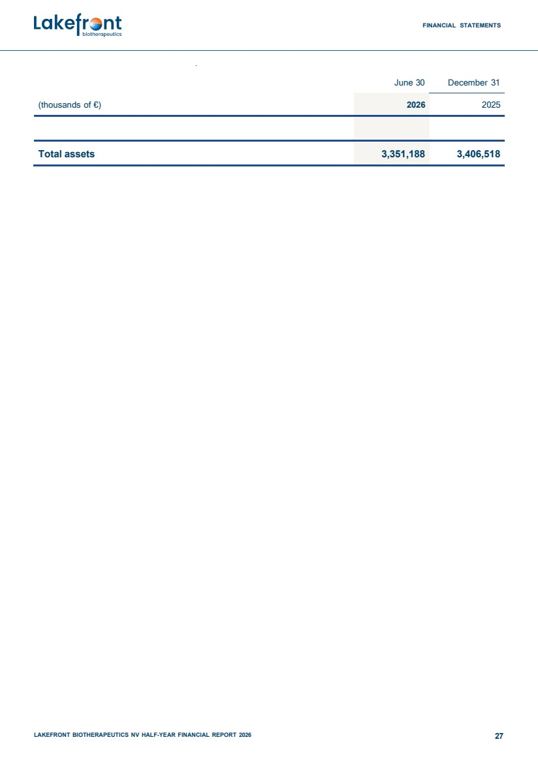 | FINANCIAL STATEMENTS LAKEFRONT BIOTHERAPEUTICS NV HALF-YEAR FINANCIAL REPORT 2026 27 June 30 December 31 (thousands of €) 2026 2025 Total assets 3,351,188 3,406,518
 | 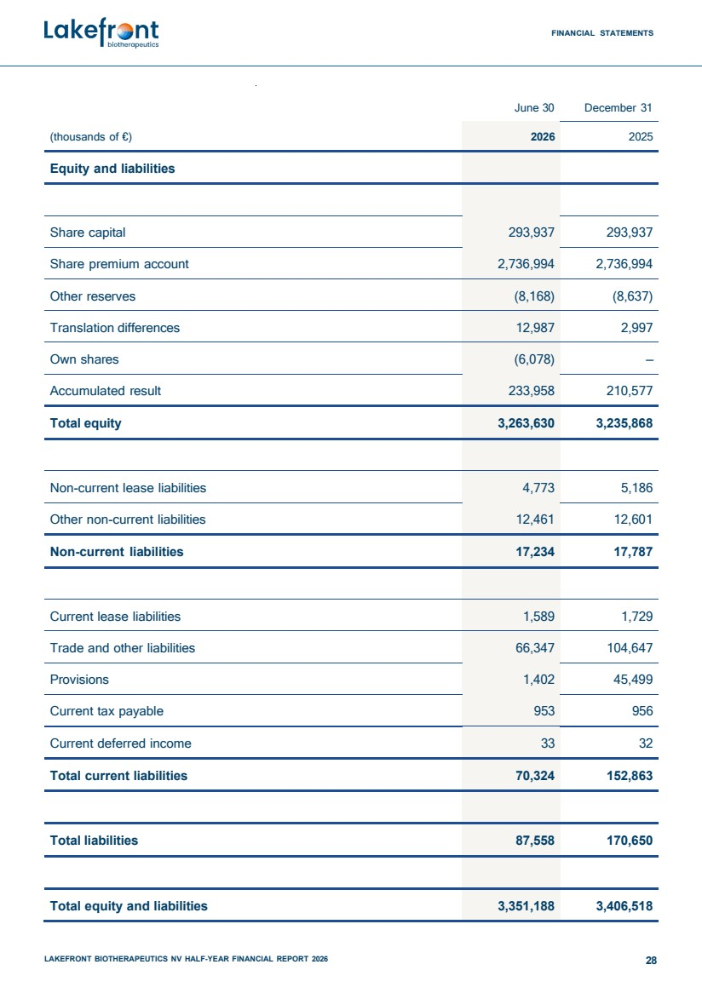 | FINANCIAL STATEMENTS LAKEFRONT BIOTHERAPEUTICS NV HALF-YEAR FINANCIAL REPORT 2026 28 June 30 December 31 (thousands of €) 2026 2025 Equity and liabilities Share capital 293,937 293,937 Share premium account 2,736,994 2,736,994 Other reserves (8,168) (8,637) Translation differences 12,987 2,997 Own shares (6,078) – Accumulated result 233,958 210,577 Total equity 3,263,630 3,235,868 Non-current lease liabilities 4,773 5,186 Other non-current liabilities 12,461 12,601 Non-current liabilities 17,234 17,787 Current lease liabilities 1,589 1,729 Trade and other liabilities 66,347 104,647 Provisions 1,402 45,499 Current tax payable 953 956 Current deferred income 33 32 Total current liabilities 70,324 152,863 Total liabilities 87,558 170,650 Total equity and liabilities 3,351,188 3,406,518
 | 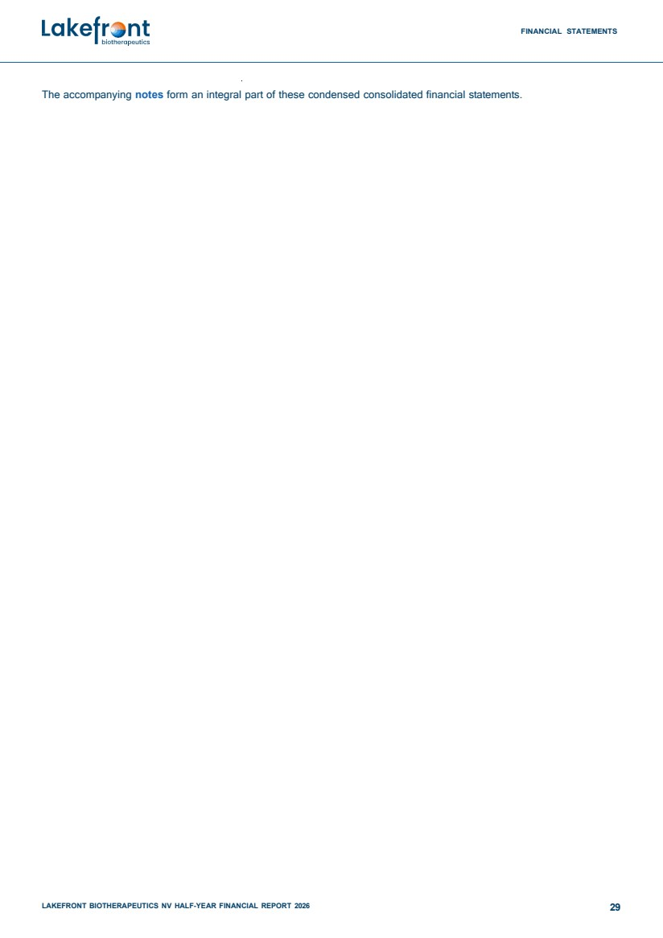 | FINANCIAL STATEMENTS LAKEFRONT BIOTHERAPEUTICS NV HALF-YEAR FINANCIAL REPORT 2026 29 The accompanying notes form an integral part of these condensed consolidated financial statements.
 | 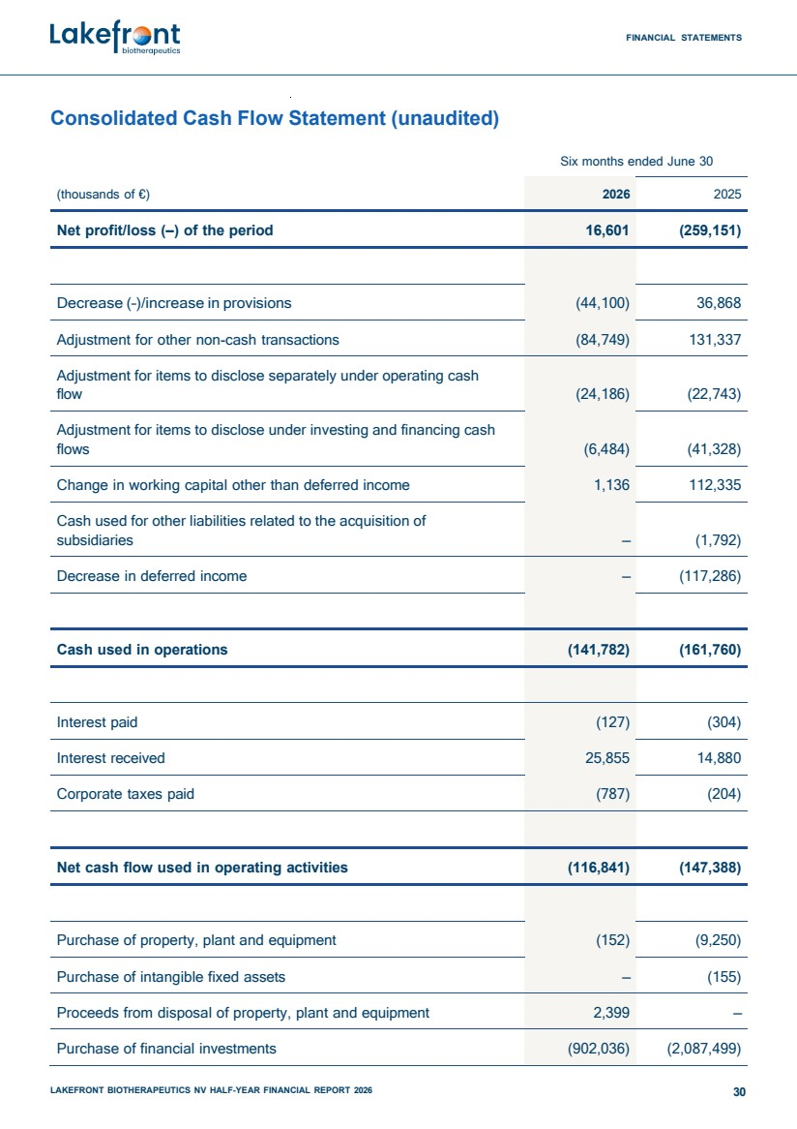 | FINANCIAL STATEMENTS LAKEFRONT BIOTHERAPEUTICS NV HALF-YEAR FINANCIAL REPORT 2026 30 Consolidated Cash Flow Statement (unaudited) Six months ended June 30 (thousands of €) 2026 2025 Net profit/loss (–) of the period 16,601 (259,151) Decrease (–)/increase in provisions (44,100) 36,868 Adjustment for other non-cash transactions (84,749) 131,337 Adjustment for items to disclose separately under operating cash flow (24,186) (22,743) Adjustment for items to disclose under investing and financing cash flows (6,484) (41,328) Change in working capital other than deferred income 1,136 112,335 Cash used for other liabilities related to the acquisition of subsidiaries – (1,792) Decrease in deferred income – (117,286) Cash used in operations (141,782) (161,760) Interest paid (127) (304) Interest received 25,855 14,880 Corporate taxes paid (787) (204) Net cash flow used in operating activities (116,841) (147,388) Purchase of property, plant and equipment (152) (9,250) Purchase of intangible fixed assets – (155) Proceeds from disposal of property, plant and equipment 2,399 – Purchase of financial investments (902,036) (2,087,499)
 | 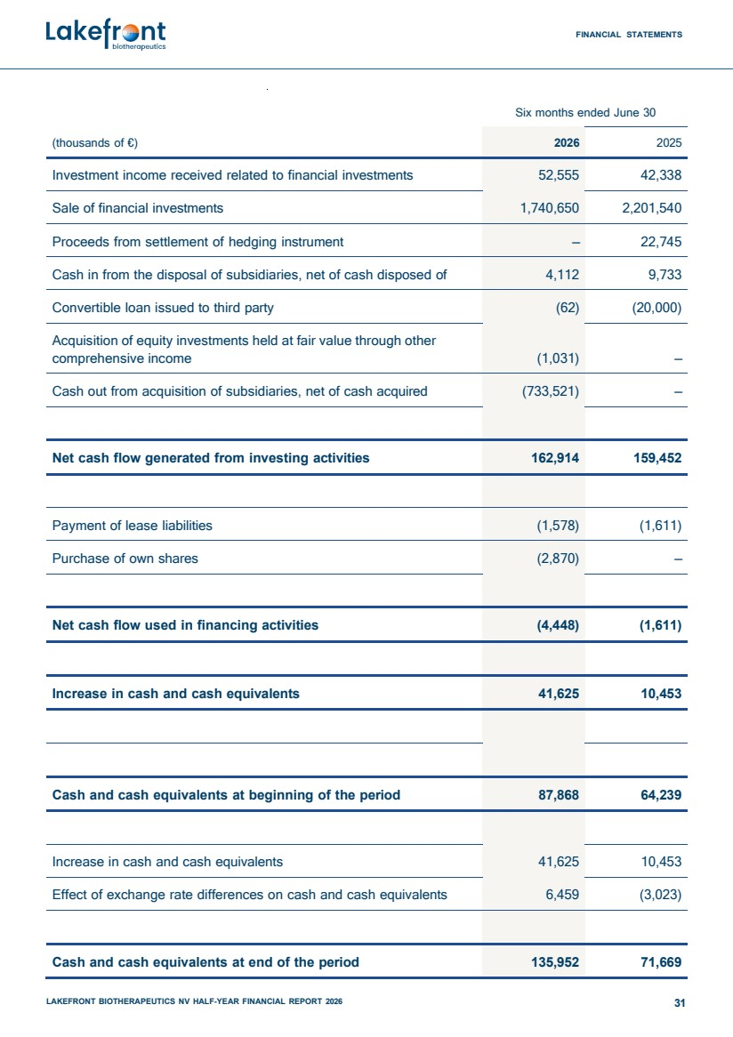 | FINANCIAL STATEMENTS LAKEFRONT BIOTHERAPEUTICS NV HALF-YEAR FINANCIAL REPORT 2026 31 Six months ended June 30 (thousands of €) 2026 2025 Investment income received related to financial investments 52,555 42,338 Sale of financial investments 1,740,650 2,201,540 Proceeds from settlement of hedging instrument – 22,745 Cash in from the disposal of subsidiaries, net of cash disposed of 4,112 9,733 Convertible loan issued to third party (62) (20,000) Acquisition of equity investments held at fair value through other comprehensive income (1,031) – Cash out from acquisition of subsidiaries, net of cash acquired (733,521) – Net cash flow generated from investing activities 162,914 159,452 Payment of lease liabilities (1,578) (1,611) Purchase of own shares (2,870) – Net cash flow used in financing activities (4,448) (1,611) Increase in cash and cash equivalents 41,625 10,453 Cash and cash equivalents at beginning of the period 87,868 64,239 Increase in cash and cash equivalents 41,625 10,453 Effect of exchange rate differences on cash and cash equivalents 6,459 (3,023) Cash and cash equivalents at end of the period 135,952 71,669
 | 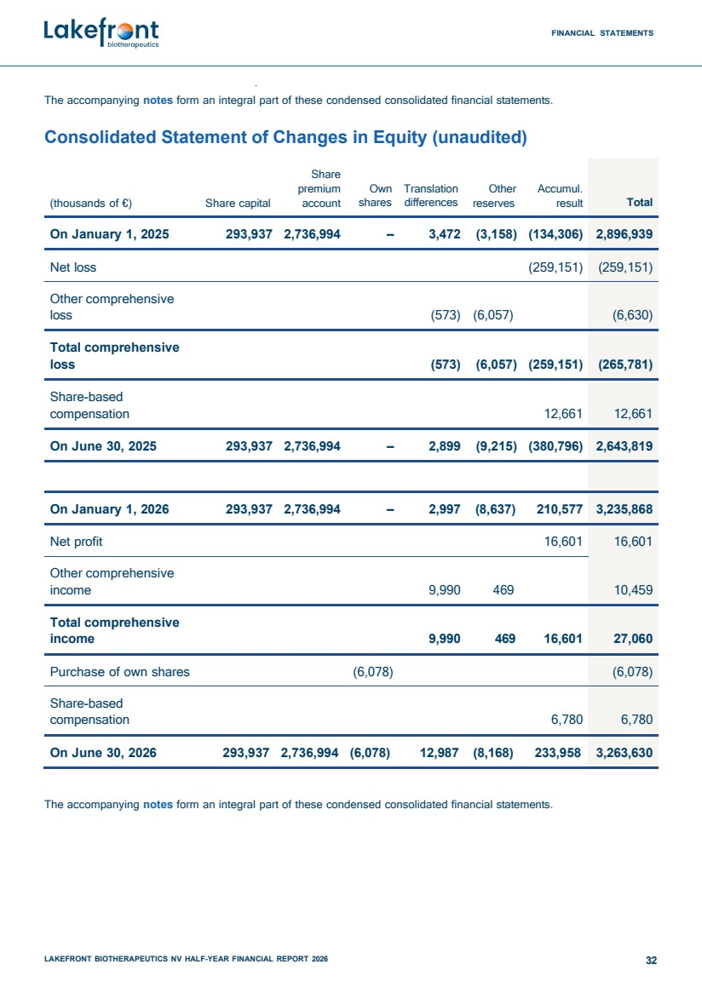 | FINANCIAL STATEMENTS LAKEFRONT BIOTHERAPEUTICS NV HALF-YEAR FINANCIAL REPORT 2026 32 The accompanying notes form an integral part of these condensed consolidated financial statements. Consolidated Statement of Changes in Equity (unaudited) (thousands of €) Share premium Share capital account Own shares Translation differences Other Accumul. reserves result Total On January 1, 2025 293,937 2,736,994 – 3,472 (3,158) (134,306) 2,896,939 Net loss (259,151) (259,151) Other comprehensive loss (573) (6,057) (6,630) Total comprehensive loss (573) (6,057) (259,151) (265,781) Share-based compensation 12,661 12,661 On June 30, 2025 293,937 2,736,994 – 2,899 (9,215) (380,796) 2,643,819 On January 1, 2026 293,937 2,736,994 – 2,997 (8,637) 210,577 3,235,868 Net profit 16,601 16,601 Other comprehensive income 9,990 469 10,459 Total comprehensive income 9,990 469 16,601 27,060 Purchase of own shares (6,078) (6,078) Share-based compensation 6,780 6,780 On June 30, 2026 293,937 2,736,994 (6,078) 12,987 (8,168) 233,958 3,263,630 The accompanying notes form an integral part of these condensed consolidated financial statements.
 | 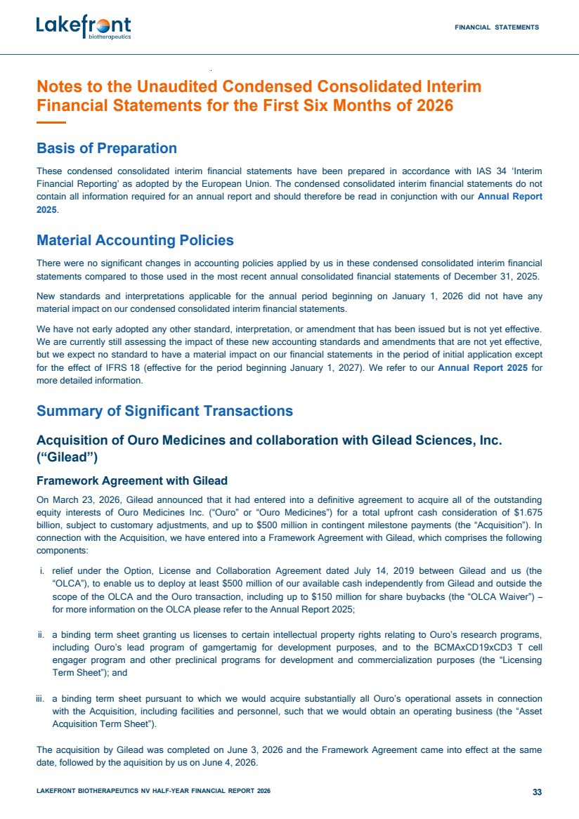 | FINANCIAL STATEMENTS LAKEFRONT BIOTHERAPEUTICS NV HALF-YEAR FINANCIAL REPORT 2026 33 Notes to the Unaudited Condensed Consolidated Interim Financial Statements for the First Six Months of 2026 Basis of Preparation These condensed consolidated interim financial statements have been prepared in accordance with IAS 34 ‘Interim Financial Reporting’ as adopted by the European Union. The condensed consolidated interim financial statements do not contain all information required for an annual report and should therefore be read in conjunction with our Annual Report 2025. Material Accounting Policies There were no significant changes in accounting policies applied by us in these condensed consolidated interim financial statements compared to those used in the most recent annual consolidated financial statements of December 31, 2025. New standards and interpretations applicable for the annual period beginning on January 1, 2026 did not have any material impact on our condensed consolidated interim financial statements. We have not early adopted any other standard, interpretation, or amendment that has been issued but is not yet effective. We are currently still assessing the impact of these new accounting standards and amendments that are not yet effective, but we expect no standard to have a material impact on our financial statements in the period of initial application except for the effect of IFRS 18 (effective for the period beginning January 1, 2027). We refer to our Annual Report 2025 for more detailed information. Summary of Significant Transactions Acquisition of Ouro Medicines and collaboration with Gilead Sciences, Inc. (“Gilead”) Framework Agreement with Gilead On March 23, 2026, Gilead announced that it had entered into a definitive agreement to acquire all of the outstanding equity interests of Ouro Medicines Inc. (“Ouro” or “Ouro Medicines”) for a total upfront cash consideration of $1.675 billion, subject to customary adjustments, and up to $500 million in contingent milestone payments (the “Acquisition”). In connection with the Acquisition, we have entered into a Framework Agreement with Gilead, which comprises the following components: i. relief under the Option, License and Collaboration Agreement dated July 14, 2019 between Gilead and us (the “OLCA”), to enable us to deploy at least $500 million of our available cash independently from Gilead and outside the scope of the OLCA and the Ouro transaction, including up to $150 million for share buybacks (the “OLCA Waiver”) – for more information on the OLCA please refer to the Annual Report 2025; ii. a binding term sheet granting us licenses to certain intellectual property rights relating to Ouro’s research programs, including Ouro’s lead program of gamgertamig for development purposes, and to the BCMAxCD19xCD3 T cell engager program and other preclinical programs for development and commercialization purposes (the “Licensing Term Sheet”); and iii. a binding term sheet pursuant to which we would acquire substantially all Ouro’s operational assets in connection with the Acquisition, including facilities and personnel, such that we would obtain an operating business (the “Asset Acquisition Term Sheet”). The acquisition by Gilead was completed on June 3, 2026 and the Framework Agreement came into effect at the same date, followed by the aquisition by us on June 4, 2026.
 | 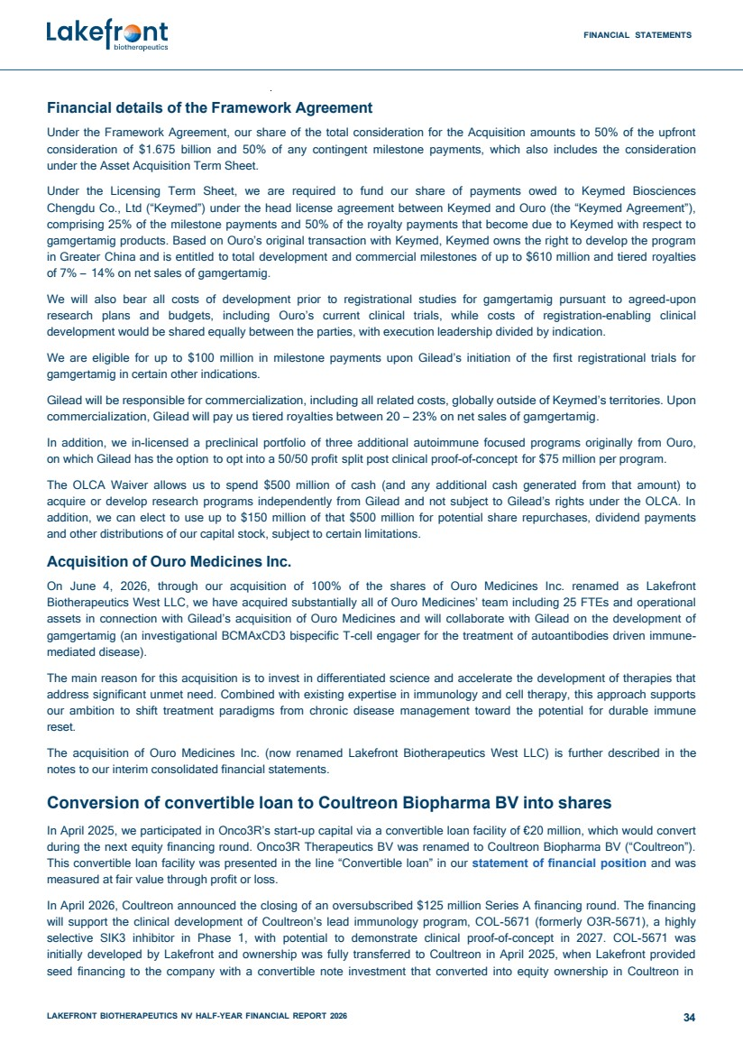 | FINANCIAL STATEMENTS LAKEFRONT BIOTHERAPEUTICS NV HALF-YEAR FINANCIAL REPORT 2026 34 Financial details of the Framework Agreement Under the Framework Agreement, our share of the total consideration for the Acquisition amounts to 50% of the upfront consideration of $1.675 billion and 50% of any contingent milestone payments, which also includes the consideration under the Asset Acquisition Term Sheet. Under the Licensing Term Sheet, we are required to fund our share of payments owed to Keymed Biosciences Chengdu Co., Ltd (“Keymed”) under the head license agreement between Keymed and Ouro (the “Keymed Agreement”), comprising 25% of the milestone payments and 50% of the royalty payments that become due to Keymed with respect to gamgertamig products. Based on Ouro’s original transaction with Keymed, Keymed owns the right to develop the program in Greater China and is entitled to total development and commercial milestones of up to $610 million and tiered royalties of 7% – 14% on net sales of gamgertamig. We will also bear all costs of development prior to registrational studies for gamgertamig pursuant to agreed-upon research plans and budgets, including Ouro’s current clinical trials, while costs of registration-enabling clinical development would be shared equally between the parties, with execution leadership divided by indication. We are eligible for up to $100 million in milestone payments upon Gilead’s initiation of the first registrational trials for gamgertamig in certain other indications. Gilead will be responsible for commercialization, including all related costs, globally outside of Keymed’s territories. Upon commercialization, Gilead will pay us tiered royalties between 20 – 23% on net sales of gamgertamig. In addition, we in-licensed a preclinical portfolio of three additional autoimmune focused programs originally from Ouro, on which Gilead has the option to opt into a 50/50 profit split post clinical proof-of-concept for $75 million per program. The OLCA Waiver allows us to spend $500 million of cash (and any additional cash generated from that amount) to acquire or develop research programs independently from Gilead and not subject to Gilead’s rights under the OLCA. In addition, we can elect to use up to $150 million of that $500 million for potential share repurchases, dividend payments and other distributions of our capital stock, subject to certain limitations. Acquisition of Ouro Medicines Inc. On June 4, 2026, through our acquisition of 100% of the shares of Ouro Medicines Inc. renamed as Lakefront Biotherapeutics West LLC, we have acquired substantially all of Ouro Medicines’ team including 25 FTEs and operational assets in connection with Gilead’s acquisition of Ouro Medicines and will collaborate with Gilead on the development of gamgertamig (an investigational BCMAxCD3 bispecific T-cell engager for the treatment of autoantibodies driven immune-mediated disease). The main reason for this acquisition is to invest in differentiated science and accelerate the development of therapies that address significant unmet need. Combined with existing expertise in immunology and cell therapy, this approach supports our ambition to shift treatment paradigms from chronic disease management toward the potential for durable immune reset. The acquisition of Ouro Medicines Inc. (now renamed Lakefront Biotherapeutics West LLC) is further described in the notes to our interim consolidated financial statements. Conversion of convertible loan to Coultreon Biopharma BV into shares In April 2025, we participated in Onco3R’s start-up capital via a convertible loan facility of €20 million, which would convert during the next equity financing round. Onco3R Therapeutics BV was renamed to Coultreon Biopharma BV (“Coultreon”). This convertible loan facility was presented in the line “Convertible loan” in our statement of financial position and was measured at fair value through profit or loss. In April 2026, Coultreon announced the closing of an oversubscribed $125 million Series A financing round. The financing will support the clinical development of Coultreon’s lead immunology program, COL-5671 (formerly O3R-5671), a highly selective SIK3 inhibitor in Phase 1, with potential to demonstrate clinical proof-of-concept in 2027. COL-5671 was initially developed by Lakefront and ownership was fully transferred to Coultreon in April 2025, when Lakefront provided seed financing to the company with a convertible note investment that converted into equity ownership in Coultreon in
 | 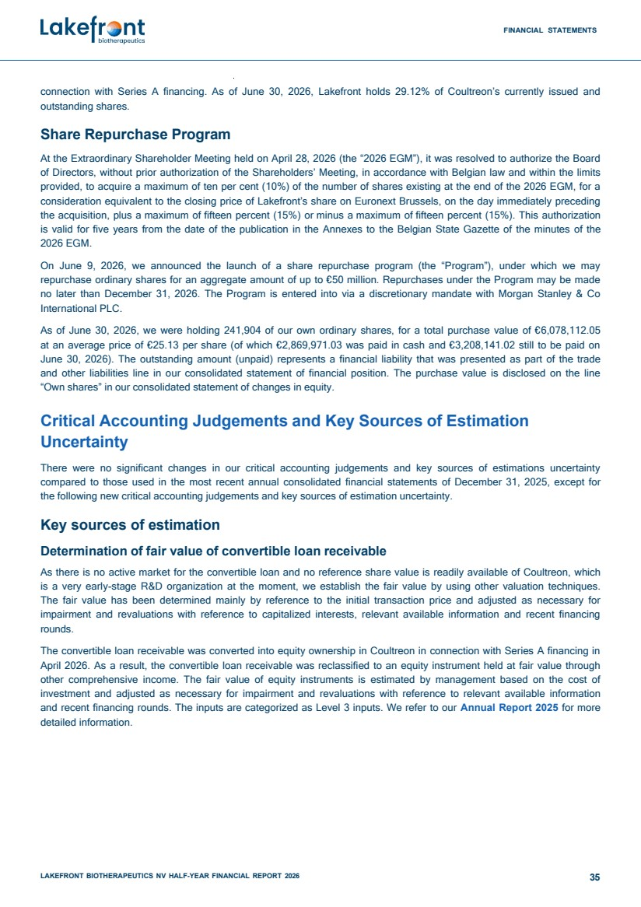 | FINANCIAL STATEMENTS LAKEFRONT BIOTHERAPEUTICS NV HALF-YEAR FINANCIAL REPORT 2026 35 connection with Series A financing. As of June 30, 2026, Lakefront holds 29.12% of Coultreon’s currently issued and outstanding shares. Share Repurchase Program At the Extraordinary Shareholder Meeting held on April 28, 2026 (the “2026 EGM”), it was resolved to authorize the Board of Directors, without prior authorization of the Shareholders’ Meeting, in accordance with Belgian law and within the limits provided, to acquire a maximum of ten per cent (10%) of the number of shares existing at the end of the 2026 EGM, for a consideration equivalent to the closing price of Lakefront’s share on Euronext Brussels, on the day immediately preceding the acquisition, plus a maximum of fifteen percent (15%) or minus a maximum of fifteen percent (15%). This authorization is valid for five years from the date of the publication in the Annexes to the Belgian State Gazette of the minutes of the 2026 EGM. On June 9, 2026, we announced the launch of a share repurchase program (the “Program”), under which we may repurchase ordinary shares for an aggregate amount of up to €50 million. Repurchases under the Program may be made no later than December 31, 2026. The Program is entered into via a discretionary mandate with Morgan Stanley & Co International PLC. As of June 30, 2026, we were holding 241,904 of our own ordinary shares, for a total purchase value of €6,078,112.05 at an average price of €25.13 per share (of which €2,869,971.03 was paid in cash and €3,208,141.02 still to be paid on June 30, 2026). The outstanding amount (unpaid) represents a financial liability that was presented as part of the trade and other liabilities line in our consolidated statement of financial position. The purchase value is disclosed on the line “Own shares” in our consolidated statement of changes in equity. Critical Accounting Judgements and Key Sources of Estimation Uncertainty There were no significant changes in our critical accounting judgements and key sources of estimations uncertainty compared to those used in the most recent annual consolidated financial statements of December 31, 2025, except for the following new critical accounting judgements and key sources of estimation uncertainty. Key sources of estimation Determination of fair value of convertible loan receivable As there is no active market for the convertible loan and no reference share value is readily available of Coultreon, which is a very early-stage R&D organization at the moment, we establish the fair value by using other valuation techniques. The fair value has been determined mainly by reference to the initial transaction price and adjusted as necessary for impairment and revaluations with reference to capitalized interests, relevant available information and recent financing rounds. The convertible loan receivable was converted into equity ownership in Coultreon in connection with Series A financing in April 2026. As a result, the convertible loan receivable was reclassified to an equity instrument held at fair value through other comprehensive income. The fair value of equity instruments is estimated by management based on the cost of investment and adjusted as necessary for impairment and revaluations with reference to relevant available information and recent financing rounds. The inputs are categorized as Level 3 inputs. We refer to our Annual Report 2025 for more detailed information.
 | 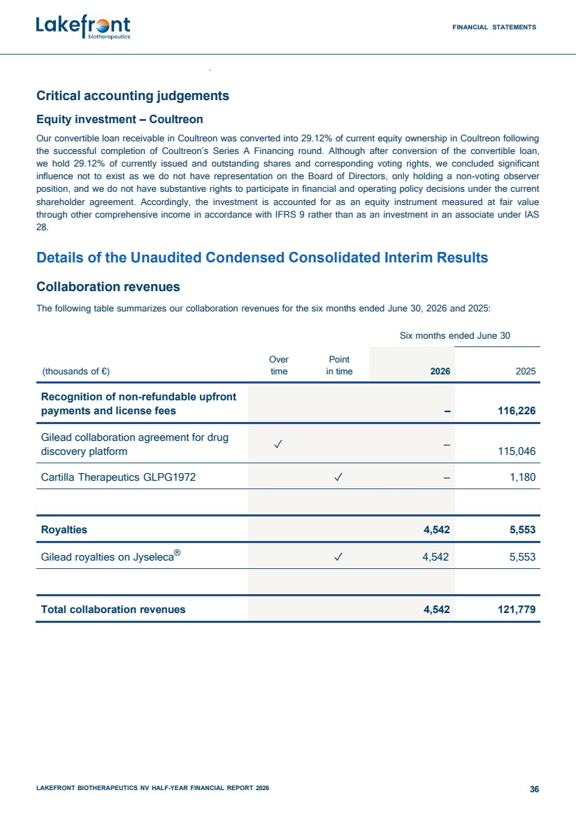 | FINANCIAL STATEMENTS LAKEFRONT BIOTHERAPEUTICS NV HALF-YEAR FINANCIAL REPORT 2026 36 Critical accounting judgements Equity investment – Coultreon Our convertible loan receivable in Coultreon was converted into 29.12% of current equity ownership in Coultreon following the successful completion of Coultreon’s Series A Financing round. Although after conversion of the convertible loan, we hold 29.12% of currently issued and outstanding shares and corresponding voting rights, we concluded significant influence not to exist as we do not have representation on the Board of Directors, only holding a non-voting observer position, and we do not have substantive rights to participate in financial and operating policy decisions under the current shareholder agreement. Accordingly, the investment is accounted for as an equity instrument measured at fair value through other comprehensive income in accordance with IFRS 9 rather than as an investment in an associate under IAS 28. Details of the Unaudited Condensed Consolidated Interim Results Collaboration revenues The following table summarizes our collaboration revenues for the six months ended June 30, 2026 and 2025: Six months ended June 30 Over Point (thousands of €) time in time 2026 2025 Recognition of non-refundable upfront payments and license fees – 116,226 Gilead collaboration agreement for drug discovery platform ✓ – 115,046 Cartilla Therapeutics GLPG1972 ✓ – 1,180 Royalties 4,542 5,553 Gilead royalties on Jyseleca® ✓ 4,542 5,553 Total collaboration revenues 4,542 121,779
 | 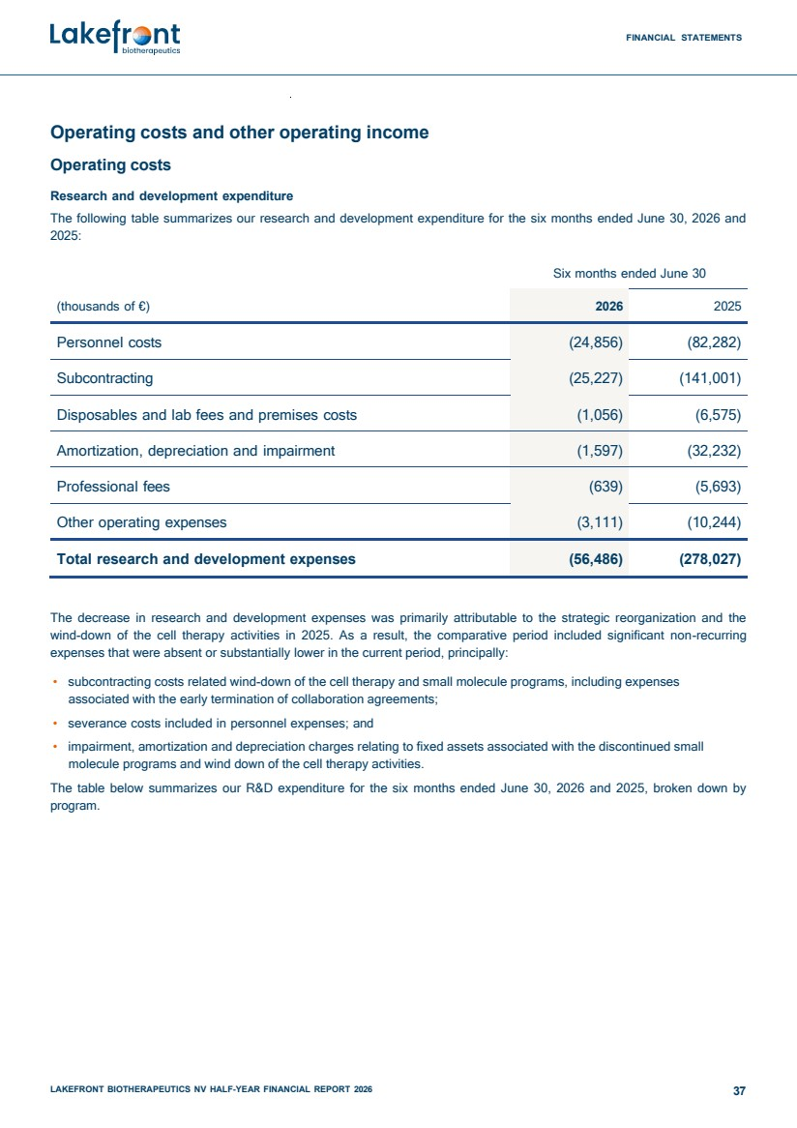 | FINANCIAL STATEMENTS LAKEFRONT BIOTHERAPEUTICS NV HALF-YEAR FINANCIAL REPORT 2026 37 Operating costs and other operating income Operating costs Research and development expenditure The following table summarizes our research and development expenditure for the six months ended June 30, 2026 and 2025: Six months ended June 30 (thousands of €) 2026 2025 Personnel costs (24,856) (82,282) Subcontracting (25,227) (141,001) Disposables and lab fees and premises costs (1,056) (6,575) Amortization, depreciation and impairment (1,597) (32,232) Professional fees (639) (5,693) Other operating expenses (3,111) (10,244) Total research and development expenses (56,486) (278,027) The decrease in research and development expenses was primarily attributable to the strategic reorganization and the wind-down of the cell therapy activities in 2025. As a result, the comparative period included significant non-recurring expenses that were absent or substantially lower in the current period, principally: • subcontracting costs related wind-down of the cell therapy and small molecule programs, including expenses associated with the early termination of collaboration agreements; • severance costs included in personnel expenses; and • impairment, amortization and depreciation charges relating to fixed assets associated with the discontinued small molecule programs and wind down of the cell therapy activities. The table below summarizes our R&D expenditure for the six months ended June 30, 2026 and 2025, broken down by program.
 | 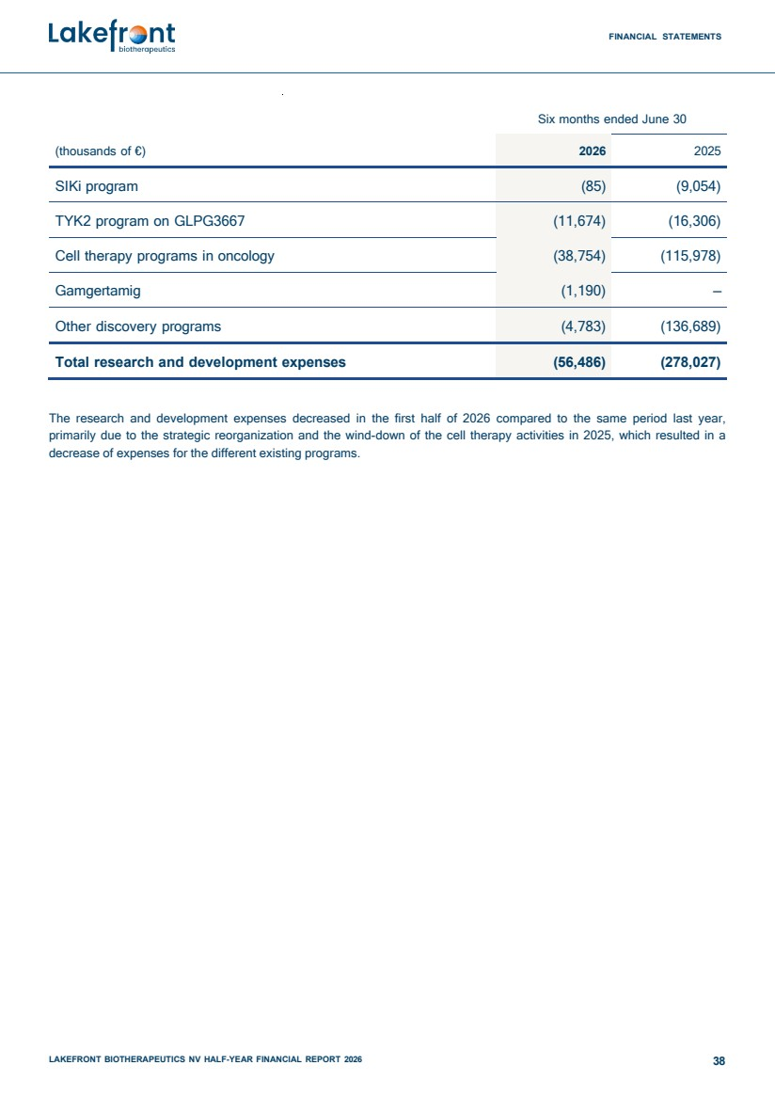 | FINANCIAL STATEMENTS LAKEFRONT BIOTHERAPEUTICS NV HALF-YEAR FINANCIAL REPORT 2026 38 Six months ended June 30 (thousands of €) 2026 2025 SIKi program (85) (9,054) TYK2 program on GLPG3667 (11,674) (16,306) Cell therapy programs in oncology (38,754) (115,978) Gamgertamig (1,190) – Other discovery programs (4,783) (136,689) Total research and development expenses (56,486) (278,027) The research and development expenses decreased in the first half of 2026 compared to the same period last year, primarily due to the strategic reorganization and the wind-down of the cell therapy activities in 2025, which resulted in a decrease of expenses for the different existing programs.
 | 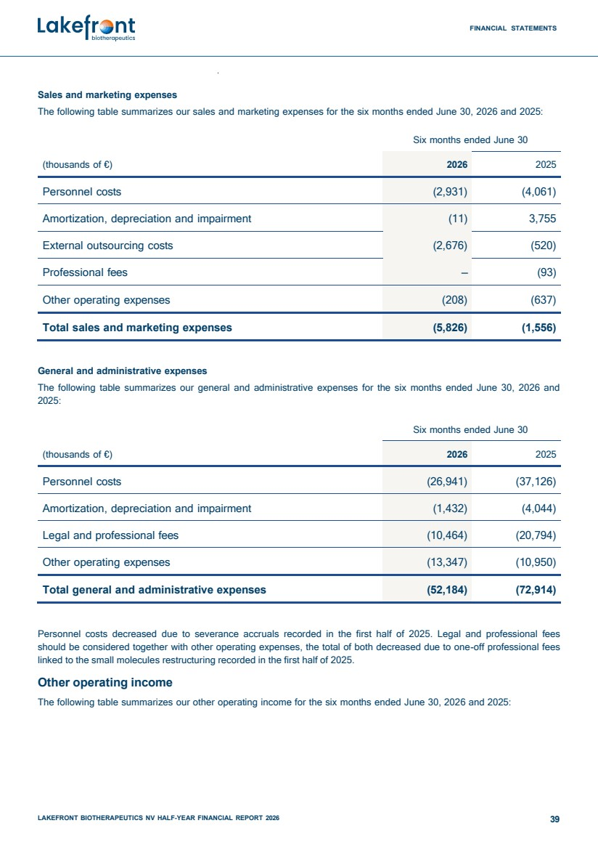 | FINANCIAL STATEMENTS LAKEFRONT BIOTHERAPEUTICS NV HALF-YEAR FINANCIAL REPORT 2026 39 Sales and marketing expenses The following table summarizes our sales and marketing expenses for the six months ended June 30, 2026 and 2025: Six months ended June 30 (thousands of €) 2026 2025 Personnel costs (2,931) (4,061) Amortization, depreciation and impairment (11) 3,755 External outsourcing costs (2,676) (520) Professional fees – (93) Other operating expenses (208) (637) Total sales and marketing expenses (5,826) (1,556) General and administrative expenses The following table summarizes our general and administrative expenses for the six months ended June 30, 2026 and 2025: Six months ended June 30 (thousands of €) 2026 2025 Personnel costs (26,941) (37,126) Amortization, depreciation and impairment (1,432) (4,044) Legal and professional fees (10,464) (20,794) Other operating expenses (13,347) (10,950) Total general and administrative expenses (52,184) (72,914) Personnel costs decreased due to severance accruals recorded in the first half of 2025. Legal and professional fees should be considered together with other operating expenses, the total of both decreased due to one-off professional fees linked to the small molecules restructuring recorded in the first half of 2025. Other operating income The following table summarizes our other operating income for the six months ended June 30, 2026 and 2025:
 | 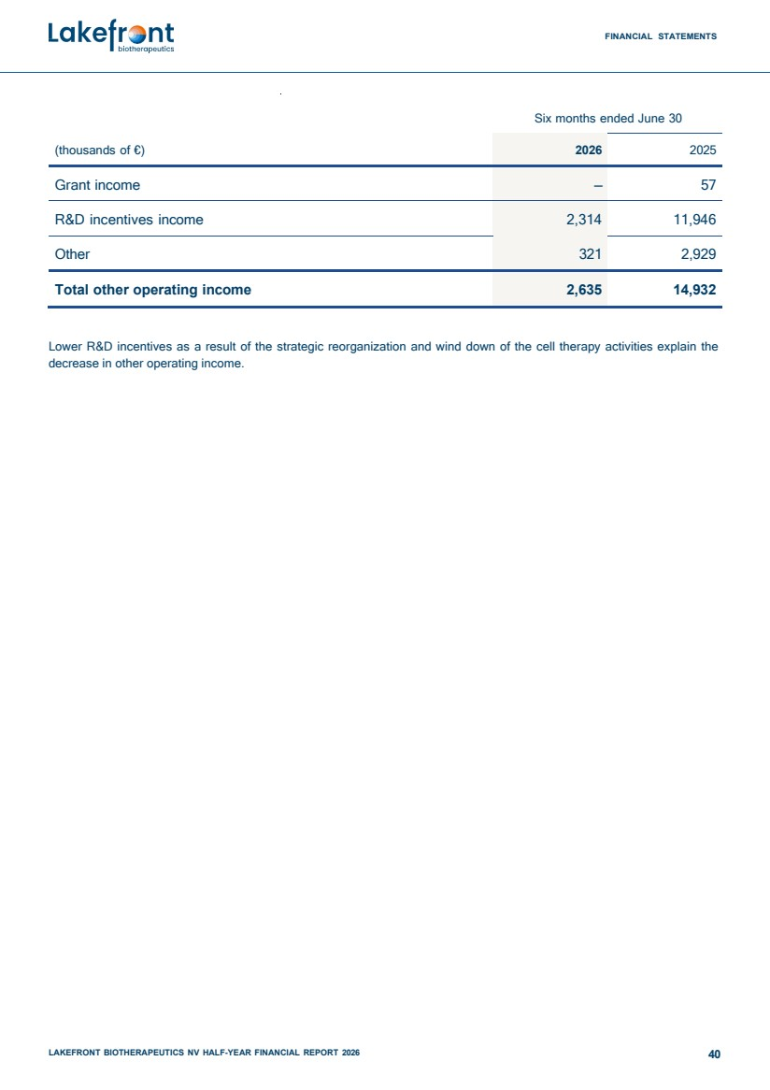 | FINANCIAL STATEMENTS LAKEFRONT BIOTHERAPEUTICS NV HALF-YEAR FINANCIAL REPORT 2026 40 Six months ended June 30 (thousands of €) 2026 2025 Grant income – 57 R&D incentives income 2,314 11,946 Other 321 2,929 Total other operating income 2,635 14,932 Lower R&D incentives as a result of the strategic reorganization and wind down of the cell therapy activities explain the decrease in other operating income.
 | 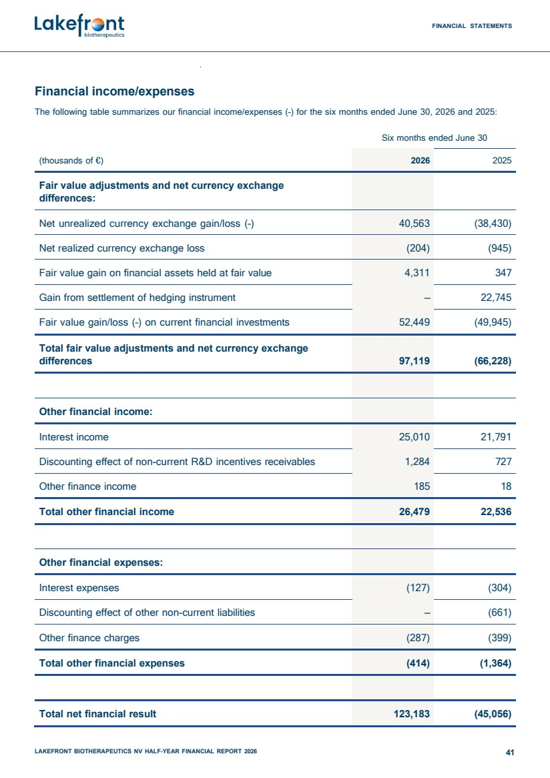 | FINANCIAL STATEMENTS LAKEFRONT BIOTHERAPEUTICS NV HALF-YEAR FINANCIAL REPORT 2026 41 Financial income/expenses The following table summarizes our financial income/expenses (–) for the six months ended June 30, 2026 and 2025: Six months ended June 30 (thousands of €) 2026 2025 Fair value adjustments and net currency exchange differences: Net unrealized currency exchange gain/loss (–) 40,563 (38,430) Net realized currency exchange loss (204) (945) Fair value gain on financial assets held at fair value 4,311 347 Gain from settlement of hedging instrument – 22,745 Fair value gain/loss (–) on current financial investments 52,449 (49,945) Total fair value adjustments and net currency exchange differences 97,119 (66,228) Other financial income: Interest income 25,010 21,791 Discounting effect of non-current R&D incentives receivables 1,284 727 Other finance income 185 18 Total other financial income 26,479 22,536 Other financial expenses: Interest expenses (127) (304) Discounting effect of other non-current liabilities – (661) Other finance charges (287) (399) Total other financial expenses (414) (1,364) Total net financial result 123,183 (45,056)
 | 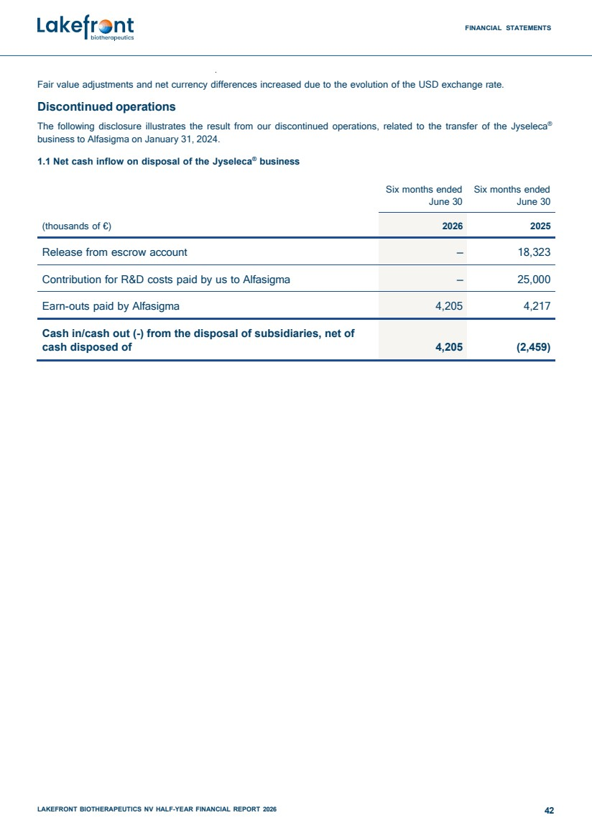 | FINANCIAL STATEMENTS LAKEFRONT BIOTHERAPEUTICS NV HALF-YEAR FINANCIAL REPORT 2026 42 Fair value adjustments and net currency differences increased due to the evolution of the USD exchange rate. Discontinued operations The following disclosure illustrates the result from our discontinued operations, related to the transfer of the Jyseleca® business to Alfasigma on January 31, 2024. 1.1 Net cash inflow on disposal of the Jyseleca® business Six months ended June 30 Six months ended June 30 (thousands of €) 2026 2025 Release from escrow account – 18,323 Contribution for R&D costs paid by us to Alfasigma – 25,000 Earn-outs paid by Alfasigma 4,205 4,217 Cash in/cash out (-) from the disposal of subsidiaries, net of cash disposed of 4,205 (2,459)
 | 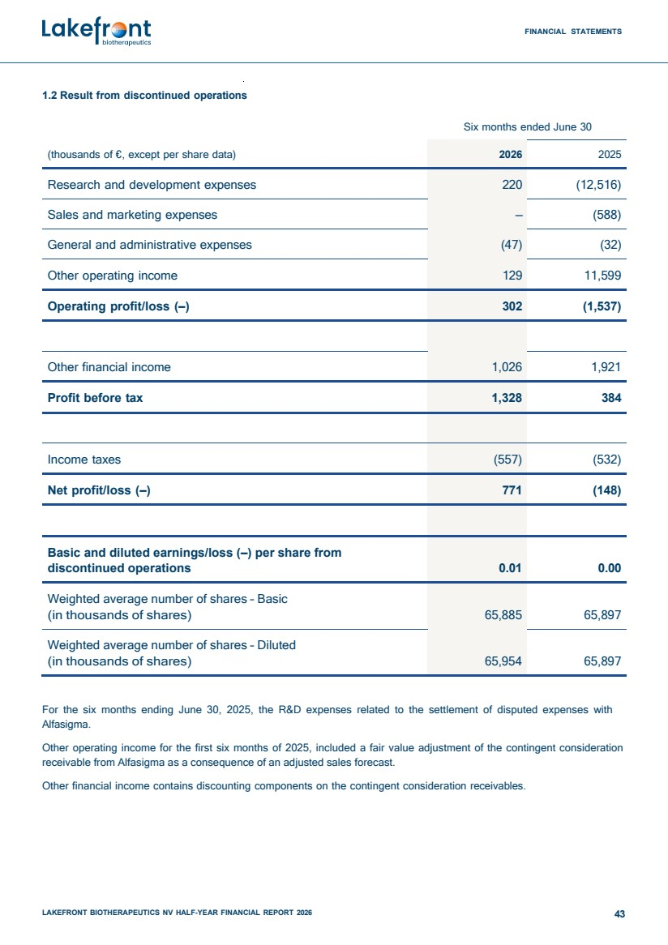 | FINANCIAL STATEMENTS LAKEFRONT BIOTHERAPEUTICS NV HALF-YEAR FINANCIAL REPORT 2026 43 1.2 Result from discontinued operations Six months ended June 30 (thousands of €, except per share data) 2026 2025 Research and development expenses 220 (12,516) Sales and marketing expenses – (588) General and administrative expenses (47) (32) Other operating income 129 11,599 Operating profit/loss (–) 302 (1,537) Other financial income 1,026 1,921 Profit before tax 1,328 384 Income taxes (557) (532) Net profit/loss (–) 771 (148) Basic and diluted earnings/loss (–) per share from discontinued operations 0.01 0.00 Weighted average number of shares – Basic (in thousands of shares) 65,885 65,897 Weighted average number of shares – Diluted (in thousands of shares) 65,954 65,897 For the six months ending June 30, 2025, the R&D expenses related to the settlement of disputed expenses with Alfasigma. Other operating income for the first six months of 2025, included a fair value adjustment of the contingent consideration receivable from Alfasigma as a consequence of an adjusted sales forecast. Other financial income contains discounting components on the contingent consideration receivables.
 | 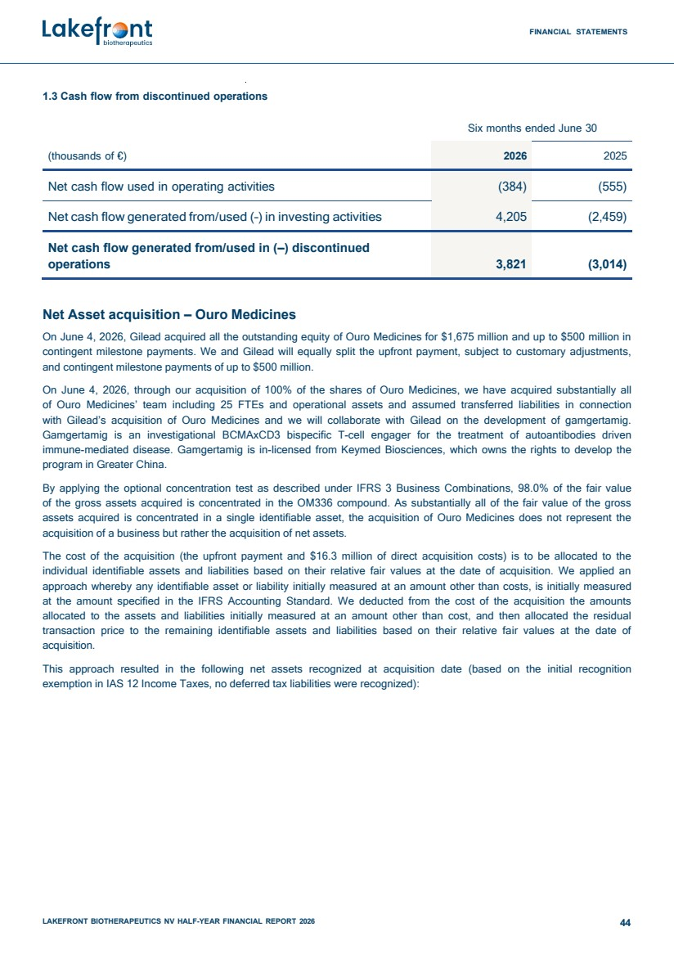 | FINANCIAL STATEMENTS LAKEFRONT BIOTHERAPEUTICS NV HALF-YEAR FINANCIAL REPORT 2026 44 1.3 Cash flow from discontinued operations Six months ended June 30 (thousands of €) 2026 2025 Net cash flow used in operating activities (384) (555) Net cash flow generated from/used (–) in investing activities 4,205 (2,459) Net cash flow generated from/used in (–) discontinued operations 3,821 (3,014) Net Asset acquisition – Ouro Medicines On June 4, 2026, Gilead acquired all the outstanding equity of Ouro Medicines for $1,675 million and up to $500 million in contingent milestone payments. We and Gilead will equally split the upfront payment, subject to customary adjustments, and contingent milestone payments of up to $500 million. On June 4, 2026, through our acquisition of 100% of the shares of Ouro Medicines, we have acquired substantially all of Ouro Medicines’ team including 25 FTEs and operational assets and assumed transferred liabilities in connection with Gilead’s acquisition of Ouro Medicines and we will collaborate with Gilead on the development of gamgertamig. Gamgertamig is an investigational BCMAxCD3 bispecific T-cell engager for the treatment of autoantibodies driven immune-mediated disease. Gamgertamig is in-licensed from Keymed Biosciences, which owns the rights to develop the program in Greater China. By applying the optional concentration test as described under IFRS 3 Business Combinations, 98.0% of the fair value of the gross assets acquired is concentrated in the OM336 compound. As substantially all of the fair value of the gross assets acquired is concentrated in a single identifiable asset, the acquisition of Ouro Medicines does not represent the acquisition of a business but rather the acquisition of net assets. The cost of the acquisition (the upfront payment and $16.3 million of direct acquisition costs) is to be allocated to the individual identifiable assets and liabilities based on their relative fair values at the date of acquisition. We applied an approach whereby any identifiable asset or liability initially measured at an amount other than costs, is initially measured at the amount specified in the IFRS Accounting Standard. We deducted from the cost of the acquisition the amounts allocated to the assets and liabilities initially measured at an amount other than cost, and then allocated the residual transaction price to the remaining identifiable assets and liabilities based on their relative fair values at the date of acquisition. This approach resulted in the following net assets recognized at acquisition date (based on the initial recognition exemption in IAS 12 Income Taxes, no deferred tax liabilities were recognized):
 | 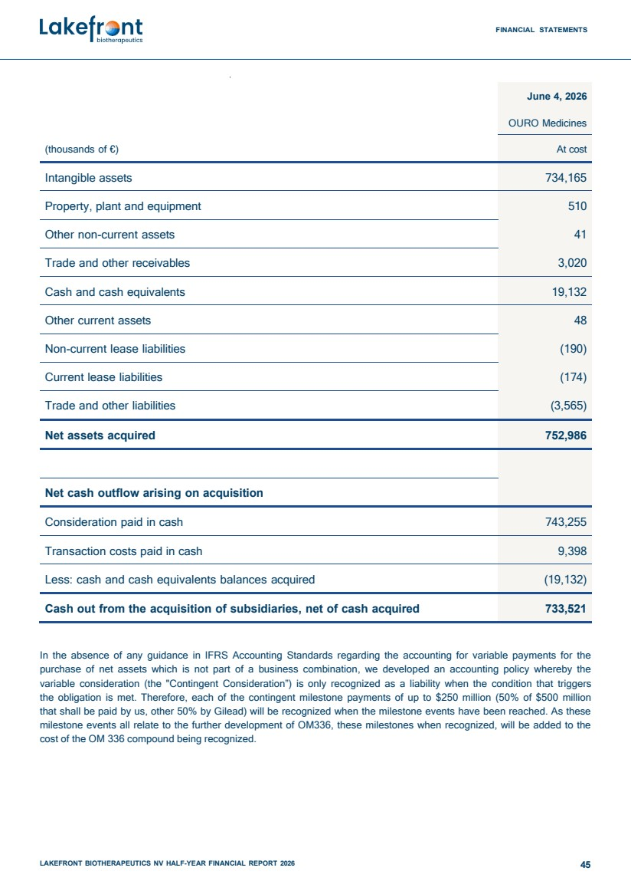 | FINANCIAL STATEMENTS LAKEFRONT BIOTHERAPEUTICS NV HALF-YEAR FINANCIAL REPORT 2026 45 (thousands of €) June 4, 2026 OURO Medicines At cost Intangible assets 734,165 Property, plant and equipment 510 Other non-current assets 41 Trade and other receivables 3,020 Cash and cash equivalents 19,132 Other current assets 48 Non-current lease liabilities (190) Current lease liabilities (174) Trade and other liabilities (3,565) Net assets acquired 752,986 Net cash outflow arising on acquisition Consideration paid in cash 743,255 Transaction costs paid in cash 9,398 Less: cash and cash equivalents balances acquired (19,132) Cash out from the acquisition of subsidiaries, net of cash acquired 733,521 In the absence of any guidance in IFRS Accounting Standards regarding the accounting for variable payments for the purchase of net assets which is not part of a business combination, we developed an accounting policy whereby the variable consideration (the "Contingent Consideration”) is only recognized as a liability when the condition that triggers the obligation is met. Therefore, each of the contingent milestone payments of up to $250 million (50% of $500 million that shall be paid by us, other 50% by Gilead) will be recognized when the milestone events have been reached. As these milestone events all relate to the further development of OM336, these milestones when recognized, will be added to the cost of the OM 336 compound being recognized.
 | 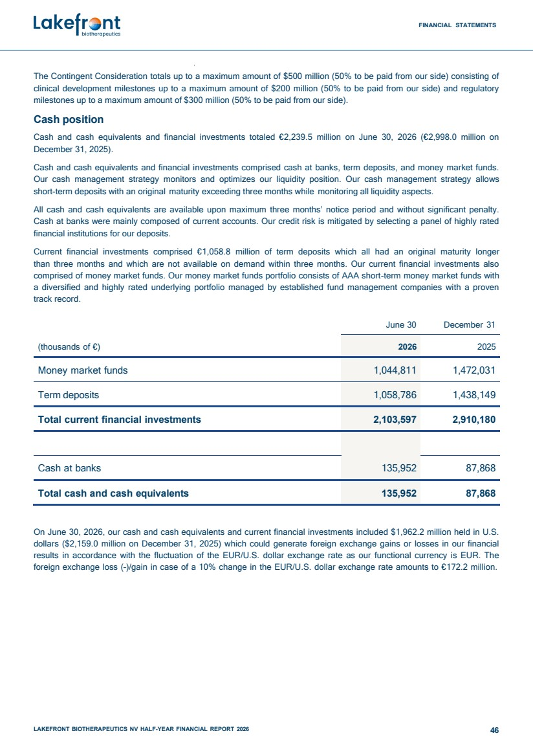 | FINANCIAL STATEMENTS LAKEFRONT BIOTHERAPEUTICS NV HALF-YEAR FINANCIAL REPORT 2026 46 The Contingent Consideration totals up to a maximum amount of $500 million (50% to be paid from our side) consisting of clinical development milestones up to a maximum amount of $200 million (50% to be paid from our side) and regulatory milestones up to a maximum amount of $300 million (50% to be paid from our side). Cash position Cash and cash equivalents and financial investments totaled €2,239.5 million on June 30, 2026 (€2,998.0 million on December 31, 2025). Cash and cash equivalents and financial investments comprised cash at banks, term deposits, and money market funds. Our cash management strategy monitors and optimizes our liquidity position. Our cash management strategy allows short-term deposits with an original maturity exceeding three months while monitoring all liquidity aspects. All cash and cash equivalents are available upon maximum three months’ notice period and without significant penalty. Cash at banks were mainly composed of current accounts. Our credit risk is mitigated by selecting a panel of highly rated financial institutions for our deposits. Current financial investments comprised €1,058.8 million of term deposits which all had an original maturity longer than three months and which are not available on demand within three months. Our current financial investments also comprised of money market funds. Our money market funds portfolio consists of AAA short-term money market funds with a diversified and highly rated underlying portfolio managed by established fund management companies with a proven track record. June 30 December 31 (thousands of €) 2026 2025 Money market funds 1,044,811 1,472,031 Term deposits 1,058,786 1,438,149 Total current financial investments 2,103,597 2,910,180 Cash at banks 135,952 87,868 Total cash and cash equivalents 135,952 87,868 On June 30, 2026, our cash and cash equivalents and current financial investments included $1,962.2 million held in U.S. dollars ($2,159.0 million on December 31, 2025) which could generate foreign exchange gains or losses in our financial results in accordance with the fluctuation of the EUR/U.S. dollar exchange rate as our functional currency is EUR. The foreign exchange loss (–)/gain in case of a 10% change in the EUR/U.S. dollar exchange rate amounts to €172.2 million.
 | 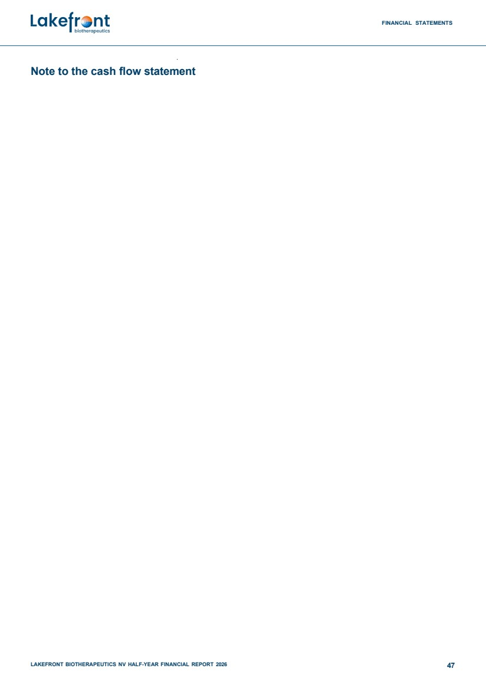 | FINANCIAL STATEMENTS LAKEFRONT BIOTHERAPEUTICS NV HALF-YEAR FINANCIAL REPORT 2026 47 Note to the cash flow statement
 | 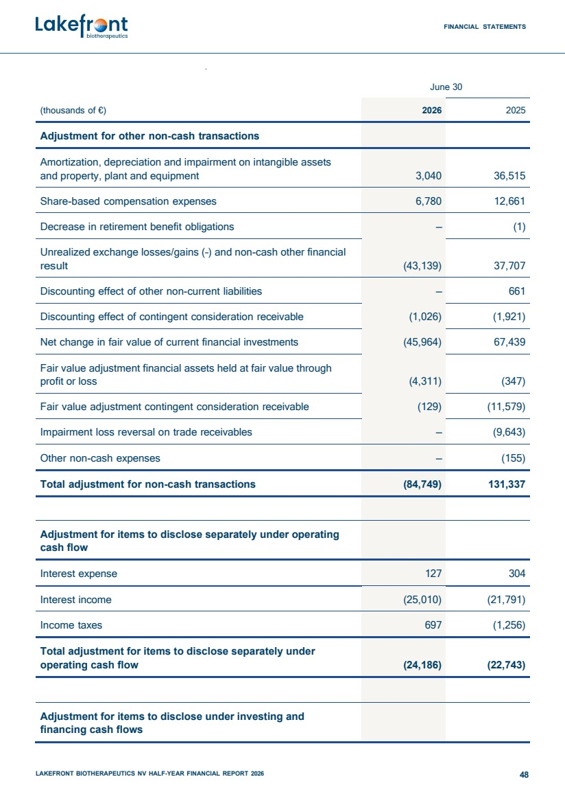 | FINANCIAL STATEMENTS LAKEFRONT BIOTHERAPEUTICS NV HALF-YEAR FINANCIAL REPORT 2026 48 June 30 (thousands of €) 2026 2025 Adjustment for other non-cash transactions Amortization, depreciation and impairment on intangible assets and property, plant and equipment 3,040 36,515 Share-based compensation expenses 6,780 12,661 Decrease in retirement benefit obligations – (1) Unrealized exchange losses/gains (–) and non-cash other financial result (43,139) 37,707 Discounting effect of other non-current liabilities – 661 Discounting effect of contingent consideration receivable (1,026) (1,921) Net change in fair value of current financial investments (45,964) 67,439 Fair value adjustment financial assets held at fair value through profit or loss (4,311) (347) Fair value adjustment contingent consideration receivable (129) (11,579) Impairment loss reversal on trade receivables – (9,643) Other non-cash expenses – (155) Total adjustment for non-cash transactions (84,749) 131,337 Adjustment for items to disclose separately under operating cash flow Interest expense 127 304 Interest income (25,010) (21,791) Income taxes 697 (1,256) Total adjustment for items to disclose separately under operating cash flow (24,186) (22,743) Adjustment for items to disclose under investing and financing cash flows
 | 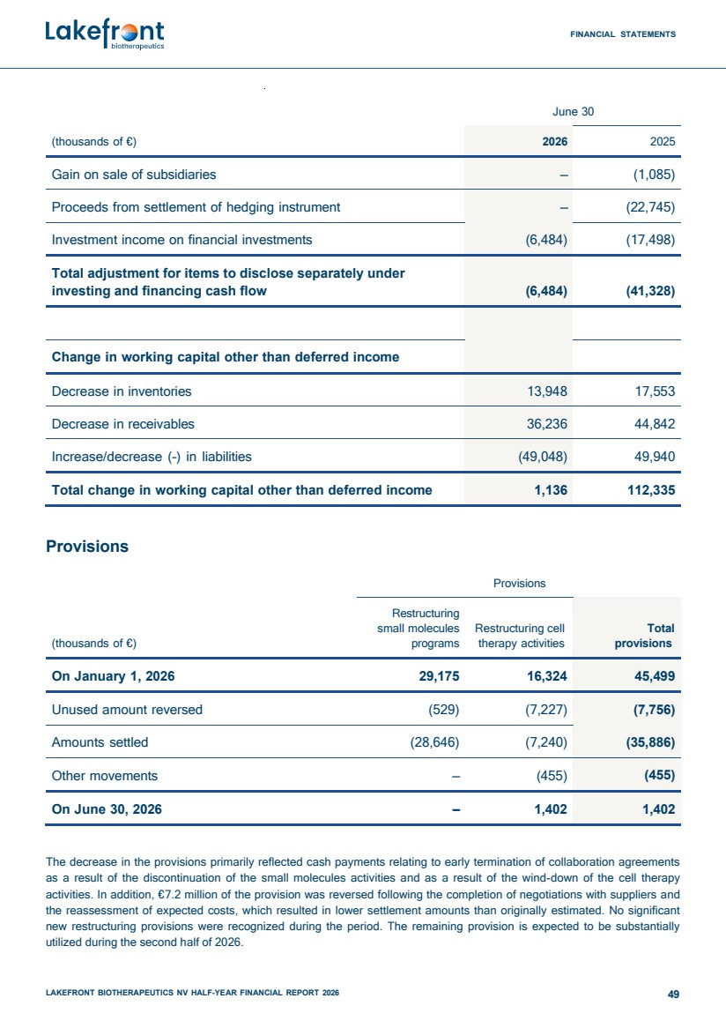 | FINANCIAL STATEMENTS LAKEFRONT BIOTHERAPEUTICS NV HALF-YEAR FINANCIAL REPORT 2026 49 June 30 (thousands of €) 2026 2025 Gain on sale of subsidiaries – (1,085) Proceeds from settlement of hedging instrument – (22,745) Investment income on financial investments (6,484) (17,498) Total adjustment for items to disclose separately under investing and financing cash flow (6,484) (41,328) Change in working capital other than deferred income Decrease in inventories 13,948 17,553 Decrease in receivables 36,236 44,842 Increase/decrease (–) in liabilities (49,048) 49,940 Total change in working capital other than deferred income 1,136 112,335 Provisions Provisions (thousands of €) Restructuring small molecules programs Restructuring cell therapy activities Total provisions On January 1, 2026 29,175 16,324 45,499 Unused amount reversed (529) (7,227) (7,756) Amounts settled (28,646) (7,240) (35,886) Other movements – (455) (455) On June 30, 2026 – 1,402 1,402 The decrease in the provisions primarily reflected cash payments relating to early termination of collaboration agreements as a result of the discontinuation of the small molecules activities and as a result of the wind-down of the cell therapy activities. In addition, €7.2 million of the provision was reversed following the completion of negotiations with suppliers and the reassessment of expected costs, which resulted in lower settlement amounts than originally estimated. No significant new restructuring provisions were recognized during the period. The remaining provision is expected to be substantially utilized during the second half of 2026.
 | 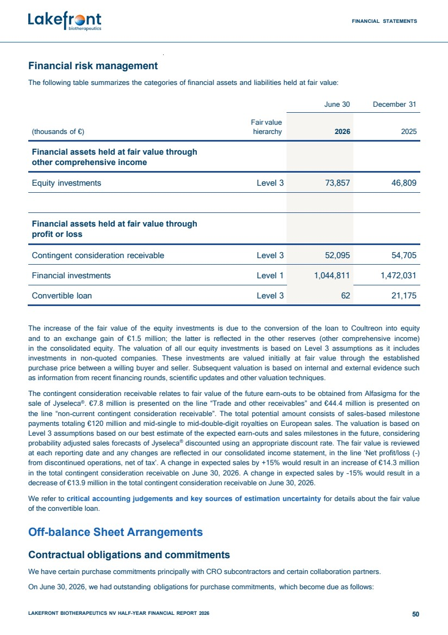 | FINANCIAL STATEMENTS LAKEFRONT BIOTHERAPEUTICS NV HALF-YEAR FINANCIAL REPORT 2026 50 Financial risk management The following table summarizes the categories of financial assets and liabilities held at fair value: June 30 December 31 (thousands of €) Fair value hierarchy 2026 2025 Financial assets held at fair value through other comprehensive income Equity investments Level 3 73,857 46,809 Financial assets held at fair value through profit or loss Contingent consideration receivable Level 3 52,095 54,705 Financial investments Level 1 1,044,811 1,472,031 Convertible loan Level 3 62 21,175 The increase of the fair value of the equity investments is due to the conversion of the loan to Coultreon into equity and to an exchange gain of €1.5 million; the latter is reflected in the other reserves (other comprehensive income) in the consolidated equity. The valuation of all our equity investments is based on Level 3 assumptions as it includes investments in non-quoted companies. These investments are valued initially at fair value through the established purchase price between a willing buyer and seller. Subsequent valuation is based on internal and external evidence such as information from recent financing rounds, scientific updates and other valuation techniques. The contingent consideration receivable relates to fair value of the future earn-outs to be obtained from Alfasigma for the sale of Jyseleca® . €7.8 million is presented on the line “Trade and other receivables” and €44.4 million is presented on the line “non-current contingent consideration receivable”. The total potential amount consists of sales-based milestone payments totaling €120 million and mid-single to mid-double-digit royalties on European sales. The valuation is based on Level 3 assumptions based on our best estimate of the expected earn-outs and sales milestones in the future, considering probability adjusted sales forecasts of Jyseleca® discounted using an appropriate discount rate. The fair value is reviewed at each reporting date and any changes are reflected in our consolidated income statement, in the line ‘Net profit/loss (–) from discontinued operations, net of tax’. A change in expected sales by +15% would result in an increase of €14.3 million in the total contingent consideration receivable on June 30, 2026. A change in expected sales by –15% would result in a decrease of €13.9 million in the total contingent consideration receivable on June 30, 2026. We refer to critical accounting judgements and key sources of estimation uncertainty for details about the fair value of the convertible loan. Off-balance Sheet Arrangements Contractual obligations and commitments We have certain purchase commitments principally with CRO subcontractors and certain collaboration partners. On June 30, 2026, we had outstanding obligations for purchase commitments, which become due as follows:
 | 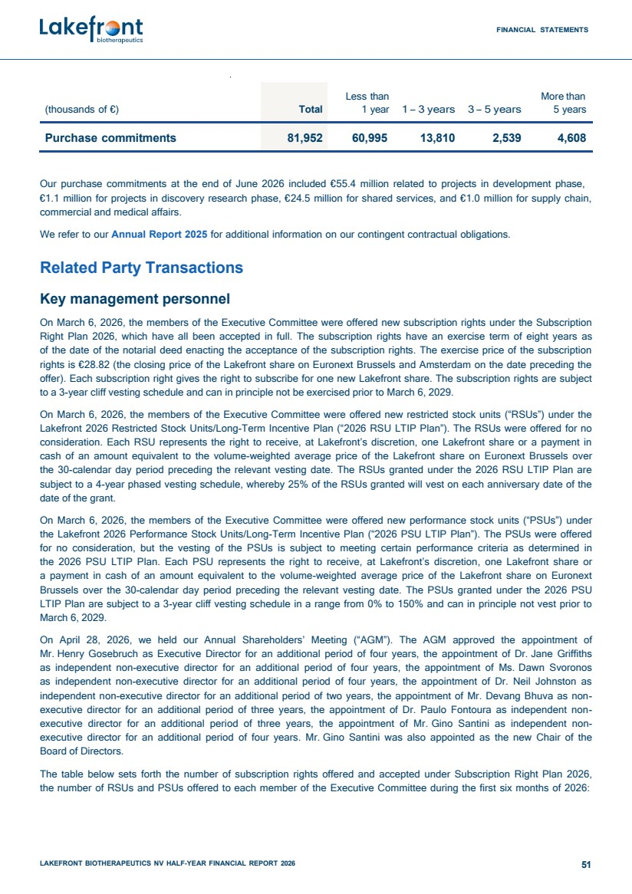 | FINANCIAL STATEMENTS LAKEFRONT BIOTHERAPEUTICS NV HALF-YEAR FINANCIAL REPORT 2026 51 (thousands of €) Total Less than 1 year 1 – 3 years 3 – 5 years More than 5 years Purchase commitments 81,952 60,995 13,810 2,539 4,608 Our purchase commitments at the end of June 2026 included €55.4 million related to projects in development phase, €1.1 million for projects in discovery research phase, €24.5 million for shared services, and €1.0 million for supply chain, commercial and medical affairs. We refer to our Annual Report 2025 for additional information on our contingent contractual obligations. Related Party Transactions Key management personnel On March 6, 2026, the members of the Executive Committee were offered new subscription rights under the Subscription Right Plan 2026, which have all been accepted in full. The subscription rights have an exercise term of eight years as of the date of the notarial deed enacting the acceptance of the subscription rights. The exercise price of the subscription rights is €28.82 (the closing price of the Lakefront share on Euronext Brussels and Amsterdam on the date preceding the offer). Each subscription right gives the right to subscribe for one new Lakefront share. The subscription rights are subject to a 3-year cliff vesting schedule and can in principle not be exercised prior to March 6, 2029. On March 6, 2026, the members of the Executive Committee were offered new restricted stock units (“RSUs”) under the Lakefront 2026 Restricted Stock Units/Long-Term Incentive Plan (“2026 RSU LTIP Plan”). The RSUs were offered for no consideration. Each RSU represents the right to receive, at Lakefront’s discretion, one Lakefront share or a payment in cash of an amount equivalent to the volume-weighted average price of the Lakefront share on Euronext Brussels over the 30-calendar day period preceding the relevant vesting date. The RSUs granted under the 2026 RSU LTIP Plan are subject to a 4-year phased vesting schedule, whereby 25% of the RSUs granted will vest on each anniversary date of the date of the grant. On March 6, 2026, the members of the Executive Committee were offered new performance stock units (“PSUs”) under the Lakefront 2026 Performance Stock Units/Long-Term Incentive Plan (“2026 PSU LTIP Plan”). The PSUs were offered for no consideration, but the vesting of the PSUs is subject to meeting certain performance criteria as determined in the 2026 PSU LTIP Plan. Each PSU represents the right to receive, at Lakefront’s discretion, one Lakefront share or a payment in cash of an amount equivalent to the volume-weighted average price of the Lakefront share on Euronext Brussels over the 30-calendar day period preceding the relevant vesting date. The PSUs granted under the 2026 PSU LTIP Plan are subject to a 3-year cliff vesting schedule in a range from 0% to 150% and can in principle not vest prior to March 6, 2029. On April 28, 2026, we held our Annual Shareholders’ Meeting (“AGM”). The AGM approved the appointment of Mr. Henry Gosebruch as Executive Director for an additional period of four years, the appointment of Dr. Jane Griffiths as independent non-executive director for an additional period of four years, the appointment of Ms. Dawn Svoronos as independent non-executive director for an additional period of four years, the appointment of Dr. Neil Johnston as independent non-executive director for an additional period of two years, the appointment of Mr. Devang Bhuva as non-executive director for an additional period of three years, the appointment of Dr. Paulo Fontoura as independent non-executive director for an additional period of three years, the appointment of Mr. Gino Santini as independent non-executive director for an additional period of four years. Mr. Gino Santini was also appointed as the new Chair of the Board of Directors. The table below sets forth the number of subscription rights offered and accepted under Subscription Right Plan 2026, the number of RSUs and PSUs offered to each member of the Executive Committee during the first six months of 2026:
 | 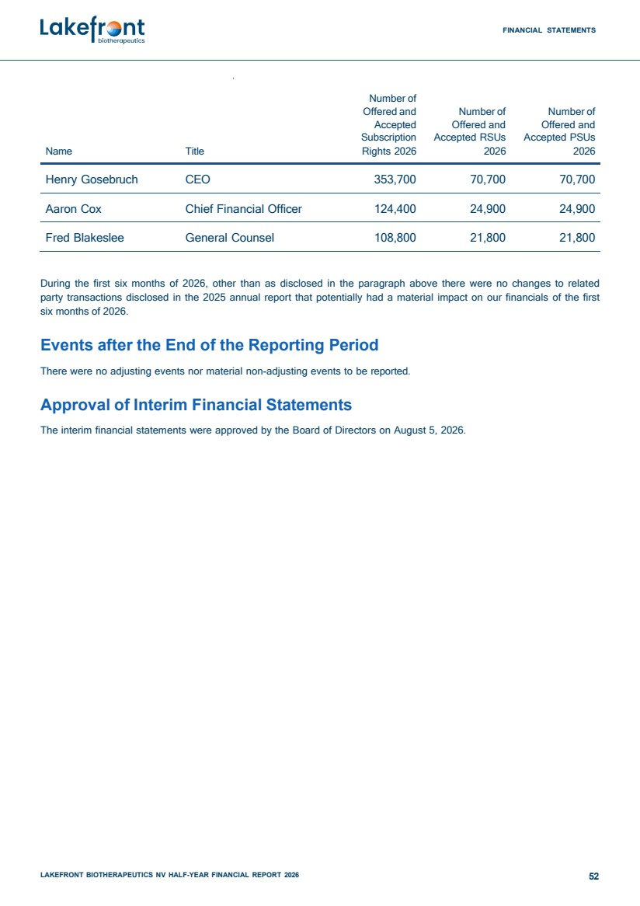 | FINANCIAL STATEMENTS LAKEFRONT BIOTHERAPEUTICS NV HALF-YEAR FINANCIAL REPORT 2026 52 Number of Offered and Accepted Subscription Number of Offered and Accepted RSUs Number of Offered and Accepted PSUs Name Title Rights 2026 2026 2026 Henry Gosebruch CEO 353,700 70,700 70,700 Aaron Cox Chief Financial Officer 124,400 24,900 24,900 Fred Blakeslee General Counsel 108,800 21,800 21,800 During the first six months of 2026, other than as disclosed in the paragraph above there were no changes to related party transactions disclosed in the 2025 annual report that potentially had a material impact on our financials of the first six months of 2026. Events after the End of the Reporting Period There were no adjusting events nor material non-adjusting events to be reported. Approval of Interim Financial Statements The interim financial statements were approved by the Board of Directors on August 5, 2026.
 | 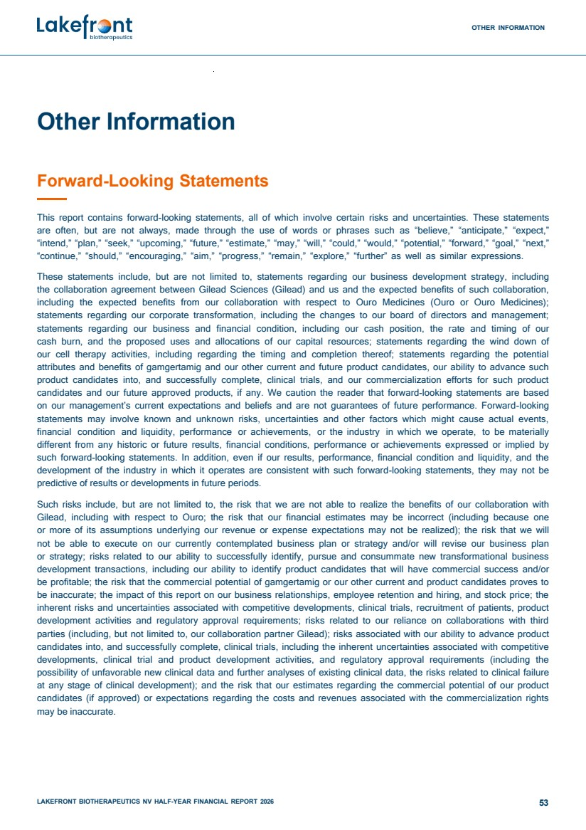 | OTHER INFORMATION LAKEFRONT BIOTHERAPEUTICS NV HALF-YEAR FINANCIAL REPORT 2026 53 Other Information Forward-Looking Statements This report contains forward-looking statements, all of which involve certain risks and uncertainties. These statements are often, but are not always, made through the use of words or phrases such as “believe,” “anticipate,” “expect,” “intend,” “plan,” “seek,” “upcoming,” “future,” “estimate,” “may,” “will,” “could,” “would,” “potential,” “forward,” “goal,” “next,” “continue,” “should,” “encouraging,” “aim,” “progress,” “remain,” “explore,” “further” as well as similar expressions. These statements include, but are not limited to, statements regarding our business development strategy, including the collaboration agreement between Gilead Sciences (Gilead) and us and the expected benefits of such collaboration, including the expected benefits from our collaboration with respect to Ouro Medicines (Ouro or Ouro Medicines); statements regarding our corporate transformation, including the changes to our board of directors and management; statements regarding our business and financial condition, including our cash position, the rate and timing of our cash burn, and the proposed uses and allocations of our capital resources; statements regarding the wind down of our cell therapy activities, including regarding the timing and completion thereof; statements regarding the potential attributes and benefits of gamgertamig and our other current and future product candidates, our ability to advance such product candidates into, and successfully complete, clinical trials, and our commercialization efforts for such product candidates and our future approved products, if any. We caution the reader that forward-looking statements are based on our management’s current expectations and beliefs and are not guarantees of future performance. Forward-looking statements may involve known and unknown risks, uncertainties and other factors which might cause actual events, financial condition and liquidity, performance or achievements, or the industry in which we operate, to be materially different from any historic or future results, financial conditions, performance or achievements expressed or implied by such forward-looking statements. In addition, even if our results, performance, financial condition and liquidity, and the development of the industry in which it operates are consistent with such forward-looking statements, they may not be predictive of results or developments in future periods. Such risks include, but are not limited to, the risk that we are not able to realize the benefits of our collaboration with Gilead, including with respect to Ouro; the risk that our financial estimates may be incorrect (including because one or more of its assumptions underlying our revenue or expense expectations may not be realized); the risk that we will not be able to execute on our currently contemplated business plan or strategy and/or will revise our business plan or strategy; risks related to our ability to successfully identify, pursue and consummate new transformational business development transactions, including our ability to identify product candidates that will have commercial success and/or be profitable; the risk that the commercial potential of gamgertamig or our other current and product candidates proves to be inaccurate; the impact of this report on our business relationships, employee retention and hiring, and stock price; the inherent risks and uncertainties associated with competitive developments, clinical trials, recruitment of patients, product development activities and regulatory approval requirements; risks related to our reliance on collaborations with third parties (including, but not limited to, our collaboration partner Gilead); risks associated with our ability to advance product candidates into, and successfully complete, clinical trials, including the inherent uncertainties associated with competitive developments, clinical trial and product development activities, and regulatory approval requirements (including the possibility of unfavorable new clinical data and further analyses of existing clinical data, the risks related to clinical failure at any stage of clinical development); and the risk that our estimates regarding the commercial potential of our product candidates (if approved) or expectations regarding the costs and revenues associated with the commercialization rights may be inaccurate.
 | 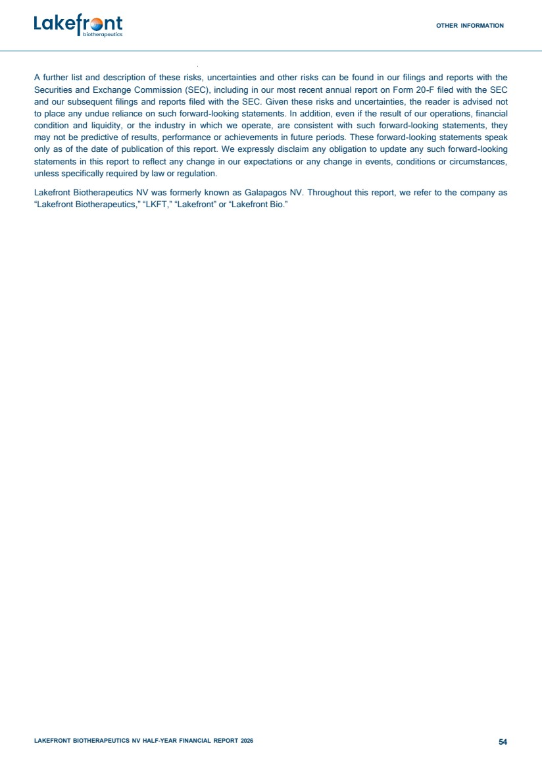 | OTHER INFORMATION LAKEFRONT BIOTHERAPEUTICS NV HALF-YEAR FINANCIAL REPORT 2026 54 A further list and description of these risks, uncertainties and other risks can be found in our filings and reports with the Securities and Exchange Commission (SEC), including in our most recent annual report on Form 20-F filed with the SEC and our subsequent filings and reports filed with the SEC. Given these risks and uncertainties, the reader is advised not to place any undue reliance on such forward-looking statements. In addition, even if the result of our operations, financial condition and liquidity, or the industry in which we operate, are consistent with such forward-looking statements, they may not be predictive of results, performance or achievements in future periods. These forward-looking statements speak only as of the date of publication of this report. We expressly disclaim any obligation to update any such forward-looking statements in this report to reflect any change in our expectations or any change in events, conditions or circumstances, unless specifically required by law or regulation. Lakefront Biotherapeutics NV was formerly known as Galapagos NV. Throughout this report, we refer to the company as “Lakefront Biotherapeutics,” “LKFT,” “Lakefront” or “Lakefront Bio.”
 | 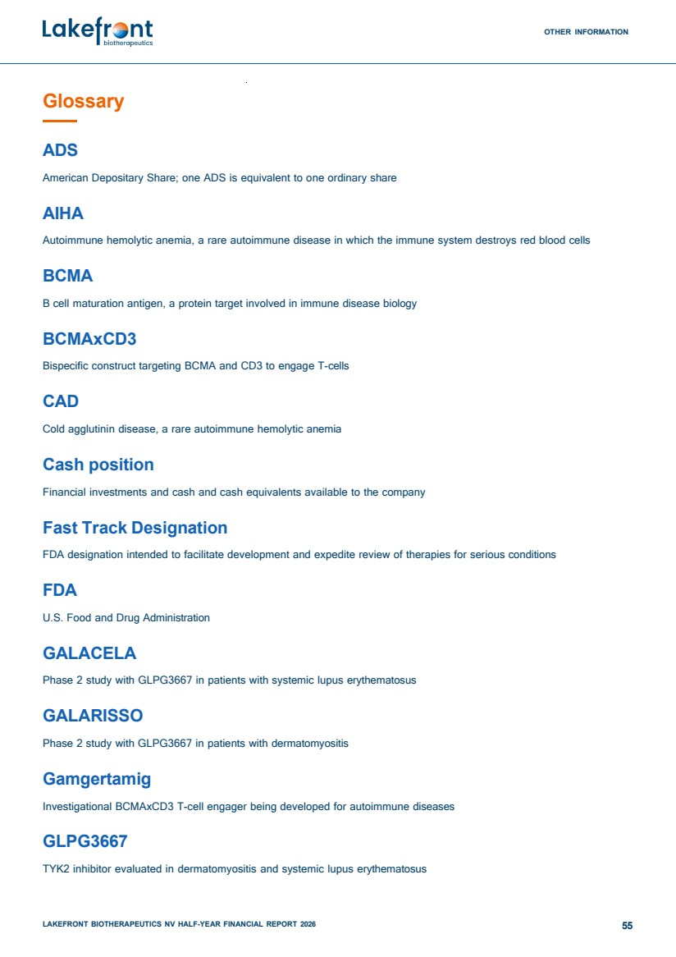 | OTHER INFORMATION LAKEFRONT BIOTHERAPEUTICS NV HALF-YEAR FINANCIAL REPORT 2026 55 Glossary ADS American Depositary Share; one ADS is equivalent to one ordinary share AIHA Autoimmune hemolytic anemia, a rare autoimmune disease in which the immune system destroys red blood cells BCMA B cell maturation antigen, a protein target involved in immune disease biology BCMAxCD3 Bispecific construct targeting BCMA and CD3 to engage T-cells CAD Cold agglutinin disease, a rare autoimmune hemolytic anemia Cash position Financial investments and cash and cash equivalents available to the company Fast Track Designation FDA designation intended to facilitate development and expedite review of therapies for serious conditions FDA U.S. Food and Drug Administration GALACELA Phase 2 study with GLPG3667 in patients with systemic lupus erythematosus GALARISSO Phase 2 study with GLPG3667 in patients with dermatomyositis Gamgertamig Investigational BCMAxCD3 T-cell engager being developed for autoimmune diseases GLPG3667 TYK2 inhibitor evaluated in dermatomyositis and systemic lupus erythematosus
 | 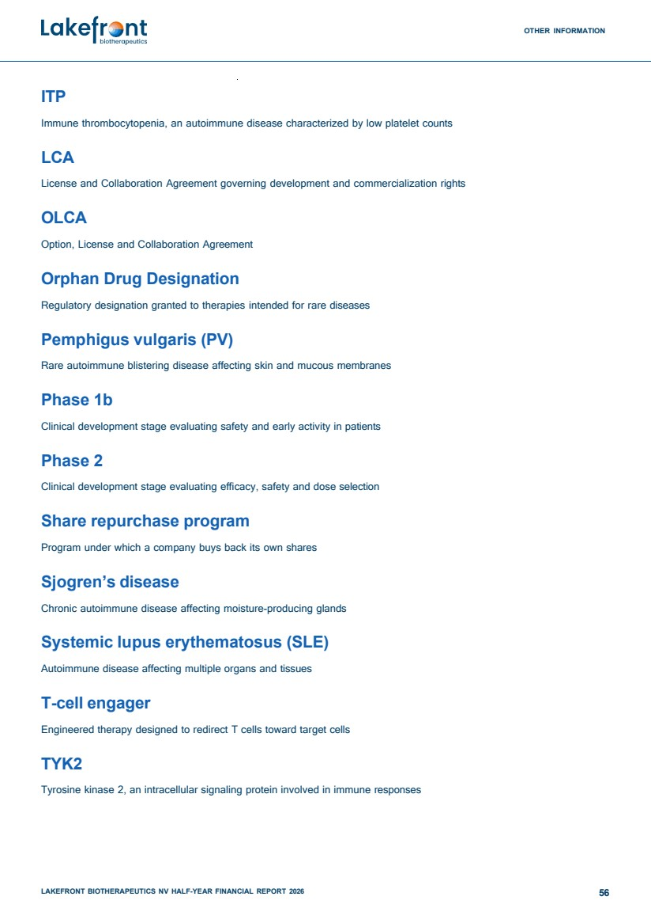 | OTHER INFORMATION LAKEFRONT BIOTHERAPEUTICS NV HALF-YEAR FINANCIAL REPORT 2026 56 ITP Immune thrombocytopenia, an autoimmune disease characterized by low platelet counts LCA License and Collaboration Agreement governing development and commercialization rights OLCA Option, License and Collaboration Agreement Orphan Drug Designation Regulatory designation granted to therapies intended for rare diseases Pemphigus vulgaris (PV) Rare autoimmune blistering disease affecting skin and mucous membranes Phase 1b Clinical development stage evaluating safety and early activity in patients Phase 2 Clinical development stage evaluating efficacy, safety and dose selection Share repurchase program Program under which a company buys back its own shares Sjogren’s disease Chronic autoimmune disease affecting moisture-producing glands Systemic lupus erythematosus (SLE) Autoimmune disease affecting multiple organs and tissues T-cell engager Engineered therapy designed to redirect T cells toward target cells TYK2 Tyrosine kinase 2, an intracellular signaling protein involved in immune responses
 | 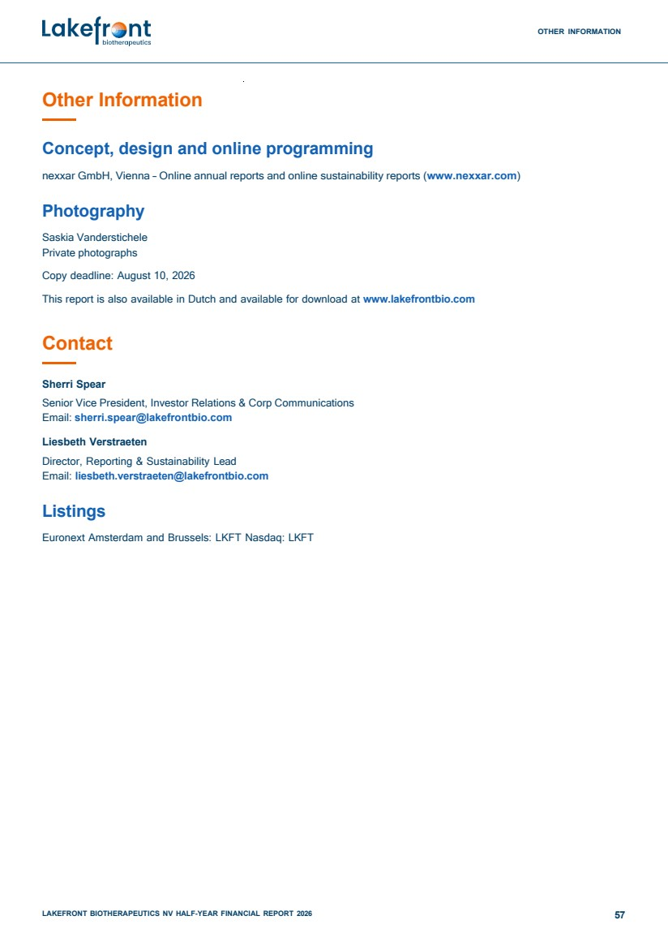 | OTHER INFORMATION LAKEFRONT BIOTHERAPEUTICS NV HALF-YEAR FINANCIAL REPORT 2026 57 Other Information Concept, design and online programming nexxar GmbH, Vienna – Online annual reports and online sustainability reports (www.nexxar.com) Photography Saskia Vanderstichele Private photographs Copy deadline: August 10, 2026 This report is also available in Dutch and available for download at www.lakefrontbio.com Contact Sherri Spear Senior Vice President, Investor Relations & Corp Communications Email: sherri.spear@lakefrontbio.com Liesbeth Verstraeten Director, Reporting & Sustainability Lead Email: liesbeth.verstraeten@lakefrontbio.com Listings Euronext Amsterdam and Brussels: LKFT Nasdaq: LKFT
 |  | Lakefront Biotherapeutics NV Schaliënhoevedreef 20 T 2800 Mechelen Belgium lakefrontbio.com

